Toxicology
105447
Second Semester
2012-2013
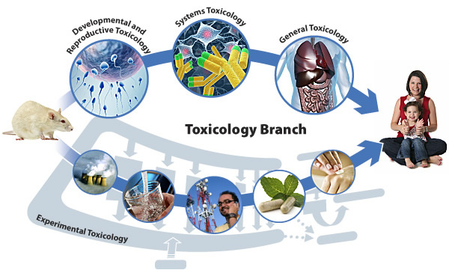
Prepared by
Dr. Basma Damiri
Toxicology

Week | Topics
_
1 | Introduction:  - History and General Principles of Toxicology  - Toxicology fileds:  - Mechanistic Toxicology  - Molecular Toxicology  - Environmental Toxicology  - Clinical Toxicology  - Aquatic Toxicology  - Ecotoxicology  - Forensic Toxicology  - Occupational Toxicology  - Entomotoxicology
2 | - Types of Toxic or Side Effects.  - Interaction of Chemicals  - Dose Response/Testing Methods
3 | Toxicodynamics and Toxicokinetics  Absorption, Distribution, Elimination and Metabolism of Toxic Agents ADEM.  Biotransformation: A balance Between Bioactivation and Detoxification
4 | Xenobiotic and Drug Metabolizing Enzymes.  Drugs and Toxic Substances  Drug-Drug interaction  Drug-Food interaction
5 | First Exam  Animal and Plant Toxicology
6 | Animal and Plant Toxicity
7 | Mutagenesis and Genetic Toxicology  Teratogens  Chemical Carcinogenesis
 | Systemic Toxicology
8 | Hematotoxicity 2, Chemically Induced Toxicity of the Blood
9 | Hepatotoxicity, Toxic Effect on the Liver  Nephrotoxicity: Toxic Responses of the Kidney
10 | Second Exam  Neurotoxicity: Toxic Responses of the Nervous System
11 | Dermal and Ocular Toxicology: Toxic effects of the Skin and Eyes  Pulmonotoxicity: Toxic Effect in the Lung
12 | Pulmonotoxicity: Toxic Effect in the Lung
13 | Immunotoxicity: Toxic Effect on the Immune System
14 | Reproductive Toxicology
15 | Endocrine Toxicology
16 | Final

References:

- Critical Care of Toxicology, Diagnosis and Management of Critically Poisoned Patient. effrey Brent, Kevin Wallace, Keith Burkhart December 31, 2004 | ISBN-10: 0815143877 | ISBN-13: 978-0815143871.
- Principles Toxicology, Environmental and Industrial Applications. 2nd Edition. Edited by PhilipL. Williams, Robert C. James, and Stephen M. Roberts (1985).
- Toxic Substances in the Environment, B. Magnus Francis (1994)
- Introduction to Toxicology 2nd Edition John Tembrell (2007)
- Mechanistic Toxicology: The Molecular Basis of How Chemicals Disrupt Biological Targets, Urs A. Boelsterli (2007)
- Modern Toxicology, 3rd Edition by Ernest Hodgson, (2004)

Course Objectives:

At the end of this course, the learner should be able to:
- Distinguish between the different fields of toxicology.
- Recognize the basic principles methods of toxicology and toxicology testing.
- Define the basic concepts of toxicokinetics and toxicodynamics.
- Explain dose-response relationship and NOEC, LOEC, and LC50 concepts.
- Define the acute and chronic toxicities of common drugs, industrial and household products and natural chemicals from animals and plants in humans.
- Describe what a toxic syndrome is.
- Explain systemic toxicology.
- Apply basic concepts of laboratory testing principles.
- Develop approaches for prevention, diagnosis and treatment of adverse effects.

REQUIRED TEXTBOOK:
Course content will be presented through textbook readings and lectures. All lecture materials will be posted to An-Najah National University website.
- Casarett, Louis (2007): Casarett & Doull's Toxicology: The Basic Science of Poisons, Seventh Edition (Casarett & Doull Toxicology), McGraw Hill.
- Williams, Philip and James, Robert and Roberts, Stephen (2003): Principles Toxicology, Environmental and Industrial Applications. 2nd Edition, John Wiley & Sons.
- Tembrell, John (2002): Introduction to Toxicology 2nd Edition, Taylor & Francis.

SUPPLEMENTARY MATERIALS & REFERENCES
Websites http://toxlearn.nlm.nih.gov/Module1.htm
http://toxicology.ucsd.edu/modules.htm
Mechanistic Toxicology, the molecular basis of how chemicals disrupt biological targets, 2nd edition, URS A. Boelsterli
Casarett & Doull's Toxicology: The Basic Science of Poisons, Seventh Edition (Casarett & Doull Toxicology) by Louis J. Casarett
Pubmed articles/ online articles

COURSE AND ATTENDANCE POLICY
Students are expected to attend each class. Official course announcements will be made in class, and if the student is not in attendance, it is his/her responsibility to obtain the information presented in class that day.

EXAMINATIONS
There will be three examinations; two during the semester and one at the time assigned during finals week. Each examination during the semester will consist of multiple-choice, true-false, matching questions, problem statement and/or case analysis, articles, short answer style questions (objective questions).
For the first and second exams, students will be given up to 1 hour (and no longer) to complete each examination and each one will be worth 15 points. The final examination will be cumulative and last for 2 hours, and will be worth 50 points. A term or a student presentation will be worth 10 points and participation 10 points.

