 | An-Najah N. University  Faculty of Information Technology  Computer Information Systems Dept.  Data Mining – 2nd Semester 2012/2013  Final Exam 15/5/13

Student Name:
Please answer all of the following questions:

Question Two: Discussion
- Give few techniques to improve the efficiency of Apriori algorithm.
- What are the things suffering the performance of Apriori candidate generation technique.

- Write the pseudo-code of the k-mean clustering algorithm

- Mention four methods used to Handle missing values in a data set

Question Three: Suppose you want to cluster the eight points shown below using k-means
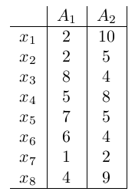
Assume that k = 3 and that initially the points are assigned to clusters as follows: C₁ = {x₁, x₂, x₃}, C₂ = {x₄, x₅, x₆}, C₃ = {x₇, x₈}. Apply the k-means algorithm until convergence (i.e., until the clusters do not change), using the Manhattan distance. Make sure you clearly identify the final clustering and show your steps
Manhattan distance between a point X=(x₁, x₂, ……,x_{n}) and a point Y=( y₁, y₂, ……,y_{n}) is:
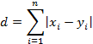
Question Four: Given are the following five transactions on items {A, B, C, D, E}:
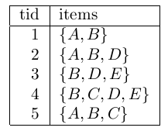
Use the Apriori algorithm to compute all frequent itemsets, and their support, with minimum support of 2. It is important that you clearly indicate the steps of the algorithm.

Question Five: Given are the following training data for binary classification problem:
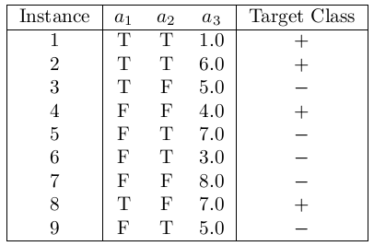
What are the information gains of a₁ and a₂ attributes with respect to the positive class?

