Name:______________________________ number:__________________________________
Q1 (10 points): An energy engineer executed an audit and collected the following data:  Motor size – 10 hp, percent loading – 40%, 3500 operating hours per year, and electricity cost – $0.2/kWh.  - How much savings can be achieved by replacing it with 6 hp motor?  - How this opportunity is expected to affect the PF value? | 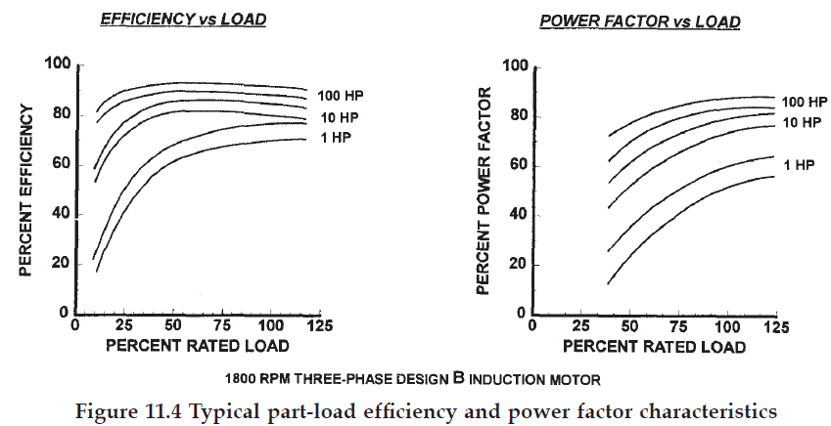

Q2 (10 points): A large centrifugal industrial fan consumes 50kW and delivers 14,000 m³/hour and 100 Pa pressure rise. The factory engineer found that 8000 m³/hr is enough. If electricity costs $0.17 per kWh and the fan is necessary for 3000 hour per year:
- Calculate the estimated savings.
- How much would you pay for this opportunity to recover (payback period) you investment in less than one year.
Q3 (10 point): A factory has motors (100kW) that operate 2000 hour per year under 82% PF conditions, it is about to install a new electric boiler (20kW) that will operate 1200 hour per year. If the factory needs to raise its PF to a value between 92% and 94% to avoid penalties:
- How the boiler will affect the PF value.
- Propose a practical solution (design required capacitor bank in kVAR) to ensure that the PF will keep between 92% and 94% (should not exceed 94%).

