REPRODUCTION AND CHROMOSOME TRANSMISSION
The cell cycle: a continuous alternation between division and non-division.
- Non- division = interphase. Interphase consists of three phases (G1 phase, S phase, and G2 phase).
During interphase, the biochemical activity is keen to Cell growth and Replication of DNA of each chromosome
Interpahse:
1 - G1 (Gap 1): In this phase the cell grows.
- Synthesis of enzymes necessary in the S phase.
- G1 checkpoint cell follows one of two paths: either inter a resting phase called G0 stage (Gap 0) or complete the cycle.
2- S phase: The period during which DNA is synthesized (replication or duplication of DNA). The cell makes copies of its chromosomes. Each chromosome now consists of two sister chromatids.
3 - G2 (Gap 2): Second growth phase.
- G2 checkpoint: The cell checks the duplicated chromosomes(make the repair if needed) and gets ready to divide.
- By the end of G2 the volume of the cell has roughly doubled, DNA has been replicated and mitosis is initiated.
2. division = - M phase (Mitosis): the cell divides into two new cells.
- Prophase:
- the centrioles migrate to two opposite sides of the cell.
- spindle fibers start to form
- the nuclear envelope begins to break down and the nucleolus fades.
- Microtubules of the cytoskeleton disassemble.
- The diffuse chromatin condenses into chromosomes.
2. Prometaphase:
- In this stage the nuclear envelope breaks down and the nucleus disappear.
- Some mitotic spindle attach to kinetochores (protein bundles at the centromere region on the chromosomes where sister chromatids are joined) and called “kinetochore microtubules”.
- Other spindle fibers elongate and attach with spindle fibers growing from the other side of the cell. These are called “polar microtubules or non-kinetochore microtubules”.
- the chromosomes start to migrate towards the center of the cell
3. Metaphase: all chromosomes align in one plane at the center of the cell called the equatorial plane (also referred to as the metaphase plate).
4. Anaphase: Spindle fibers shorten, the kinetochores separate, and the sister chromatids (daughter chromosomes) are pulled apart and begin moving to the cell poles.
5. Telophase : The daughter chromosomes arrive at the poles and the spindle fibers disappear.
- Cytokinesis of the cytoplasm (division of the cytoplasm) occurs resulting in two identical cells.
- chromosomes begin to uncoil, nuclear envelope re-forms and The nucleolus gradually re-forms
Meiosis (reduction division)
- Meiosis produces gametes with only one haploid set of chromosomes (reduction of the number of chromosomes by half)
- Meiosis is divided into two main steps:
- Meiosis I
- Prophase I divided into 5 substages:
- Leptonema (Leptotene stage): (from Greek words meaning "thin threads“. Chromatin material begins to condense. Each chromosome begins to search its homologue (homology search)
- Zygonema (Zygotene stage): The chromosomes continue to condense. Homologous chromosomes find each other and a synaptonemal complex starts to form (synapsis begins) between the homologs. At the completion of zygonema the paired homologs represent structures referred to as “bivalents” (also called tetrads because each one consists of four chromatids two sister chromatids and two non-sister chromatids)
- Pachynema (Pachytene stage): "thick threads": The aligned homologous chromosomes become much more closely associated. Synapsis complete . The chromosomes continue to condense. Crossing-over occurs (Exchange of genetic material between non-sister chromatids of homologous chromosomes)
- Diplonema (Diplotene stage): "two threads": The homologous chromosomes in each tetrad begin to separate, but they remain connected at points of crossing over. Each point of crossing over is known as a chiasma (plural: chiasmata). Also at this stage, the nuclear envelope begins to break down
- Diakinesis: "moving through": The chiasmata proceed to the end of the chromatids, then separate (terminalization). This leaves chromatids that engaged in crossing over with exchanged genetic material. The nucleolus and nuclear envelope break down. The centromeres of the chromosomes become attached to spindle fibers.
- Metaphase I: Chromosomes (bivalents) align at the center of the cell (the metaphase plate). A single centromere holds each pair of sister chromatids together. The centromere does not divide and the two sister chromatids remain attached
- Anaphase I: One-half of each tetrad (one pair of sister chromatids) called a “dyad” is pulled towards one pole of the cell at random. This process is called disjunction
- Telophase I: Chromosomes (each consisting of two chromatids) complete their migration to the poles. A nuclear membrane forms around each set of dyads. Cytokinesis occurs during Telophase I so that two cells are produced each containing half the number of tetrads.
- Meiosis II:
- Prophase II: each dyad is composed of one pair of sister chromatids attached by one centromere. the nuclear membrane that formed during Telophase I breakdown and chromosomes re-condense
- Metaphase II: the dyads move and align at the center of the cell. then the centromere divide
- Anaphase II: the sister chromatids of each dyad separate and begin to move towards the opposite poles of each cell. each chromatid is now considered a separate chromosome called “monad”
- Telophase II: nuclear membranes form again and Cytokinesis occurs. at the end of Meiosis II, 4 haploid cells are produced from a single cell entering meiosis.
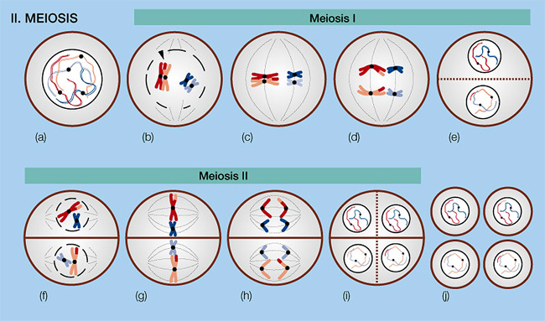

- Mitosis vs Meiosis
  - Mitosis produces two diploid daughter cells
  - Meiosis produce four haploid daughter cells
  - Mitosis produces daughter cells that are genetically identical
  - Meiosis produces daughter cells that are not genetically identical
    - The daughter cells contain only one homologous chromosome from each pair

