Introduction to quantitative genetics

Quantitative traits
Most traits encountered in plant breeding are quantitatively inherited. Many genes control such traits, each contributing a small effect to the overall phenotypic expression of a trait. Variation in quantitative trait expression is without natural discontinuities (i.e., the variation is continuous). The traits that exhibit continuous variations are also called metric traits. Any attempt to classify such traits into distinct groups is only arbitrary. For example, height is a quantitative trait. If plants are grouped into tall versus short plants, one could find relatively tall plants in the short group and, similarly, short plants in the tall group.

Qualitative genetics versus quantitative genetics
The major ways in which qualitative genetics and quantitative genetics differ may be summarized as:
- Nature of traits: Qualitative genetics is concerned with traits that have Mendelian inheritance and can be described according to kind and can be unambiguously categorized. Quantitative genetics traits are described in terms of the degree of expression of the trait, rather than the kind.
- Scale of variability: Qualitative genetic traits provide discontinuous phenotypic variation, whereas quantitative genetic traits produce phenotypic variation that spans the full spectrum (continuous).
- Number of genes: In qualitative genetics, the effects of single genes are readily detectable, while in quantitative genetics, single gene effects are not discernible.
- Statistical analysis: Qualitative genetic analysis is quite straightforward, and is based on counts and ratios. On the other hand, quantitative analysis provides estimates of population parameters (attributes of the population from which the sample was obtained).

The environment and quantitative variation
All genes are expressed in an environment (phenotype = genotype + environmental effect). However, quantitative traits tend to be influenced to a greater degree than qualitative traits. It should be pointed out that, under significantly large environmental effects, qualitative traits (controlled by one or a few major genes) can exhibit a quantitative trait inheritance pattern (Figure 8.1). A strong environmental influence causes the otherwise distinct classes to overlap.

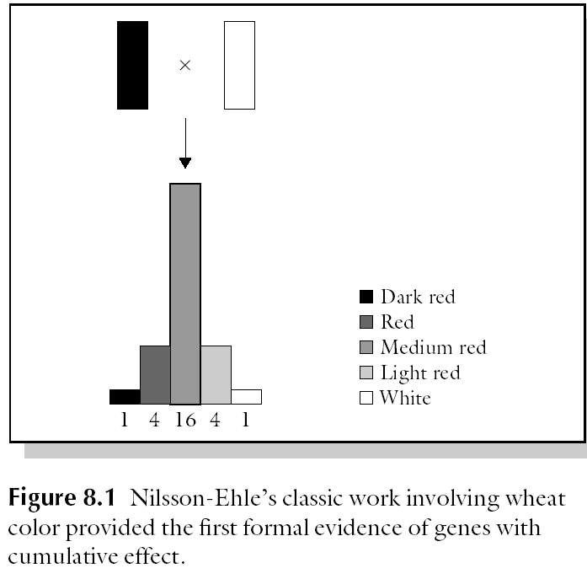

Polygenes and polygenic inheritance
Quantitative traits are controlled by multiple genes or polygenes.

What are polygenes?
Polygenes are genes with effects that are too small to be individually distinguished. They are sometimes called minor genes. In polygenic inheritance, segregation occurs at a large number of loci affecting a trait. The phenotypic expression of polygenic traits is susceptible to significant modification by the variation in environmental factors to which plants in the population are subjected. Polygenic variation cannot be classified into discrete groups (i.e., variation is continuous). This is because of the large number of segregating loci, each with effects so small that it is not possible to identify individual gene effects in the segregating population or to meaningfully describe individual genotypes. Instead, biometrics is used to describe the population in terms of means and variances. Continuous variation is caused by environmental variation and genetic variation due to the simultaneous segregation of many genes affecting the trait. These effects convert the intrinsically discrete variation to a continuous one. Biometric genetics is used to distinguish between the two factors that cause continuous variability to occur.
Another aspect of polygenic inheritance is that different combinations of polygenes can produce a particular phenotypic expression. Furthermore, it is difficult to measure the role of the environment on trait expression because it is very difficult to measure the environmental effect on the plant basis. Consequently, a breeder attempting to breed a polygenic trait should evaluate the cultivar in an environment that is similar to that prevailing in the production region.
Polygenic inheritance may be explained by making three basic assumptions:
- Many genes determine the quantitative trait.
- These genes lack dominance.
- The action of the genes are additive.

In 1910, a Swedish geneticist, Nilsson-Ehle provided a classic demonstration of polygenic inheritance and in the process helped to bridge the gap between our understanding of the essence of quantitative and qualitative traits. Nilsson-Ehle crossed two varieties of wheat, one with deep red grain of genotype R₁R₁R₂R₂, and the other white grain of genotype r₁r₁r₂r₂. The results are summarized in Table 8.1. He observed that all the seed of the F₁ was medium red. The F₂ showed about 1/16 dark red and 1/16 white seed, the remainder being intermediate. The intermediates could be classified into 6/16 medium red (like the F₁), 4/16 red, and 4/16 light red. His interpretation was that the two genes each had a pair of alleles that exhibited cumulative effects. In other words, the genes lacked dominance and their action was additive. Each R₁ or R₂ allele added some red to the phenotype so that the genotypes of white contained neither of these alleles, while the dark red genotype contained only R₁ and R₂.

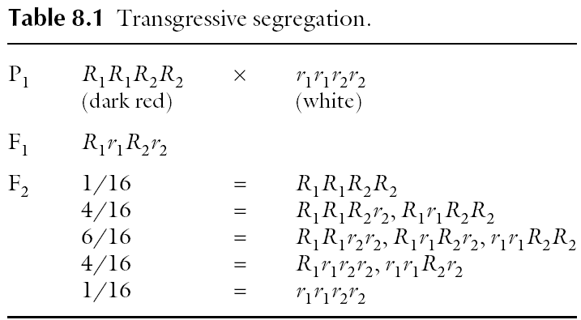

The study involved only two loci. However, most polygenic traits are conditioned by genes at many loci. The number of genotypes that may be observed in the F₂ is calculated as 3^{n}, where n is the number of loci (each with two alleles). Hence, for three loci, the number of genotypes is 27, and for 10 loci, it will be 310.

Gene action
There are four types of gene action: additive, dominance, epistatic, and overdominance. Because gene effects do not always fall into clear-cut categories, and quantitative traits are governed by genes with small individual effects, they are often described by their gene action rather than by the number of genes by which they are encoded. It should be pointed out that gene action is conceptually the same for major genes as well as minor genes, the essential difference being that the action of a minor gene is small and significantly influenced by the environment.

- Additive gene action
The effect of a gene is said to be additive when each additional gene enhances the expression of the trait by equal increments. Consequently, if one gene adds one unit to a trait, the effect of aabb = 0, Aabb = 1, AABb = 3, and AABB = 4. For a single locus (A, a) the heterozygote would be exactly intermediate between the parents (i.e., AA = 2, Aa = 1, aa = 0). That is, the performance of an allele is the same irrespective of other alleles at the same locus. This means that the phenotype reflects the genotype in additive action, assuming the absence of environmental effect.

- Dominance gene action
Dominance action describes the relationship of alleles at the same locus. Dominance variance has two components – variance due to homozygous alleles (which is additive) and variance due to heterozygous genotypic values. Dominance effects are deviations from additivity that make the heterozygote resemble one parent more than the other. When dominance is complete, the heterozygote is equal to the homozygote in effects (i.e., Aa = AA). The breeding implication is that the breeder cannot distinguish between the heterozygous and homozygous phenotypes.

- Overdominance gene action
Overdominance gene action exists when each allele at a locus produces a separate effect on the phenotype, and their combined effect exceeds the independent effect of the alleles (i.e., aa = 1, AA = 1, Aa = 2). From the breeding standpoint, the breeder can fix overdominance effects only in the first generation (i.e., F₁ hybrid cultivars) through apomixis, or through chromosome doubling of the product of a wide cross.

- Epistasic gene action
Epistatic effects in qualitative traits are often described as the masking of the expression of a gene by one at another locus. In quantitative inheritance, epistasis is described as non-allelic gene interaction. When two genes interact, an effect can be produced where there was none (e.g., Aabb = 0, aaBB = 0, but A–B– = 4). The estimation of gene action or genetic variance requires the use of large populations and a mating design. The effect of the environment on polygenes makes estimations more challenging.

Variance components of a quantitative trait
The genetic properties of a population are determined by the relative magnitudes of the components of variance. In addition, by knowing the components of variance, one may estimate the relative importance of the various determinants of phenotype. K. Mather expressed the phenotypic value of quantitative traits in this commonly used expression:
P (phenotype) = G (genotype) + E (environment)
Individuals differ in phenotypic value. When the phenotypes of a quantitative trait are measured, the observed value represents the phenotypic value of the individual. The phenotypic value is variable because it depends on genetic differences among individuals, as well as environmental factors and the interaction between genotypes and the environment (called G × E interaction).
Total variance of a quantitative trait may be mathematically expressed as follows:
V_{P} = V_{G} + V_{E} + V_{GE}
where V_{P} = total phenotypic variance of the segregating population, V_{G} = genetic variance, V_{E} = environmental variance, and V_{GE} = variance associated with the genetic and environmental interaction. The genetic component of variance may be further partitioned into three components as follows:
V_{G} = V_{A} + V_{D} + V_{I}
where V_{A} = additive variance (variance from additive gene effects), V_{D} = dominance variance (variance from dominance gene action), and V_{I} = interaction (variance from interaction between genes). Additive genetic variance (or simply additive variance) is the variance of breeding values and is the primary cause of resemblance between relatives. Hence V_{A} is the primary determinant of the observable genetic properties of the population, and of the response of the population to selection. Further, V_{A} is the only component that the researcher can most readily estimate from observations made on the population.
The total phenotypic variance may then be rewritten as:
V_{P} = V_{A} + V_{D} + V_{I} + V_{E} + V_{GE}

Concept of heritability
A phenotype observed is an interaction between the genes that encode it and the environment in which the genes are being expressed. Plant breeders typically select plants based on the phenotype of the desired trait, according to the breeding objective. Sometimes, a genetically inferior plant may appear superior to other plants only because it is located in a more favourable region of the soil. This may mislead the breeder. In other words, the selected phenotype will not give rise to the same progeny. If the genetic variance is high and the environmental variance is low, the progeny will be like the selected phenotype. The converse is also true. If such a plant is selected for advancing the breeding program, the expected genetic gain will not materialize. Quantitative traits are more difficult to select in a breeding program because they are influenced to a greater degree by the environment than are qualitative traits. If two plants are selected randomly from a mixed population, the observed difference in a specific trait may be due to the average effects of genes (hereditary differences), or differences in the environments in which the plants grew up, or both.

Definition
Heritability is defined as a fraction: it is the ratio of genetically caused variation to total variation (including both environmental and genetic variation).

Types of heritability
There are two different estimates of heritability.
- Broad sense heritability.
Heritability estimated using the total genetic variance (V_{G}) is called broad sense heritability. It is expressed mathematically as:
H = V_{G}/V_{P}
It tends to yield a high value. Some use the symbol H² instead of H.

- Narrow sense heritability.
Because the additive component of genetic variance determines the response to selection, the narrow sense heritability estimate is more useful to plant breeders than the broad sense estimate. It is estimated as:
h² = V_{A}/V_{P}
However, when breeding clonally propagated species (e.g., sugarcane, banana), in which both additive and non-additive gene actions are fixed and transferred from parent to offspring, broad sense heritability is also useful. The magnitude of narrow sense heritability cannot exceed, and is usually less than, the corresponding broad sense heritability estimate. The estimates are expressed as a fraction, but may also be reported as a percentage by multiplying by 100. A heritability estimate may be unity (1) or less.

Factors affecting heritability estimates

- Genetic population: The amount of genotypic variance present for a trait in a population influences estimates of heritability. Parents are responsible for the genetic structure of the populations they produce. More divergent parents yield a population that is more genetically variable.

- Sample size: Because it is impractical to measure all individuals in a large population, heritabilities are estimated from sample data. To obtain the true genetic variance for a valid estimate of the true heritability of the trait, the sampling should be random. A weakness in heritability estimates stems from bias and lack of statistical precision.

- Method of computation
Heritabilities are estimated by several methods that use different genetic populations and produce estimates that may vary.

Methods of computation
- Variance component method
The variance component method of estimating heritability uses the statistical procedure of analysis of variance. Variance estimates depend on the types of populations in the experiment. Estimating genetic components suffers from certain statistical weaknesses. Variances are less accurately estimated than means. Also, variances are unrobost and sensitive to departure from normality. An example of a heritability estimate using F2 and backcross populations is as follows:
V_{F2} = V_{A} + V_{D} + V_{E}
V_{B1} + V_{B2} = V_{A} + 2V_{D} + 2V_{E}
V_{E} = V_{P1} + V_{P2} + V_{F1}
H = (V_{A} + V_{D})/(V_{A} + V_{D} + V_{E}) = V_{G}/V_{P}
h² = (V_{A})/(V_{A} + V_{D} + V_{E}) = V_{A}/V_{P}

Example For example, using the data in the table below:
 | P1 | P2 | F1 | F2 | BC1 | BC2
Mean | 20.5 | 40.2 | 28.9 | 32.1 | 25.2 | 35.4
Variance | 10.1 | 13.2 | 7.0 | 52.3 | 35.1 | 56.5

V_{E} = [V_{P1} + V_{P2} + V_{F1}]/3
= [10.1 + 13.2 + 7]/3
= 30.3/3
= 10.1
V_{A} = 2V_{F2} − (V_{B1} + V_{B2})
= 2(52.3) − (35.1 + 56.5)
= 104.6 – 91.6
= 13.0
V_{D} = [(V_{B1} + V_{B2}) − F₂ − (V_{P1} + V_{P2} + F₁)]/3
= [(35.1 + 56.5) − 52.3 − (10.1 + 13.2 + 7.0)]/3
= [91.6 − 52.3 − 30.3]/3
= 3.0
Broad sense heritability
H = [13.0 + 3.0]/[13.0 + 3.0 + 10.1]
= 16/26.1
= 0.6130
= 61.30%
Narrow sense heritability
h² = 13.0[13.0 + 3.0 + 10.1]
= 13.0/26.1
= 0.4980
= 49.80%

This estimate is fairly close to that obtained by using the previous formula.
- Evaluating parental germplasm
A useful application of heritability is in evaluating the germplasm assembled for a breeding project to determine if there is sufficient genetic variation for successful improvement to be pursued. A replicated trial of the available germplasm is conducted and analyzed by ANOVA as follows:
Source | Degrees of freedom (df) | Error mean sum of squares (EMS)
Replication | r − 1
Genotypes | g − 1 | σ² + rσ²_{g}
Error | (r − 1)(g − 1) | σ²

From the analysis, heritability may be calculated as:
H/h² = [σ²_{g}]/[σ²_{g}+ σ²_{e} ]
It should be pointed out that whether the estimate is heritability in the narrow or broad sense depends on the nature of the genotypes. Pure lines or inbred lines would yield additive type of variance, making the estimate narrow sense. Segregating population would make the estimate broad sense.

Applications of heritability
Heritability estimates are useful for breeding quantitative traits. The major applications of heritability are:
- To determine whether a trait would benefit from breeding. If, in particular, the narrow sense heritability for a trait is high, it indicates that the use of plant breeding methods will likely be successful in improving the trait of interest.
- To determine the most effective selection strategy to use in a breeding program. Breeding methods that use selection based on phenotype are effective when heritability is high for the trait of interest.
- To predict gain from selection. Response to selection depends on heritability. A high heritability would likely result in high response to selection to advance the population in the desired direction of change.

Response to selection in breeding
The focus of this section is on the response to selection (genetic gain or genetic advance). After generating variability, the next task for the breeder is the critical one of advancing the population through selection. Selection, in essence, entails discriminating among genetic variation (heterogeneous population) to identify and choose a number of individuals to establish the next generation. The breeder hopes, by selecting from a mixed population, that superior individuals (with high genetic potential) will be advanced, and will consequently change the population mean of the trait in a positive way in the next generation. The breeder needs to have a clear objective. The trait to be improved needs to be clearly defined. Characters controlled by major genes are usually easy to select. However, polygenic characters, being genetically and biologically complex, present a considerable challenge to the breeder.
The response to selection (R) is the difference between the mean phenotypic value of the offspring of the selected parents and the whole of the parental generation before selection. The response to selection is simply the change of population mean between generations following selection. Similarly, the selection differential (S) is the mean phenotypic value of the individuals selected as parents expressed as a deviation from the population mean (i.e., from the mean phenotypic value of all the individuals in the parental generation before selection).

Prediction of response in one generation: genetic advance due to selection
The genetic advance achieved through selection depends on three factors:
- The total variation (phenotypic) in the population in which selection will be conducted.
- Heritability of the target character.
- The selection pressure to be imposed by the plant breeder (i.e., the proportion of the population that is selected for the next generation).

A large phenotypic variance would provide the breeder with a wide range of variability from which to select. Even when the heritability of the trait of interest is very high, genetic advance would be small without a large amount of phenotypic variation.

When the heritability is high, selecting and advancing only the top few performers is likely to produce a greater genetic advance than selecting many moderate performers.

When heritability is low, the breeder should impose a lower selection pressure in order to advance as many high-potential genotypes as possible.

It should be pointed out that heritability changes are not usually large. If heritability is unity (V_{A} = V_{P}; no environmental variance), progress in a breeding program would be perfect, and the mean of the offspring would equal the mean of the selected parents. On the other hand, if heritability is zero, there would be no progress at all (R = 0).

The response in one generation may be mathematically expressed as:
ΔG = ih²σ_{p}

Where: ΔG = genetic gain or genetic advance, i = intensity of selection, h² = heritability and σ_{p} = phenotypic standard deviation of the parental population.
This equation has been suggested by some to be one of the fundamental equations of plant breeding, which must be understood by all breeders, and hence is called the breeders’ equation. The factor “i”, the intensity of selection, is a statistical factor that depends on the fraction of the current population retained to be used as parents for the next generation. The breeder may consult statistical tables for specific values (e.g., at 1% i = 2.668; at 5% i = 2.06; at 10% i = 1.755). The breeder must decide the selection intensity to achieve a desired objective. The selection differential can be predicted if the phenotypic values of the trait of interest are normally distributed, and the selection is by truncation (i.e., the individuals are selected solely in order of merit according to their phenotypic value – no individual being selected is less good than any of those rejected). The response equation is effective in predicting response to selection, provided the heritability estimate (h²) is fairly accurate. In terms of practical breeding, the parameters for the response equation are seldom available and hence not widely used..

Example
For example:
 | X | σ_{p} | V_{P} | V_{A} | V_{E}
Parents | 15 | 2 | 6 | 4 | 3
Offspring | 20.2 | 15 | 4.3 | 2.5 | 3

Parents
h² = V_{A}/V_{P}
= 4/6
= 0.67

for i at P = 10% = 1.755 (read from tables and assuming a very large population).
ΔG = 1.755 × 0.67 × 2
= 2.35

Offspring
h² = V_{A}/V_{P}
= 2.5/4.3
= 0.58
ΔG = 1.755 × 0.58 × 1.5
= 1.53

Generally, as selection advances to higher generations, genetic variance and heritability decline. Similarly, the advance from one generation to the next declines, while the mean value of the trait being improved increases.

