What are the criteria of genetic materials?
- Information: The genetic material must contain the information necessary to construct an entire organism.
- Transmission: During reproduction, the genetic material must be passed from parents to offspring.
- Replication: Because the genetic material is passed from parents to offspring, and from mother cell to daughter cells during cell division, it must be copied.
- Variation: Within any species, a significant amount of phenotypic variability occurs.
How the DNA structure revealed and by whom?
The first essentially correct three-dimensional structure of the DNA molecule was proposed In 1953 James Watson and Francis Crick published a model of DNA structure (the double helix structure).
Their work was based on X-ray crystallography data provided by Maurice Wilkins and Rosalind Franklin.
Although DNA is the genetic material of all living cells, some viruses use RNA as their genetic material.
What are the components of DNA ?
Levene concluded correctly that DNA and RNA molecules are made of repeating units of the three components.
Each unit, consisting of a sugar (Pentose sugar) attached to a phosphate group and a base, is called a nucleotide.
How you can identify the identity of each nucleotide.?
- The identity of the base distinguishes one nucleotide from another.
Describe the structure of DNA?
- Two spiraling strand. These two strands run in opposite directions to each other and are therefore anti-parallel.
- The bases are adenine (A), thymine (T), cytosine (C) and guanine (G).
- A and G are purines (double ringed) while T and C are pyrimidines (single-ringed)
- A and T are connected by two hydrogen bonds. G and C are connected by three hydrogen bonds.
- The DNA is like a leader the inner steps are nitrogenous base connected by hydrogen bonds and the outer columns are sugar phosphate backbone.
- Nucleotides are connected by phosphodiester bond and the two-unit polymer resulting from this reaction still has a free 5′ phosphate group at one end and a free 3′ hydroxyl group
- the carbon atoms in the sugar are numbered 1′ to 5′, proceeding clockwise from the oxygen atom; the prime symbol (′) indicates that the number refers to a carbon in a sugar rather than a base.
Explain Chargaff’s Analysis:
- The four nucleotides were not present in equal proportions in DNA molecules after all.
- The proportion of A always equals that of T, and the proportion of G always equals that of C: A = T, and G = C.
- 2. It follows that there is always an equal proportion of purines (A and G) and pyrimidines (C and T).
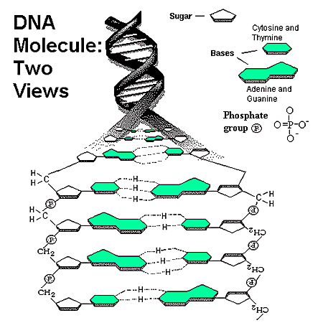
- The distance between two base pairs is 3.4 A° (Angistrom).
- Each complete turn of the helix is 34 A° (10 base pairs).
- In any segment of the molecule, alternating larger (major grooves) and smaller “minor grooves” are apparent along the axis.
- The double helix measures 20 A° (2 nm) in diameter.
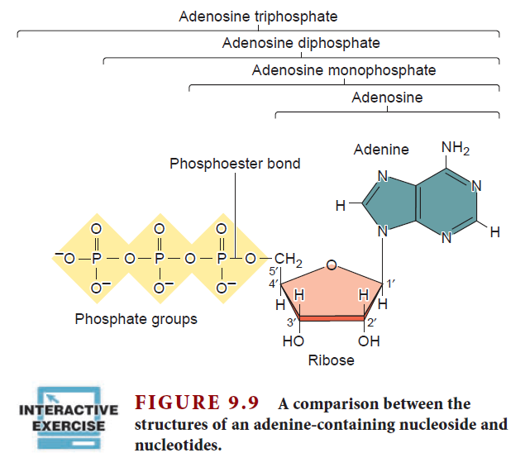
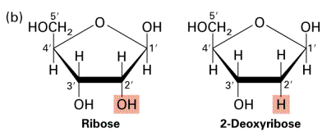

Polynucleotides
- The linkage between two mononucleotides consists of a phosphate group linked to two sugars forming a phosphodiester bond
- The phosphate groups link the 3’ carbon of one deoxyribose molecule to the 5’ carbon of the next (3’ – 5’ orientation).
- Joining of two mononucleotides forms a dinucleotide, joining of three nucleotides forms a trinucleotide and so on.
