Core Components of an APA Reference:
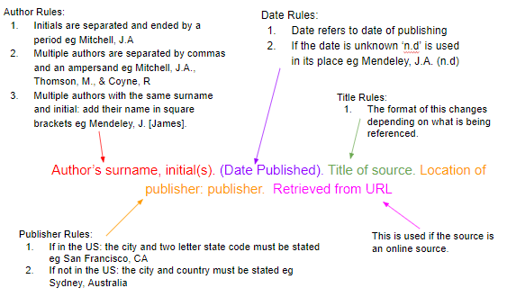
Citations, which are called in-text citations, are included when you’re adding information from another individual’s work into your own project. When you add text word-for-word from another source into your project, or take information from another source and place it in your own words and writing style (known as paraphrasing), you create an in-text citation. These citations are short in length and are placed in the main part of your project, directly after the borrowed information.
References are found at the end of your research project, usually on the last page. Included on this reference list page is the full information for any in-text citations found in the body of the project. These references are listed in alphabetical order by the author's last name.
An APA in-text citation includes only three items: the last name(s) of the author(s), the year the source was published, and sometimes the page or location of the information. References include more information such as the name of the author(s), the year the source was published, the full title of the source, and the URL or page range.
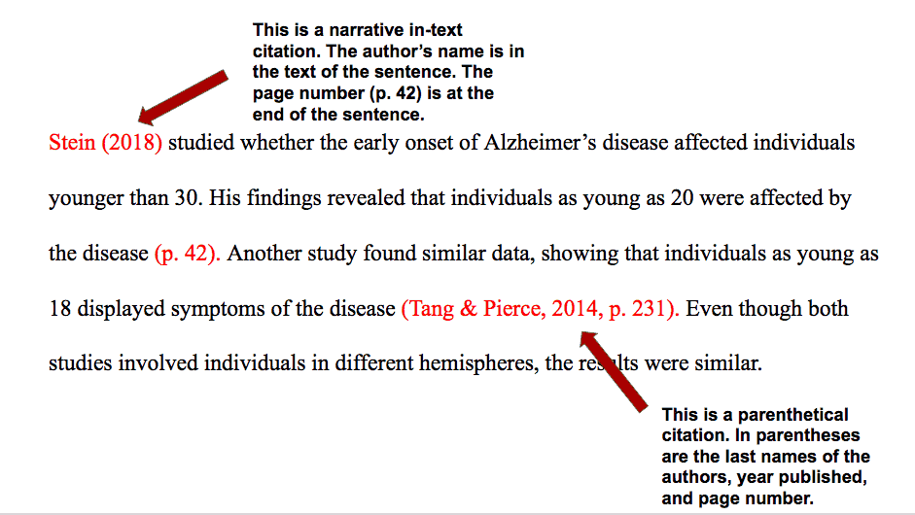
Here is the text description of the in-text citation examples. 