The story of Coca-Cola

Probably the best-known drink in the world.
What is the most recognizable object in the world? Could it be a football? Or a Big-Mac? No, the answer is a Coca-Cola bottle. The famous Coca-Cola bottle is over 100 years old !
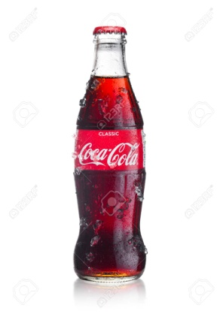

Coca-cola advertisement in Las Vegas
Footballs and big macs are certainly part of life for lots of people; but Coca-Cola is now a permanent part of world culture. People know and drink Coca-Cola all over the world.
It is said that the Coca-Cola bottle is the most recognised object in the world. Hundreds of millions of people can recognise a Coke bottle by its shape, even if they cannot see it! And the famous Coca-Cola logo is the most famous logo in the world. Unlike any other famous commercial logo, it has not changed in 100 years!
But the story of Coca-Cola is even older than that. It was in 1886 that John Pemberton, a druggist in Atlanta, Georgia, invented a new type of syrup, using coca leaves, sugar and cola nuts, plus a few other secret ingredients! Pemberton sold it as a medicine; and with its coca (the source of cocaine), it must have made people feel good!
Nevertheless, Pemberton's medicine was not very successful, so he sold his secret formula to another druggist, Asa Candler. Candler was interested, because he had another idea; he thought that Pemberton's "medicine" would be much better if it was mixed with soda.
Candler was thus the man who really invented the drink Coca-Cola. At first he sold it in his drugstore; then he began selling the syrup to other drugstores, who used it with their soda fountains. Candler also advertised his new drink, and soon people were going to drugstores just to get a drink of Coca-cola.
Before long, other people became interested in the product, including a couple of businessmen who wanted to sell it in bottles. Candler sold them a licence to bottle the drink, and very quickly the men became millionnaires. The famous bottle, with its very distinctive shape, was designed in 1916.
During the First World War, American soldiers in Europe began asking for Coca-Cola, so the Coca-cola company began to export to Europe. It was so popular with soldiers, that they then had to start bottling the drink in Europe.
Today, Coca-Cola is made in countries all over the world, including Russia and China; it is the world's most popular drink.
As for the famous formula, it is probably the world's most valuable secret! The exact ingredients for making Coca-Cola are only known to a handful of people. And as for the "coca" that was in the original drink, that was eliminated in 1903. It was a drug, and too dangerous. Today's Coca-Cola contains caffeine, but not cocaine!

WORD GUIDE
shape : form - logo: logotype, name-image - unlike : differently to - druggist: pharmacist - syrup: concentrated sweet drink - nuts: hard round fruits - ingredient: element - source: origin - formula: recipe, instructions for making something - soda: bubbling water, fizzy water - advertise: publicise - licence: permit, authorisation - distinctive: memorable, special - as for: concerning - a handful of: a very small number of - eliminate: take out –

Coca Cola was by John Pemberton, a living in Atlanta. The original drink was a , and Pemberton sold it medicine. It was really a , being made from coca Pemberton his to Asa Candler, decided to sell it drink, soda. At first he it in his
drugstores, then he the to drugstores. After that, he a to some businessmen, and they began to the drink. That was the of the of Coca Cola.

