Chapter 10 Files and Exceptions
Introduction
- In this chapter you’ll learn:
  - To work with files so your programs can quickly analyze lots of data.
  - To handle errors so your programs don’t crash when they encounter unexpected situations.
  - You’ll learn about exceptions, which are special objects Python creates to manage errors that arise while a program is running. You’ll also learn about the json module, which allows you to save user data so it isn’t lost when your program stops running.
Reading from a File
- An incredible amount of data is available in text files. Text files can contain weather data, traffic data, socioeconomic data, literary works, and more.
- Reading from a file is particularly useful in data analysis applications, but it’s also applicable to any situation in which you want to analyze or modify information stored in a file.
- When you want to work with the information in a text file, the first step is to read the file into memory. You can read the entire contents of a file, or you can work through the file one line at a time.

Reading an Entire File
- To begin, we need a file with a few lines of text in it. Let’s start with a file that contains pi to 30 decimal places, with 10 decimal places per line:

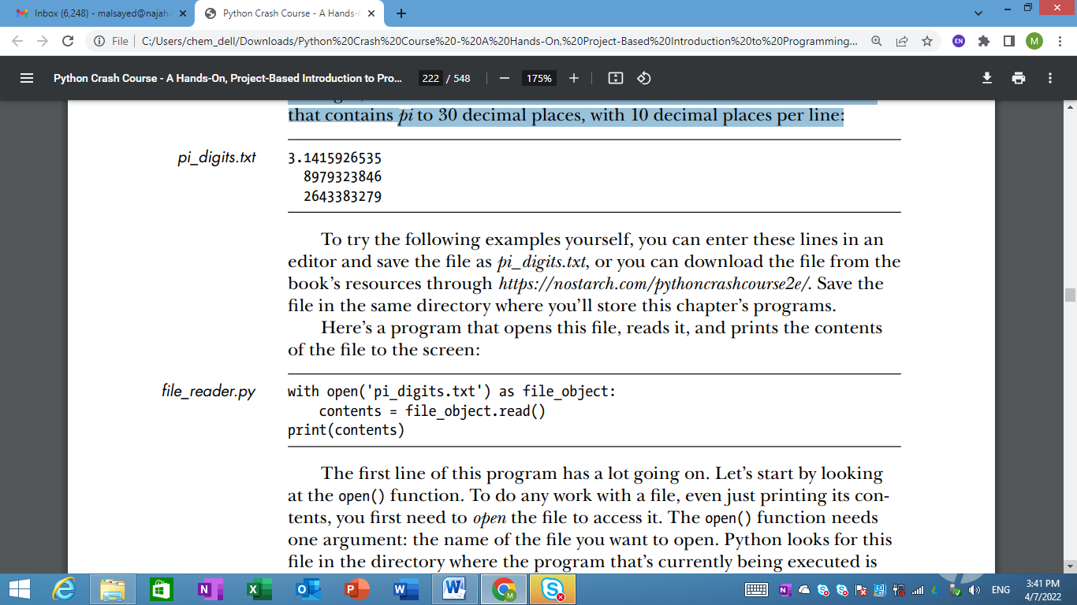
- To try the following examples yourself, you can enter these lines in an editor and save the file as pi_digits.txt, or you can download the file from the book’s resources through https://nostarch.com/pythoncrashcourse2e/ .
- a program that opens this file, reads it, and prints the contents of the file to the screen:
- The first line of this program has a lot going on:
  - To do any work with a file, even just printing its contents, you first need to open the file to access it. The open() function needs one argument: the name of the file you want to open.
  - Python looks for this file in the directory where the program that’s currently being executed is stored. In this example, file_reader.py is currently running, so Python looks for pi_digits.txt in the directory where file_reader.py is stored.
  - The open() function returns an object representing the file. Here, open('pi_digits.txt') returns an object representing pi_digits.txt.
  - Python assigns this object to file_object, which we’ll work with later in the program.
- The keyword with closes the file once access to it is no longer needed.
  - Notice how we call open() in this program but not close(). You could open and close the file by calling open() and close(), but if a bug in your program prevents the close() method from being executed, the file may never close.
  - Improperly closed files can cause data to be lost or corrupted.
  - If you call close() too early in your program, you’ll find yourself trying to work with a closed file (a file you can’t access), which leads to more errors.
  - All you have to do is open the file and work with it as desired, trusting that Python will close it automatically when the with block finishes execution.
- Once we have a file object representing pi_digits.txt, we use the read() method in the second line of our program to read the entire contents of the file and store it as one long string in contents. When we print the value of contents, we get the entire text file back:
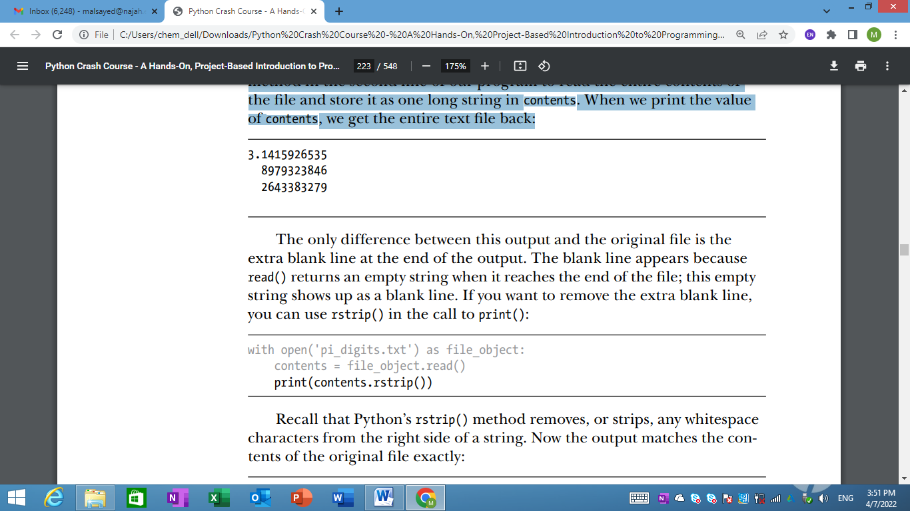
- The only difference between this output and the original file is the extra blank line at the end of the output.
  - The blank line appears because read() returns an empty string when it reaches the end of the file; this empty string shows up as a blank line.
  - If you want to remove the extra blank line, you can use rstrip() in the call to print():

File Paths
- When you pass a simple filename like pi_digits.txt to the open() function, Python looks in the directory where the file that’s currently being executed (that is, your .py program file) is stored.
- Sometimes, depending on how you organize your work, the file you want to open won’t be in the same directory as your program file.
- For example, you might store your program files in a folder called python_work; inside python_work, you might have another folder called text_files to distinguish your program files from the text files they’re manipulating.
- To get Python to open files from a directory other than the one where your program file is stored, you need to provide a file path, which tells Python to look in a specific location on your system. Because text_files is inside python_work, you could use a relative file path to open a file from text_files.
- For example, you’d write:
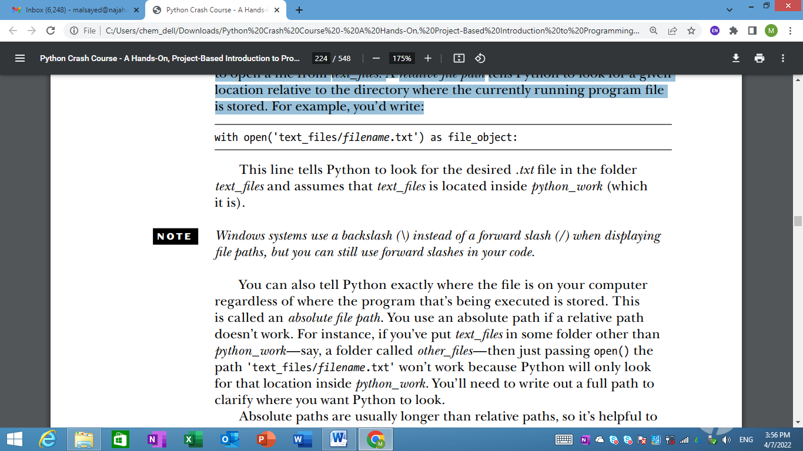
- This line tells Python to look for the desired .txt file in the folder text_files and assumes that text_files is located inside python_work (which it is).
Note: Windows systems use a backslash (\) instead of a forward slash (/) when displaying file paths, but you can still use forward slashes in your code.

- You can also tell Python exactly where the file is on your computer regardless of where the program that’s being executed is stored. This is called an absolute file path.
- Absolute paths are usually longer than relative paths, so it’s helpful to assign them to a variable and then pass that variable to open():
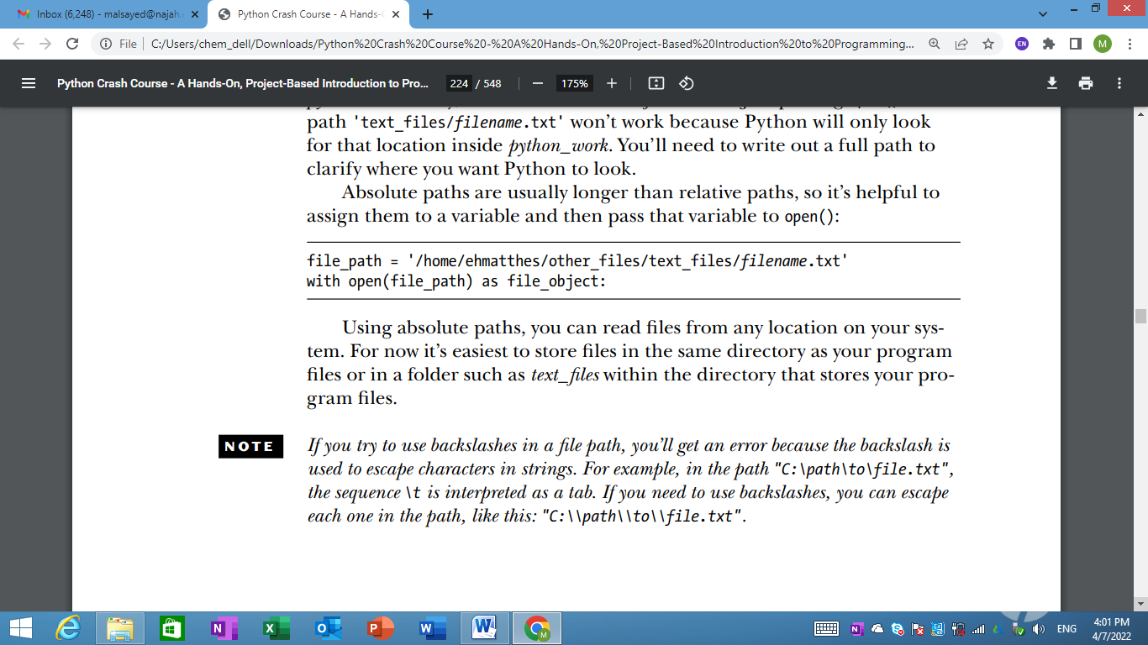
Note: If you try to use backslashes in a file path, you’ll get an error because the backslash is used to escape characters in strings. For example, in the path "C:\path\to\file.txt", the sequence \t is interpreted as a tab. If you need to use backslashes, you can escape each one in the path, like this: "C:\\path\\to\\file.txt".

Reading Line by Line
When you’re reading a file, you’ll often want to examine each line of the file. You might be looking for certain information in the file, or you might want to modify the text in the file in some way.
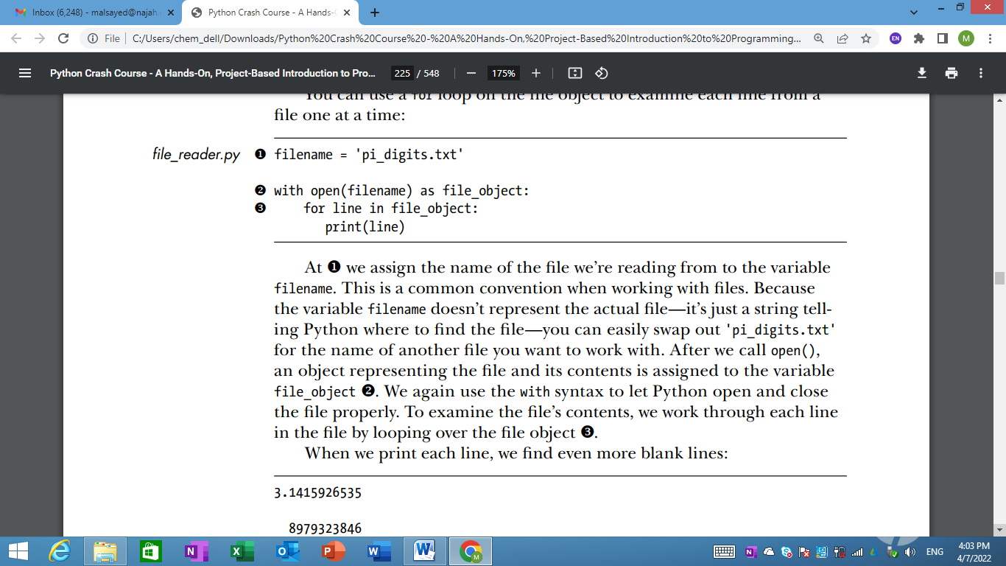

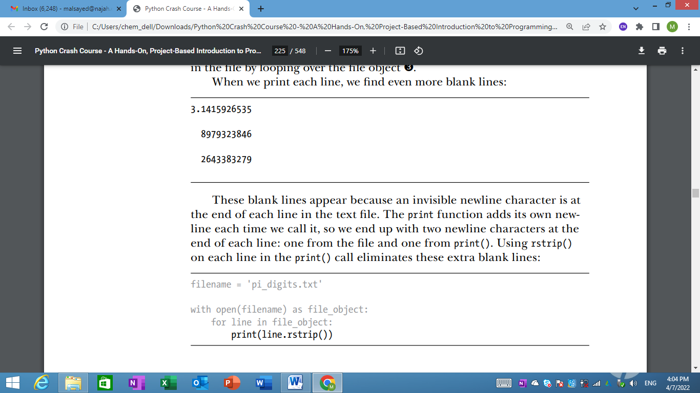

Making a List of Lines from a File
- When you use with, the file object returned by open() is only available inside the with block that contains it.
- If you want to retain access to a file’s contents outside the with block, you can store the file’s lines in a list inside the block and then work with that list.
- readlines() method takes each line from the file and stores it in a list.
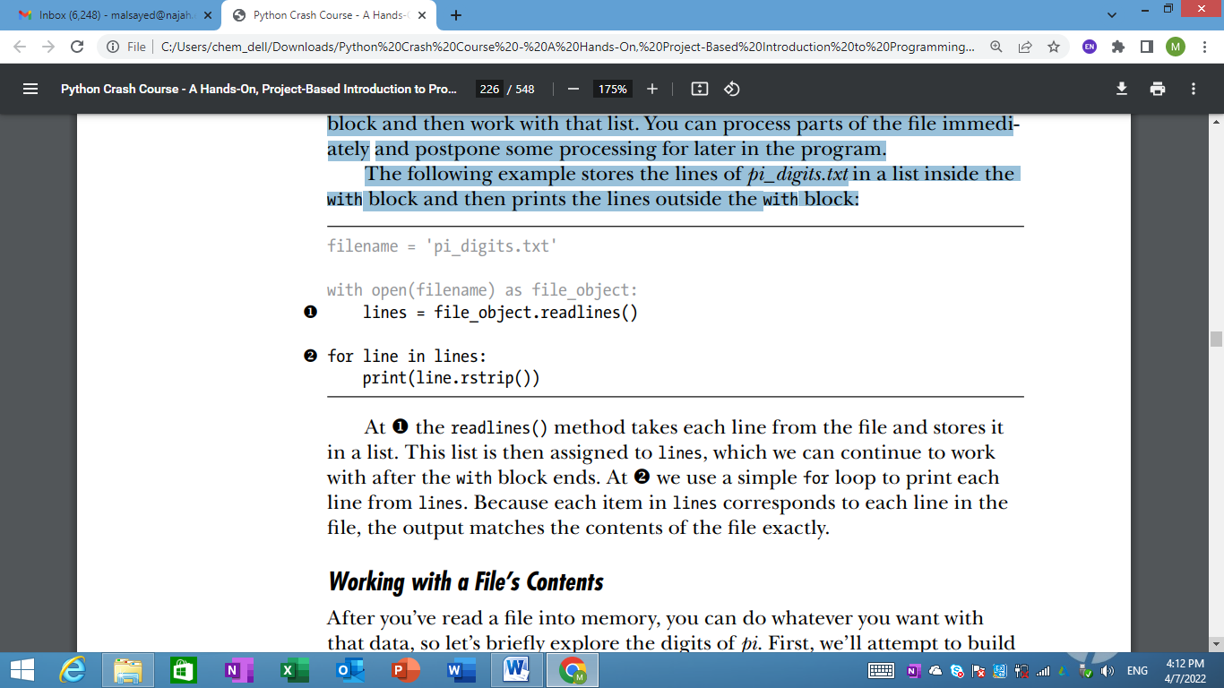

Working with a File’s Contents
After you’ve read a file into memory, you can do whatever you want with that data, so let’s briefly explore the digits of pi.
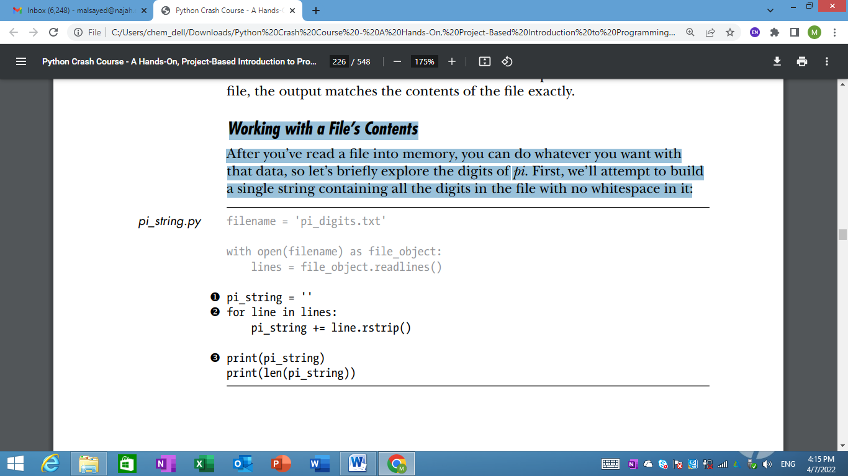

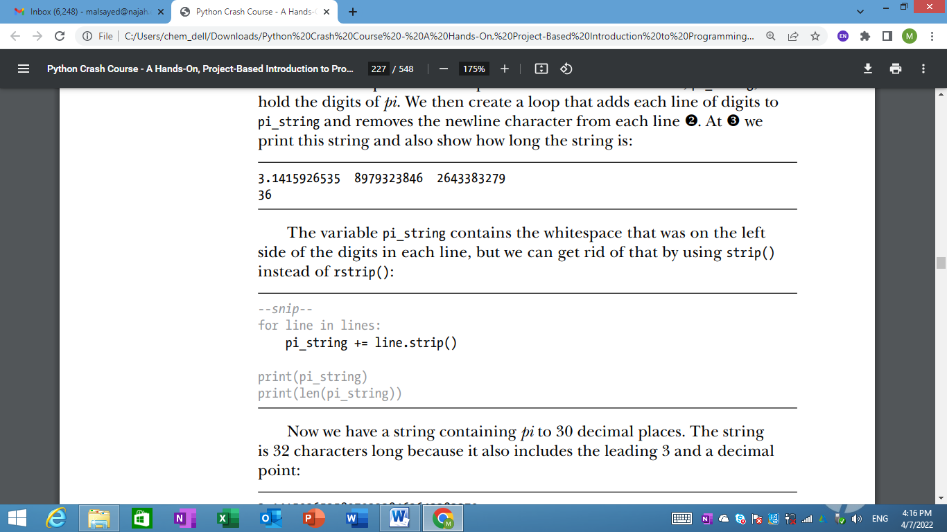

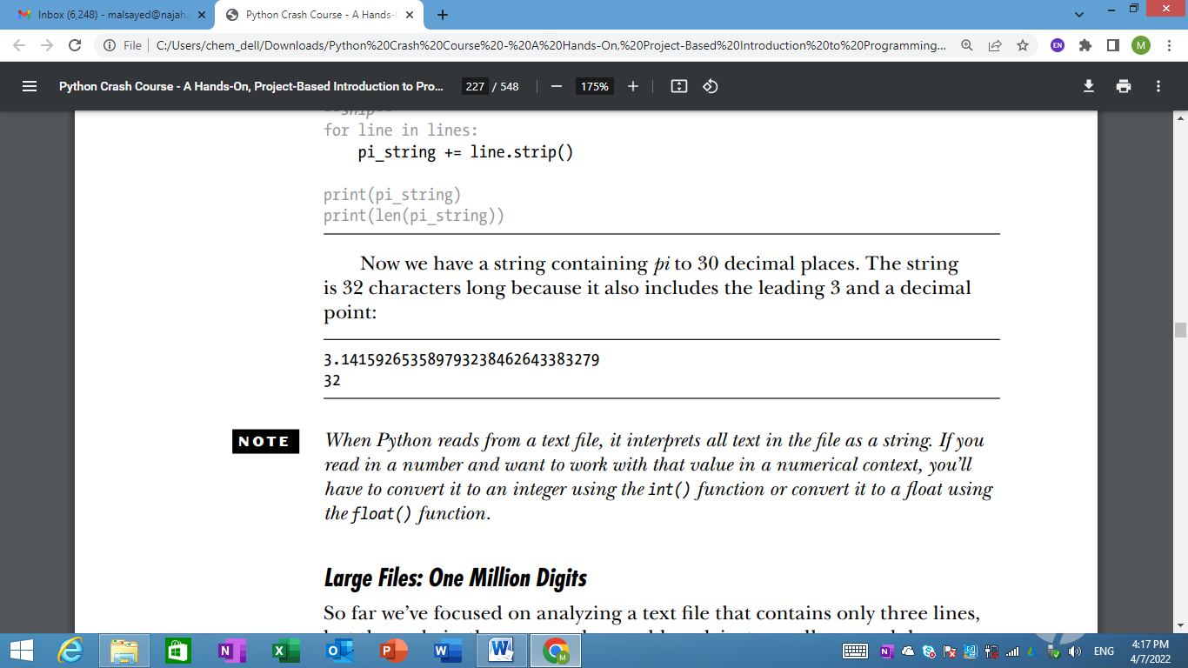

Note: When Python reads from a text file, it interprets all text in the file as a string. If you read in a number and want to work with that value in a numerical context, you’ll have to convert it to an integer using the int() function or convert it to a float using the float() function.

Large Files: One Million Digits
- So far we’ve focused on analyzing a text file that contains only three lines, but the code in these examples would work just as well on much larger files. If we start with a text file that contains pi to 1,000,000 decimal places instead of just 30, we can create a single string containing all these digits.
- We’ll also print just the first 50 decimal places, so we don’t have to watch a million digits scroll by in the terminal.
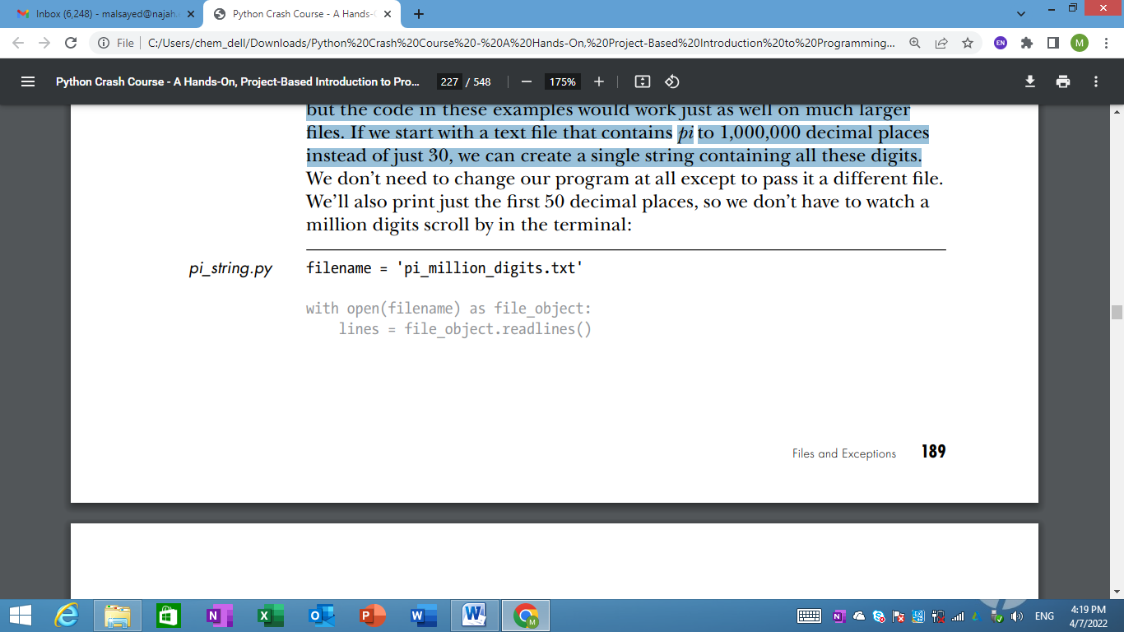
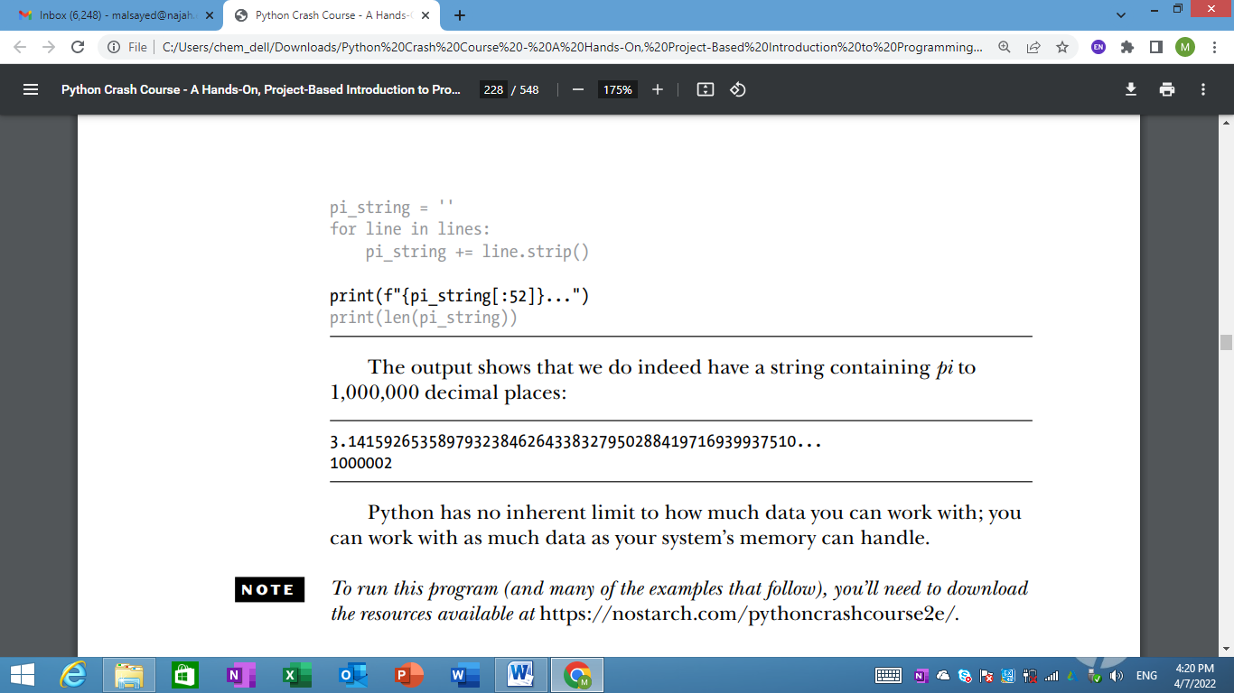
Note: To run this program (and many of the examples that follow), you’ll need to download the resources available at https://nostarch.com/pythoncrashcourse2e/ .

Is Your Birthday Contained in Pi?
Let’s use the program we just wrote to find out if someone’s birthday appears anywhere in the first million digits of pi.
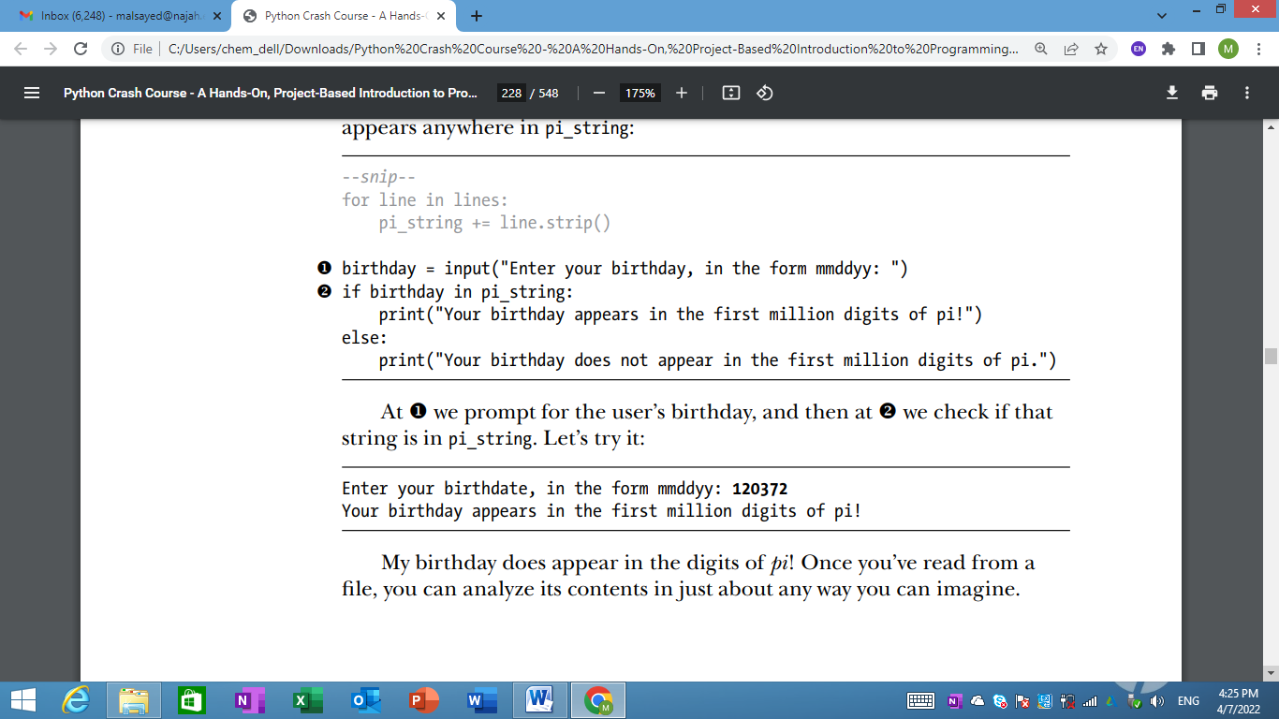

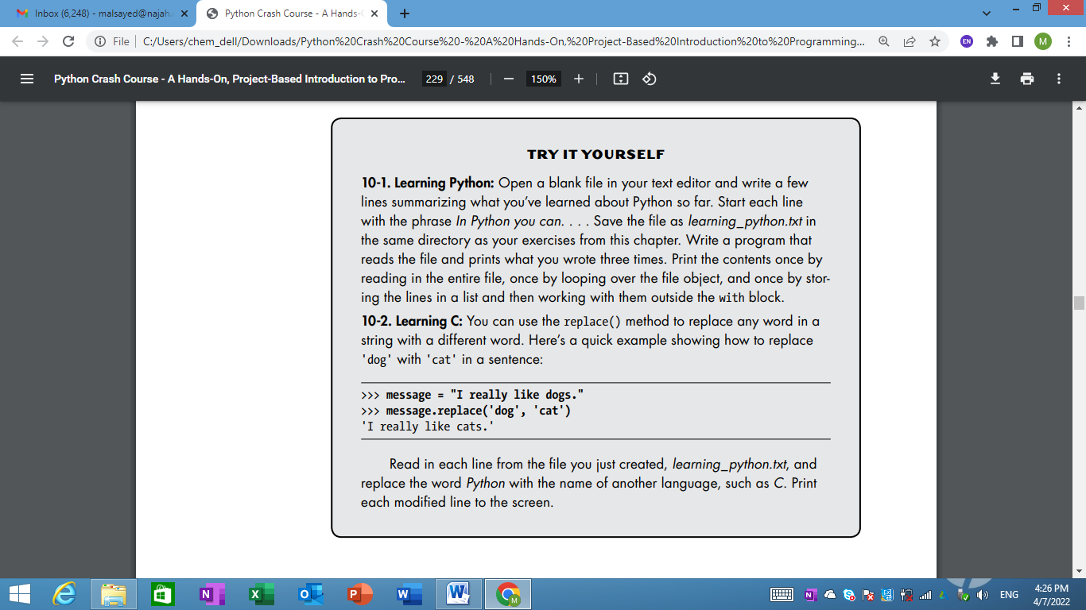

Writing to a File
- Writing to an Empty File To write text to a file, you need to call open() with a second argument telling Python that you want to write to the file.
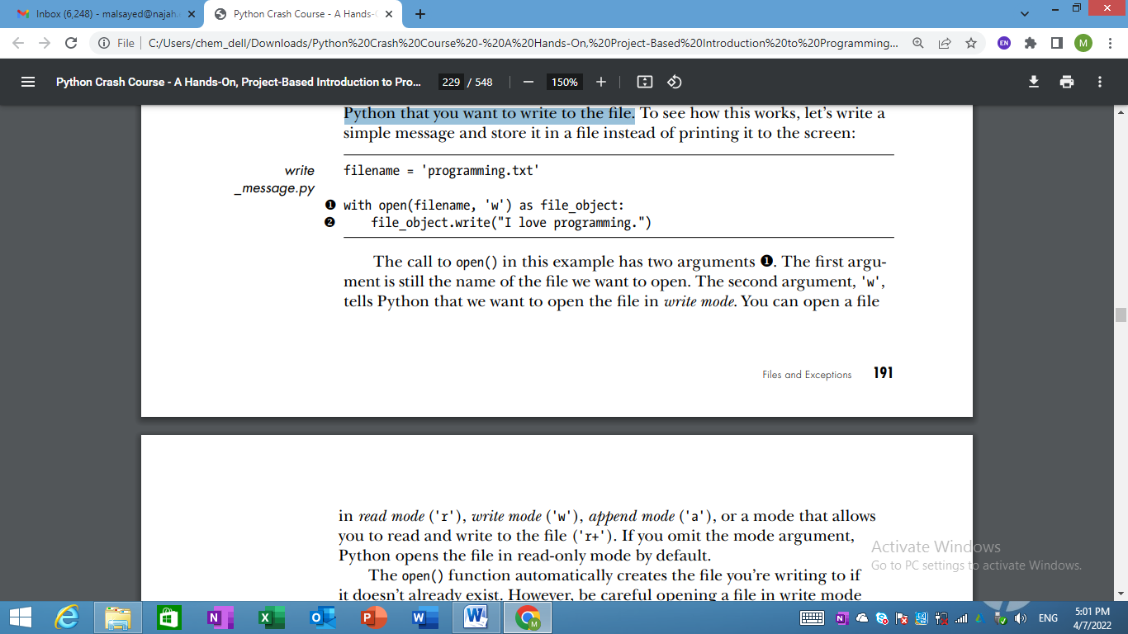
- 'w', tells Python that we want to open the file in write mode. You can open a file in read mode ('r'), write mode ('w'), append mode ('a'), or a mode that allows you to read and write to the file ('r+').
- If you omit the mode argument, Python opens the file in read-only mode by default.
- The open() function automatically creates the file you’re writing to if it doesn’t already exist. However, be careful opening a file in write mode ('w') because if the file does exist, Python will erase the contents of the file before returning the file object.
Note: Python can only write strings to a text file. If you want to store numerical data in a text file, you’ll have to convert the data to string format first using the str() function.

Writing Multiple Lines
The write() function doesn’t add any newlines to the text you write. So if you write more than one line without including newline characters, your file may not look the way you want it to:
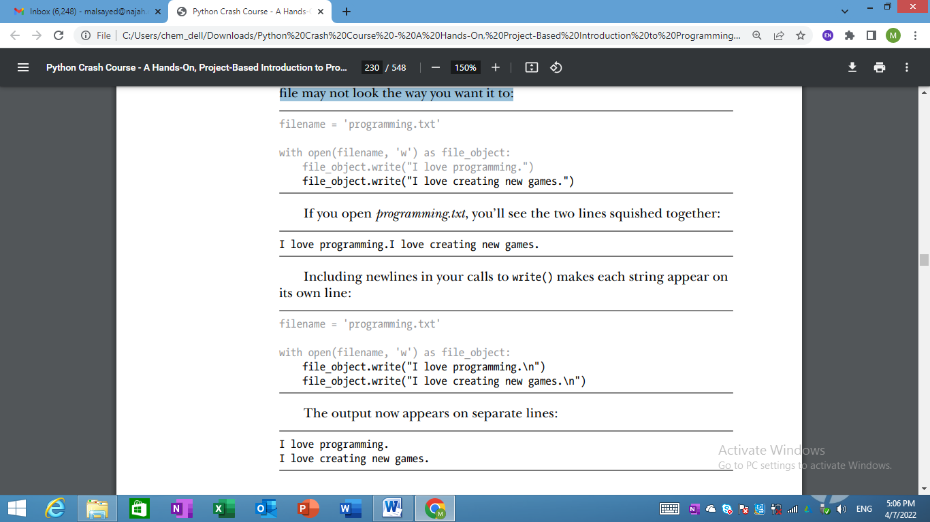
Appending to a File
If you want to add content to a file instead of writing over existing content, you can open the file in append mode.
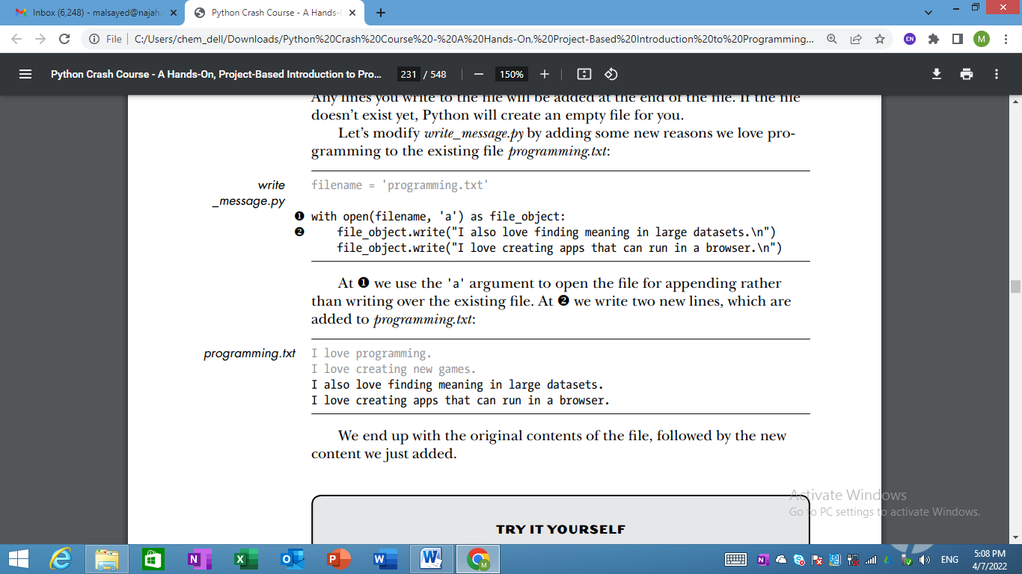
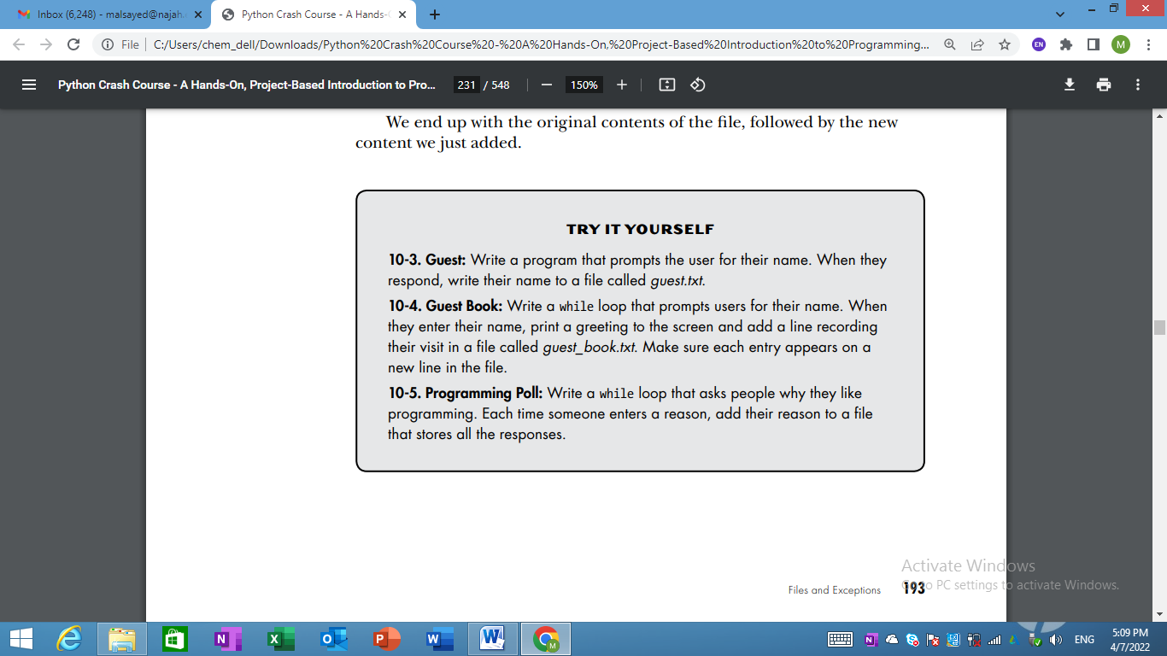

Exceptions
- Python uses special objects called exceptions to manage errors that arise during a program’s execution.
- Whenever an error occurs that makes Python unsure what to do next, it creates an exception object.
- If you write code that handles the exception, the program will continue running.
- Exceptions are handled with try-except blocks. A try-except block asks Python to do something, but it also tells Python what to do if an exception is raised. When you use try-except blocks, your programs will continue running even if things start to go wrong.
Handling the ZeroDivisionError Exception
Let’s look at a simple error that causes Python to raise an exception. You probably know that it’s impossible to divide a number by zero, but let’s ask Python to do it anyway:
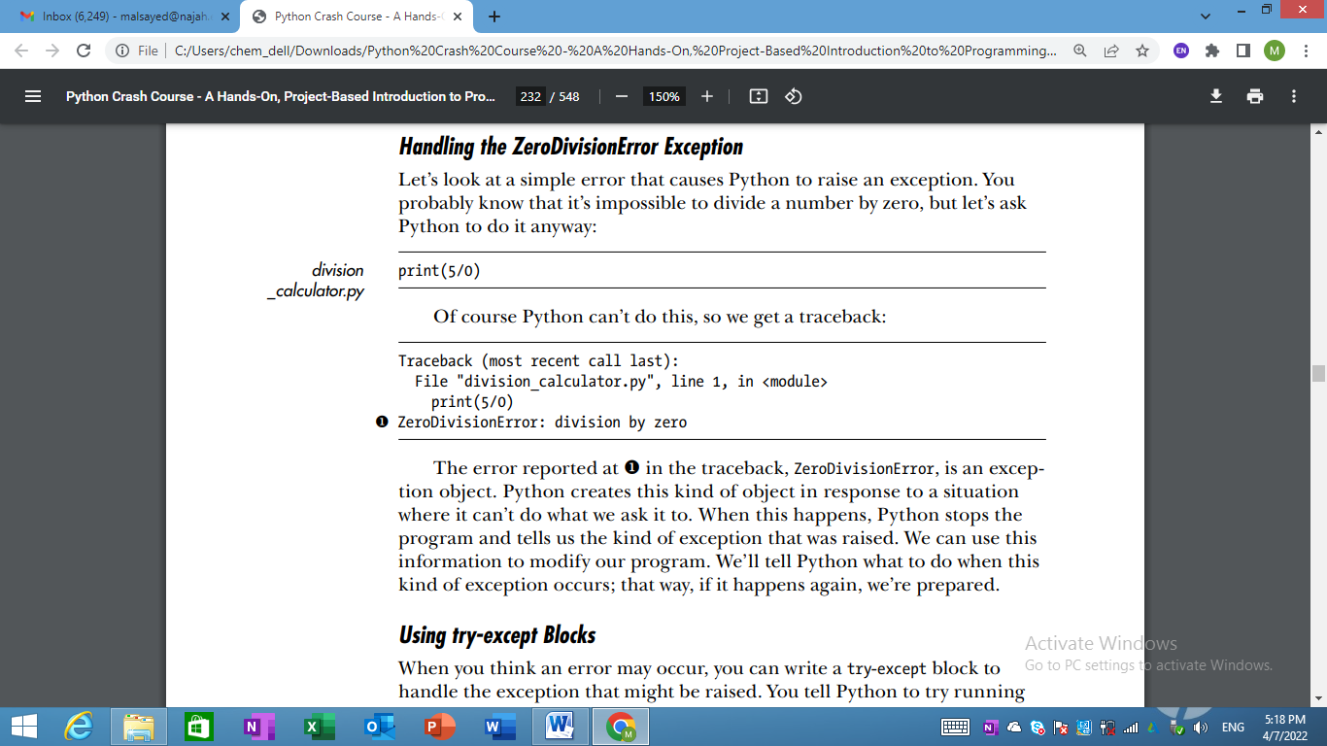
Using try-except Blocks
- When you think an error may occur, you can write a try-except block to handle the exception that might be raised.
- You tell Python to try running some code, and you tell it what to do if the code results in a particular kind of exception. H
- Here’s what a try-except block for handling the ZeroDivisionError exception looks like:
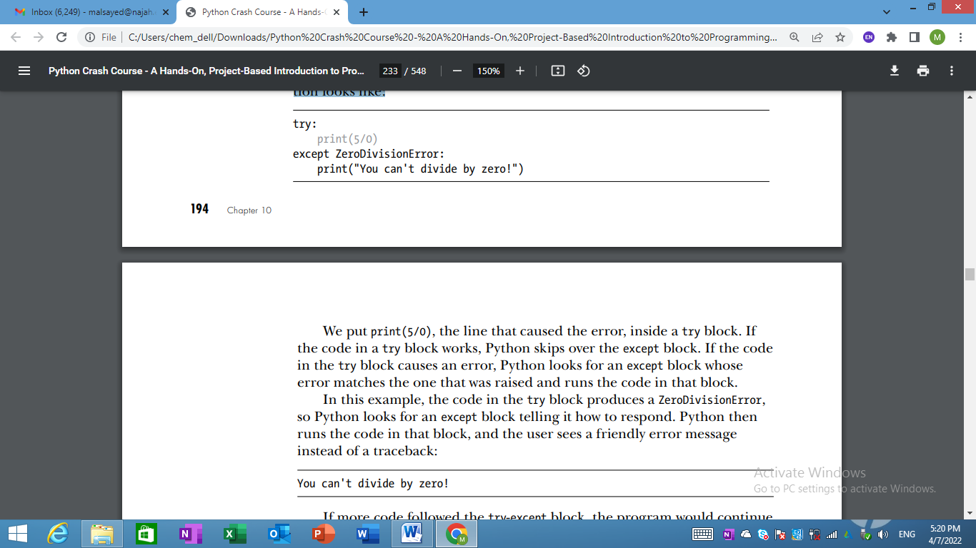
Using Exceptions to Prevent Crashes
- Handling errors correctly is especially important when the program has more work to do after the error occurs.
- This happens often in programs that prompt users for input. If the program responds to invalid input appropriately, it can prompt for more valid input instead of crashing.
- Let’s create a simple calculator that does only division:
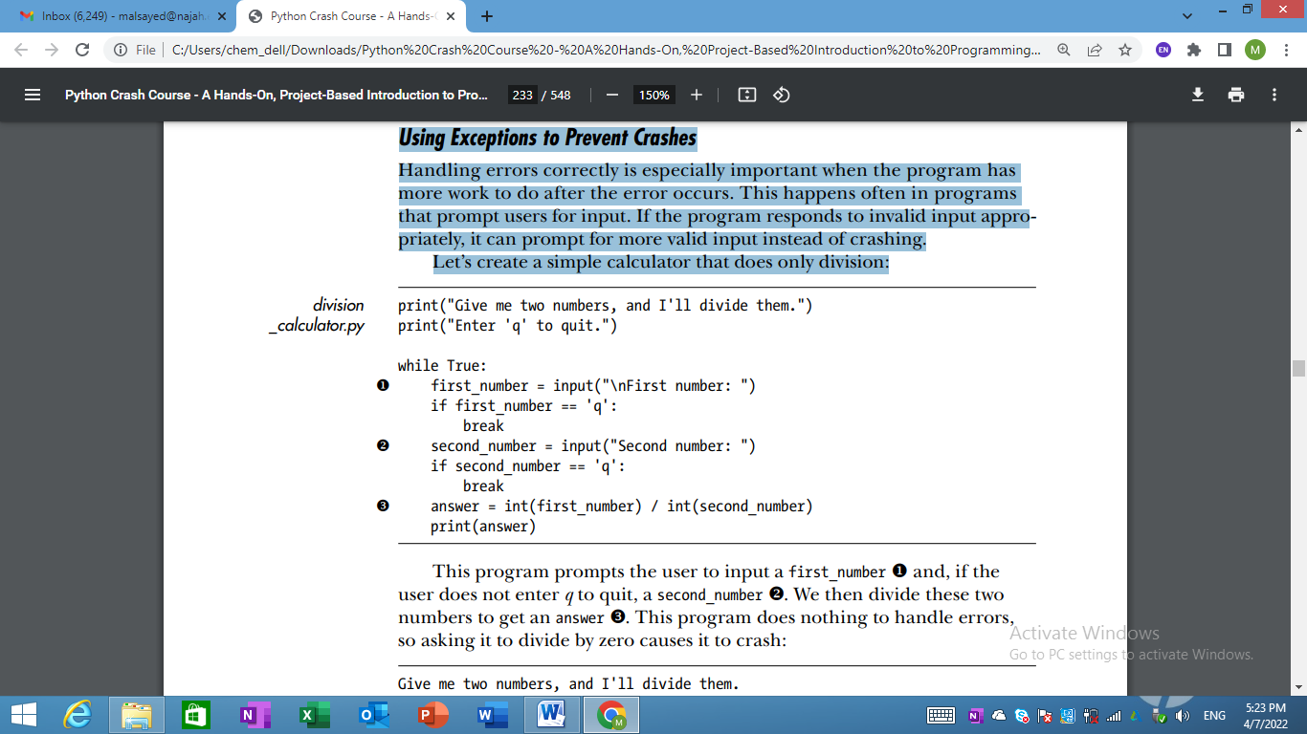
- This program does nothing to handle errors, so asking it to divide by zero causes it to crash:
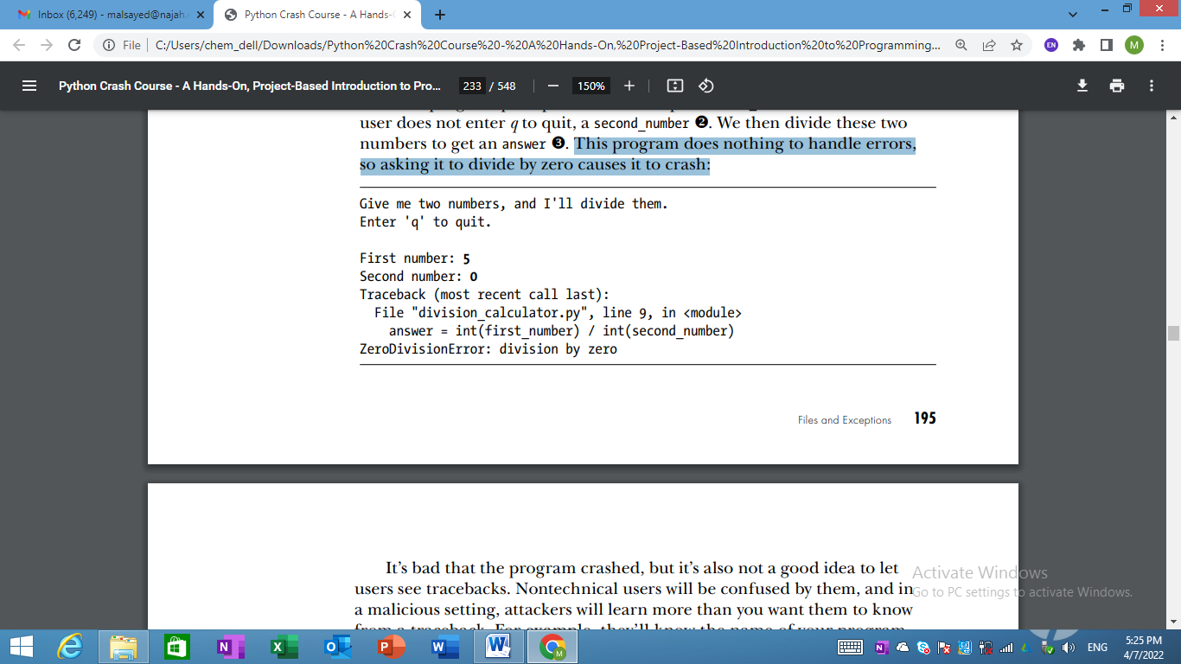
The else Block
We can make this program more error resistant by wrapping the line that might produce errors in a try-except block.
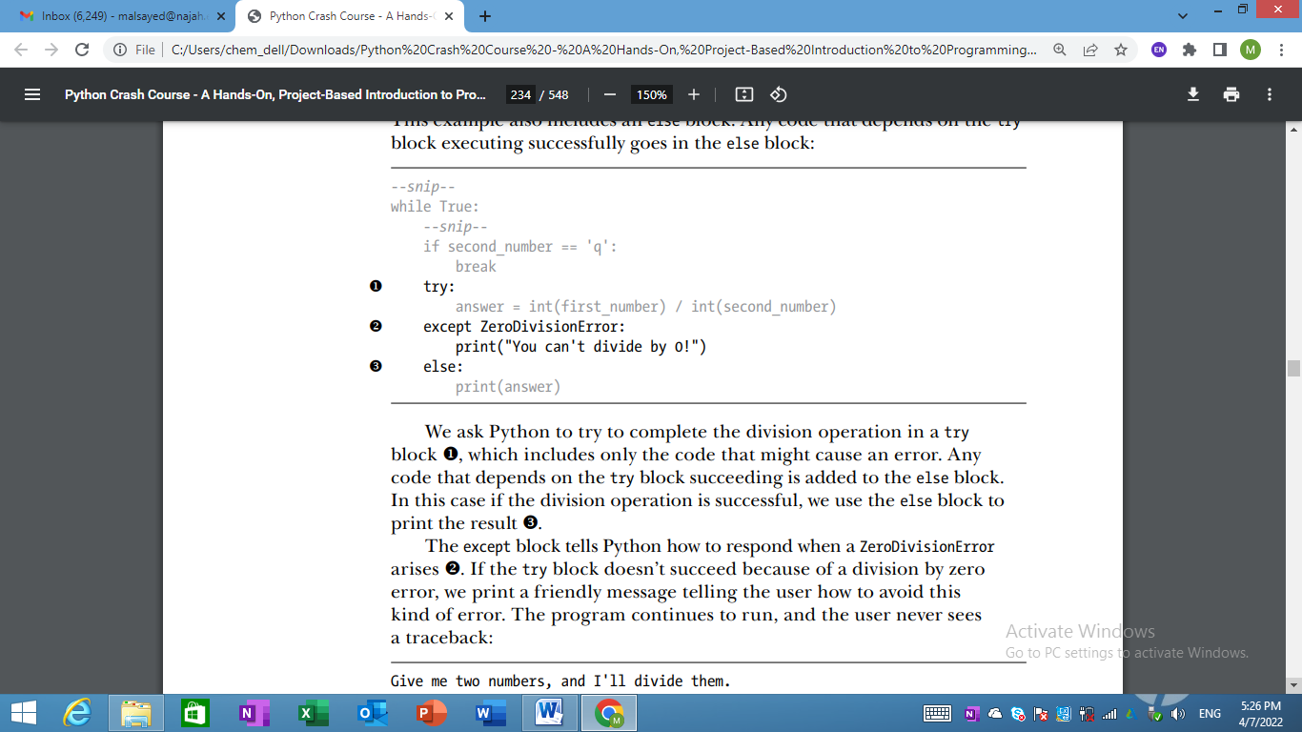
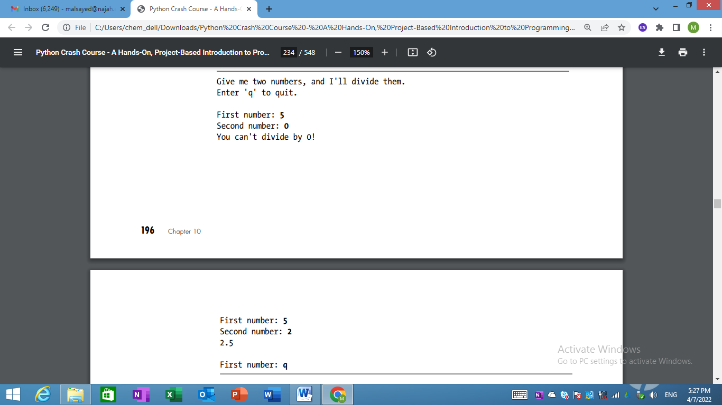
Handling the FileNotFoundError Exception
- One common issue when working with files is handling missing files.
- The file you’re looking for might be in a different location, the filename may be misspelled, or the file may not exist at all.
- Let’s try to read a file that doesn’t exist. The following program tries to read in the contents of Alice in Wonderland, but I haven’t saved the file alice.txt in the same directory.
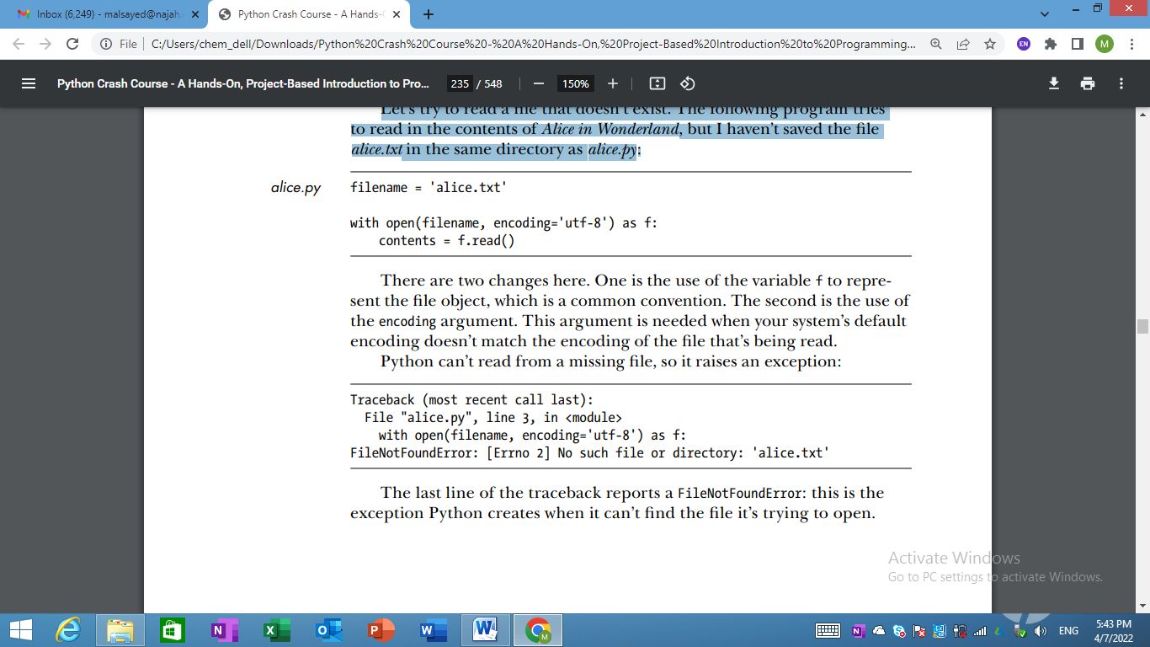

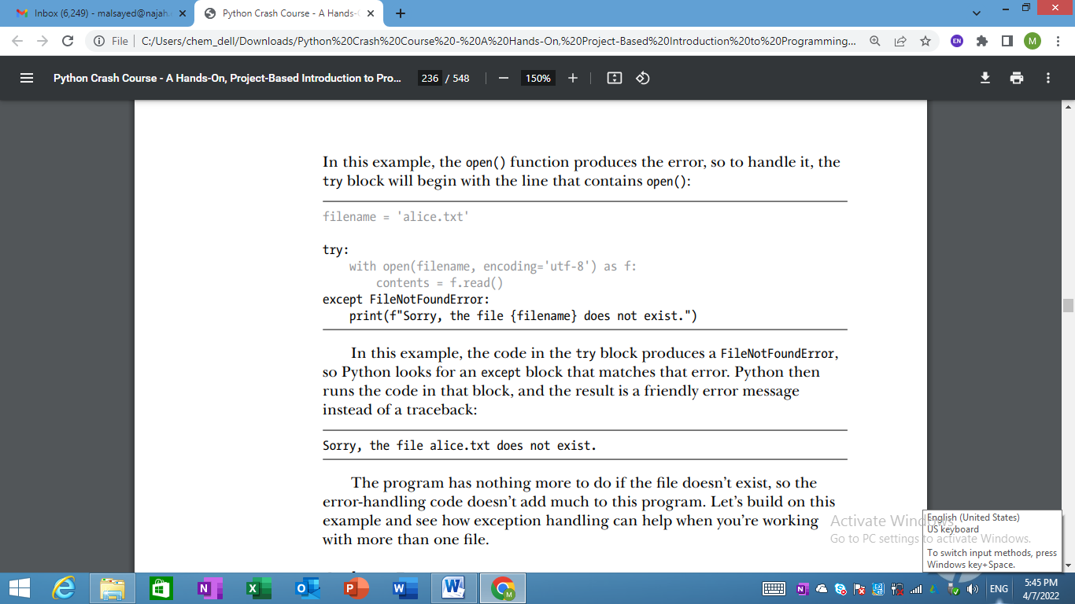

Analyzing Text
- You can analyze text files containing entire books.
- Many classic works of literature are available as simple text files because they are in the public domain.
- The texts used in this section come from Project Gutenberg (http://gutenberg .org/).
- Project Gutenberg maintains a collection of literary works that are available in the public domain, and it’s a great resource if you’re interested in working with literary texts in your programming projects.
- Let’s pull in the text of Alice in Wonderland and try to count the number of words in the text.
- We’ll use the string method split(), which can build a list of words from a string. Here’s what split() does with a string containing just the title "Alice in Wonderland":
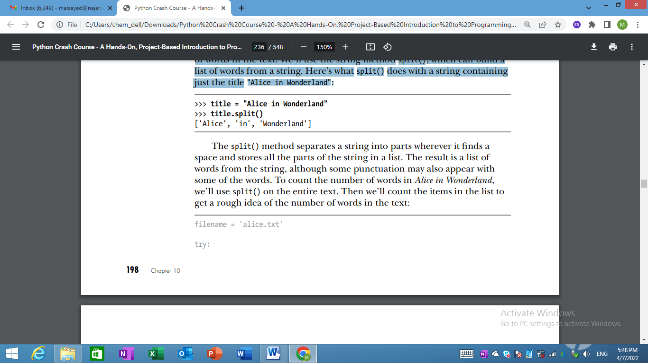
- The split() method separates a string into parts wherever it finds a space and stores all the parts of the string in a list.
- The result is a list of words from the string, although some punctuation may also appear with some of the words.
- To count the number of words in Alice in Wonderland, we’ll use split() on the entire text.
- Then we’ll count the items in the list to get a rough idea of the number of words in the text:
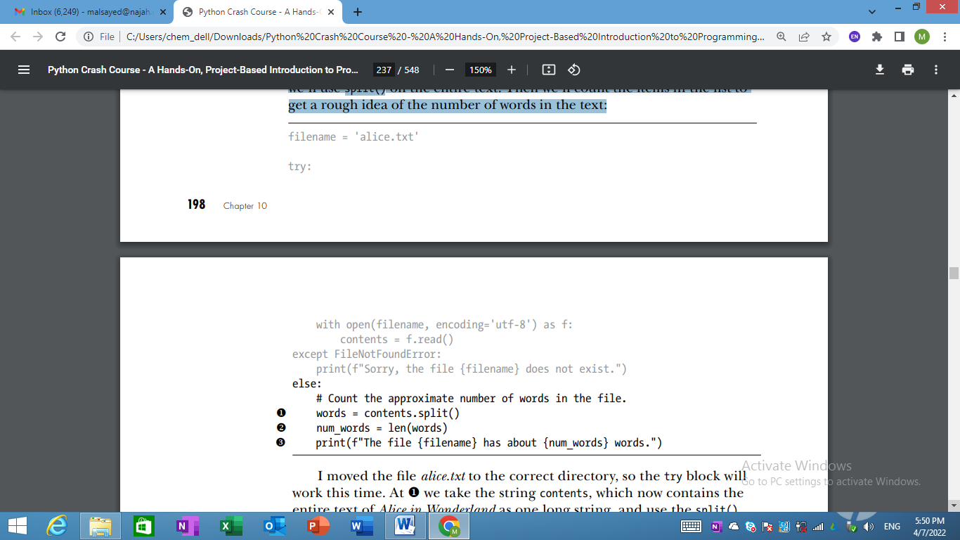
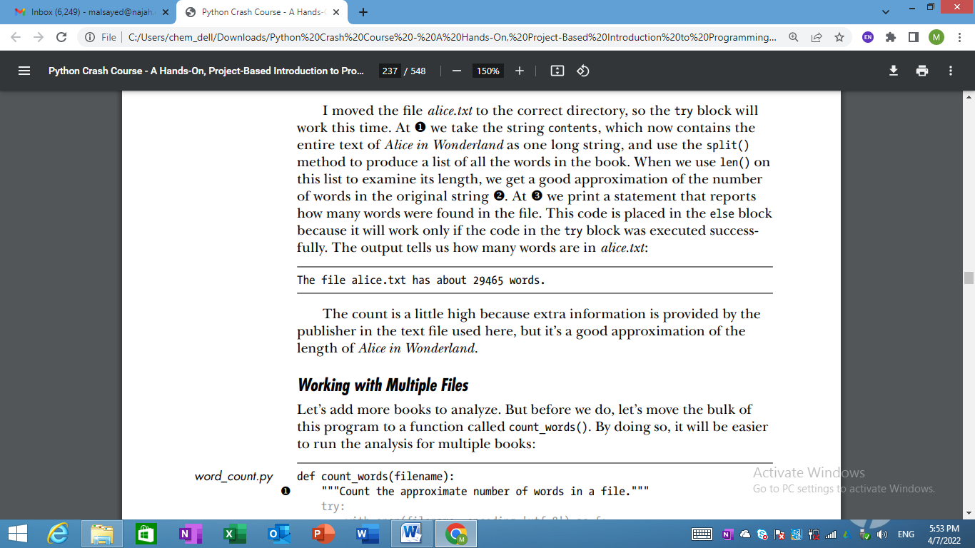

Working with Multiple Files
Let’s add more books to analyze.
But before we do, let’s move the bulk of this program to a function called count_words().
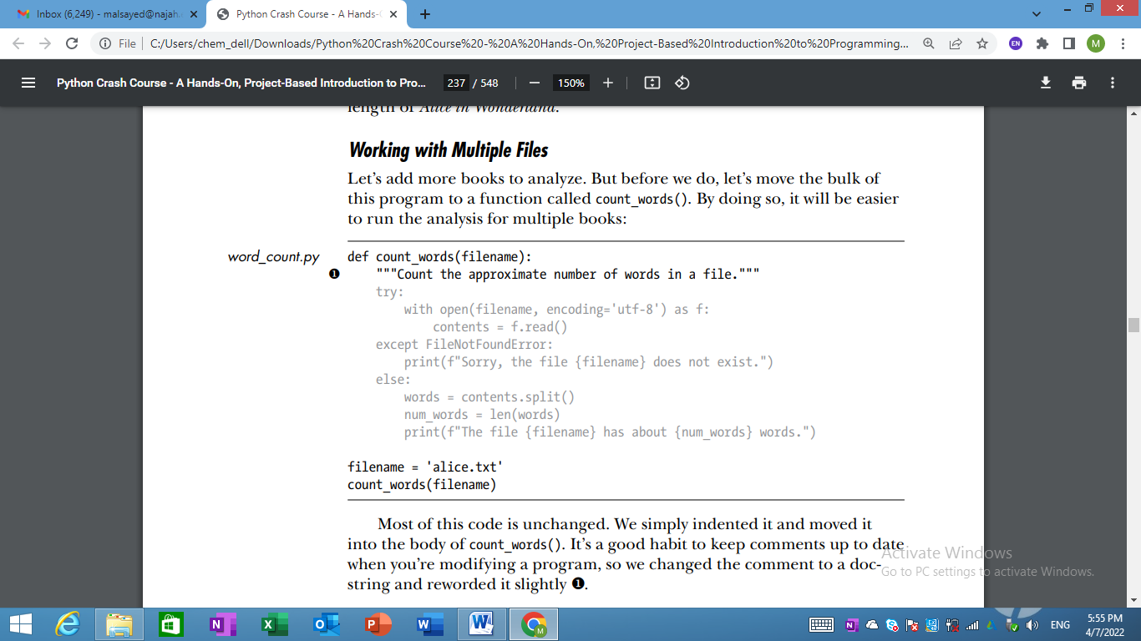
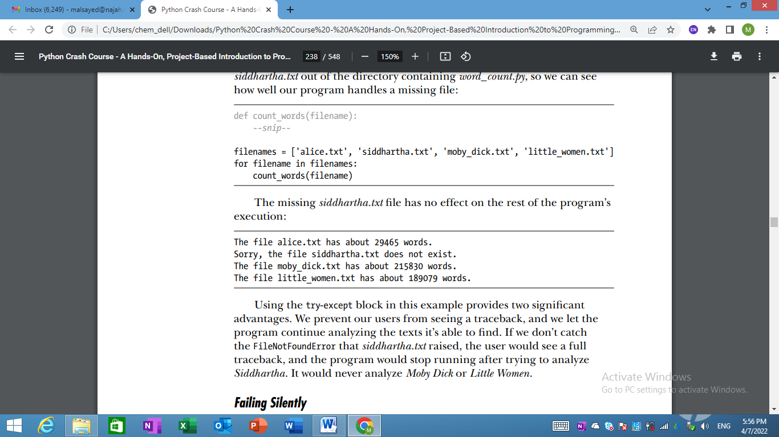
Failing Silently
- In the previous example, we informed our users that one of the files was unavailable.
- But you don’t need to report every exception you catch.
- Sometimes you’ll want the program to fail silently when an exception occurs and continue on as if nothing happened.
- Python has a pass statement that tells it to do nothing in a block:
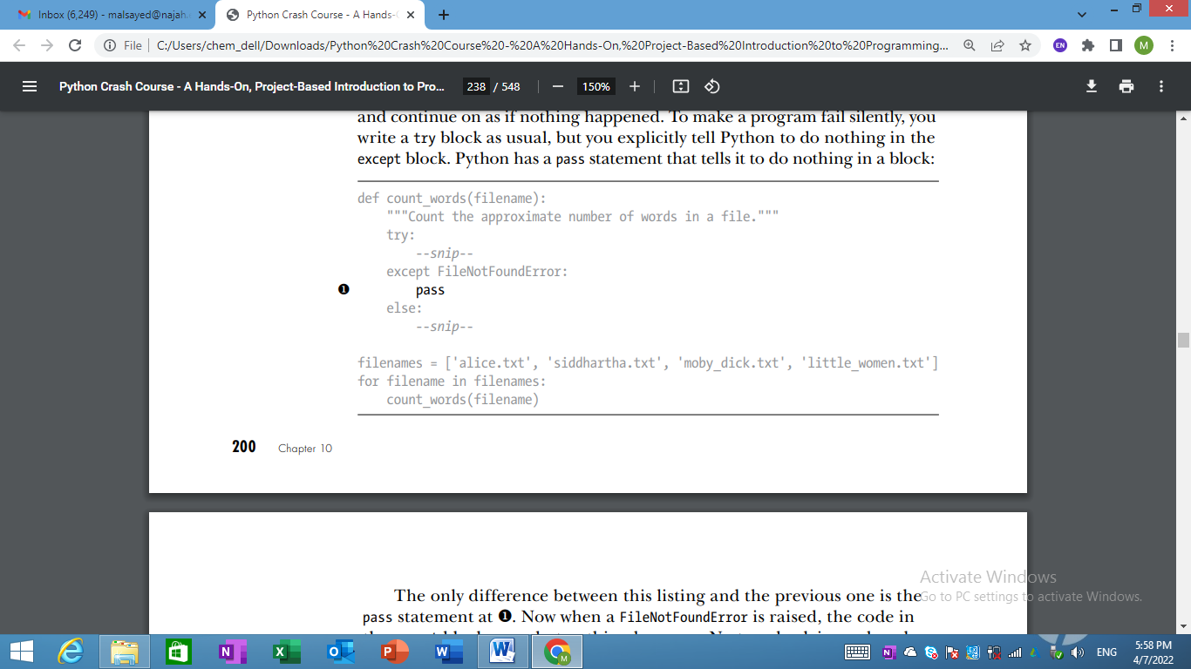
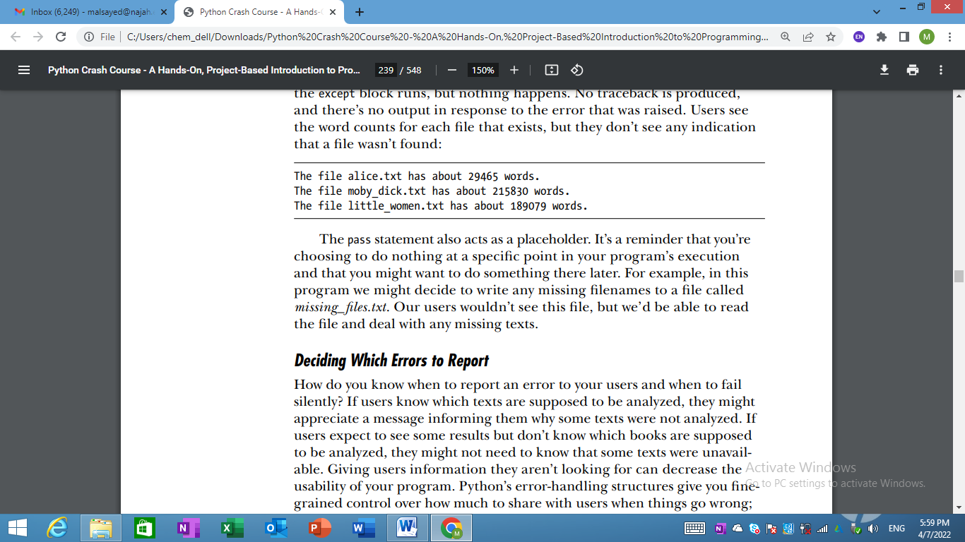
Deciding Which Errors to Report
- How do you know when to report an error to your users and when to fail silently?
- If users know which texts are supposed to be analyzed, they might appreciate a message informing them why some texts were not analyzed.
- If users expect to see some results but don’t know which books are supposed to be analyzed, they might not need to know that some texts were unavailable.
- Giving users information they aren’t looking for can decrease the usability of your program.
- Well-written, properly tested code is not very prone to internal errors, such as syntax or logical errors. But every time your program depends on something external, such as user input, the existence of a file, or the availability of a network connection, there is a possibility of an exception being raised.
- A little experience will help you know where to include exception handling blocks in your program and how much to report to users about errors that arise.
Try It Yourself
10-6. Addition: One common problem when prompting for numerical input occurs when people provide text instead of numbers. When you try to convert the input to an int, you’ll get a ValueError. Write a program that prompts for two numbers. Add them together and print the result. Catch the ValueError if either input value is not a number, and print a friendly error message. Test your program by entering two numbers and then by entering some text instead of a number.
10-7. Addition Calculator: Wrap your code from Exercise 10-6 in a while loop so the user can continue entering numbers even if they make a mistake and enter text instead of a number.
10-8. Cats and Dogs: Make two files, cats.txt and dogs.txt. Store at least three names of cats in the first file and three names of dogs in the second file. Write a program that tries to read these files and print the contents of the file to the screen. Wrap your code in a try-except block to catch the FileNotFound error, and print a friendly message if a file is missing. Move one of the files to a different location on your system, and make sure the code in the except block executes properly.
10-9. Silent Cats and Dogs: Modify your except block in Exercise 10-8 to fail silently if either file is missing.
10-10. Common Words: Visit Project Gutenberg (https://gutenberg.org/ ) and find a few texts you’d like to analyze. Download the text files for these works, or copy the raw text from your browser into a text file on your computer. You can use the count() method to find out how many times a word or phrase appears in a string. For example, the following code counts the number of times 'row' appears in a string:
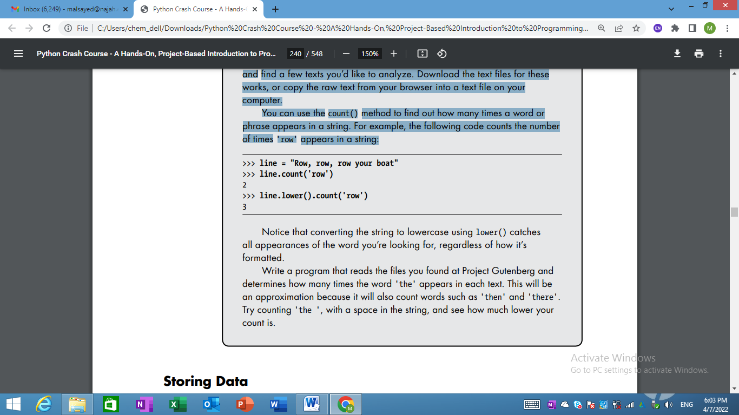
Notice that converting the string to lowercase using lower() catches all appearances of the word you’re looking for, regardless of how it’s formatted.
Write a program that reads the files you found at Project Gutenberg and determines how many times the word 'the' appears in each text. This will be an approximation because it will also count words such as 'then' and 'there'. Try counting 'the ', with a space in the string, and see how much lower your count is.

Storing Data
- Many of your programs will ask users to input certain kinds of information.
- You might allow users to store preferences in a game or provide data for a visualization.
- Whatever the focus of your program is, you’ll store the information users provide in data structures such as lists and dictionaries.
- When users close a program, you’ll almost always want to save the information they entered. A simple way to do this involves storing your data using the json module.
  - The json module allows you to dump simple Python data structures into a file and load the data from that file the next time the program runs.
  - You can also use json to share data between different Python programs.
  - Even better, the JSON data format is not specific to Python, so you can share data you store in the JSON format with people who work in many other programming languages. It’s a useful and portable format, and it’s easy to learn.
Note: The JSON (JavaScript Object Notation) format was originally developed for JavaScript. However, it has since become a common format used by many languages, including Python.

Using json.dump() and json.load()
- Let’s write a short program that stores a set of numbers and another program that reads these numbers back into memory.
- The json.dump() function takes two arguments: a piece of data to store and a file object it can use to store the data. Here’s how you can use json.dump() to store a list of numbers:
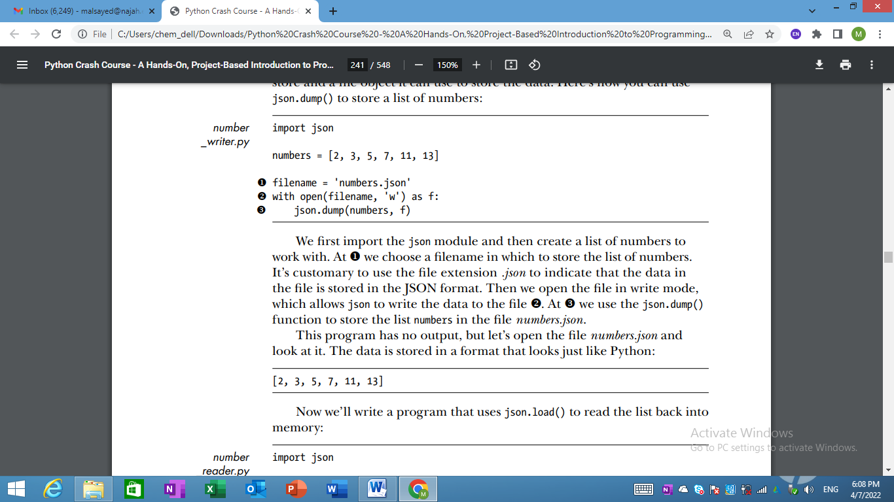
Now we’ll write a program that uses json.load() to read the list back into memory:
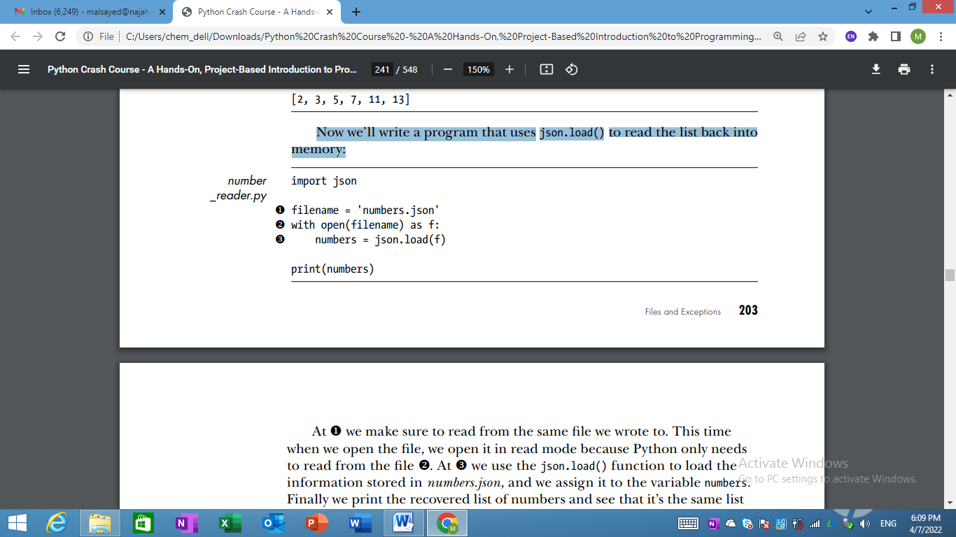

Saving and Reading User-Generated Data
- Saving data with json is useful when you’re working with user-generated data, because if you don’t store your user’s information somehow, you’ll lose it when the program stops running.
- Let’s look at an example where we prompt the user for their name the first time they run a program and then remember their name when they run the program again.
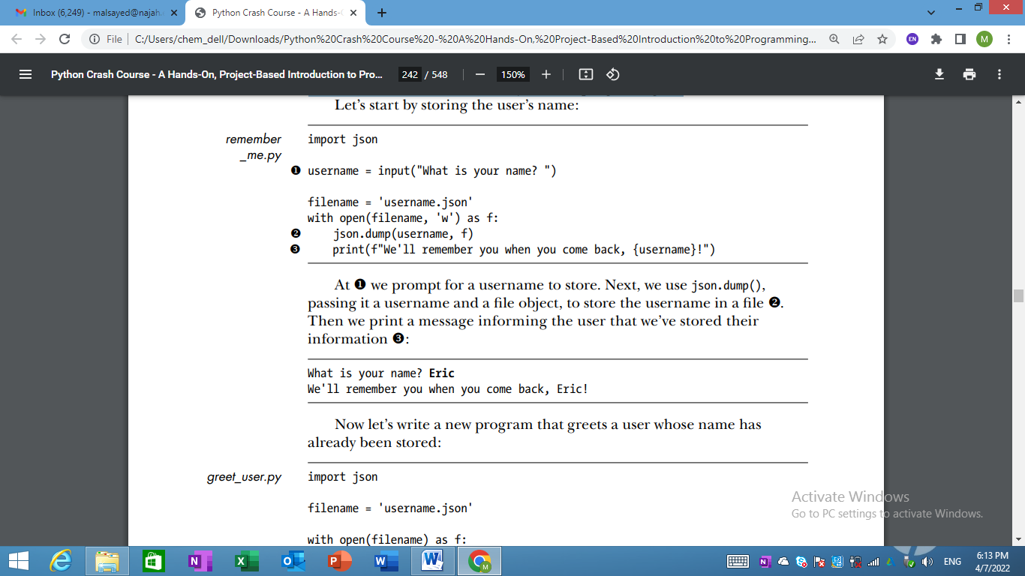
- Now let’s write a new program that greets a user whose name has already been stored:
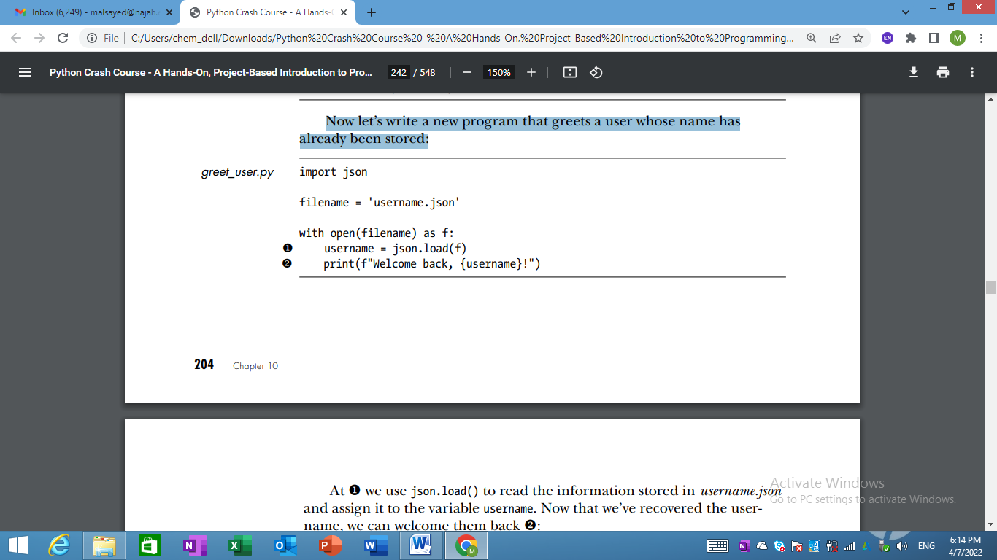
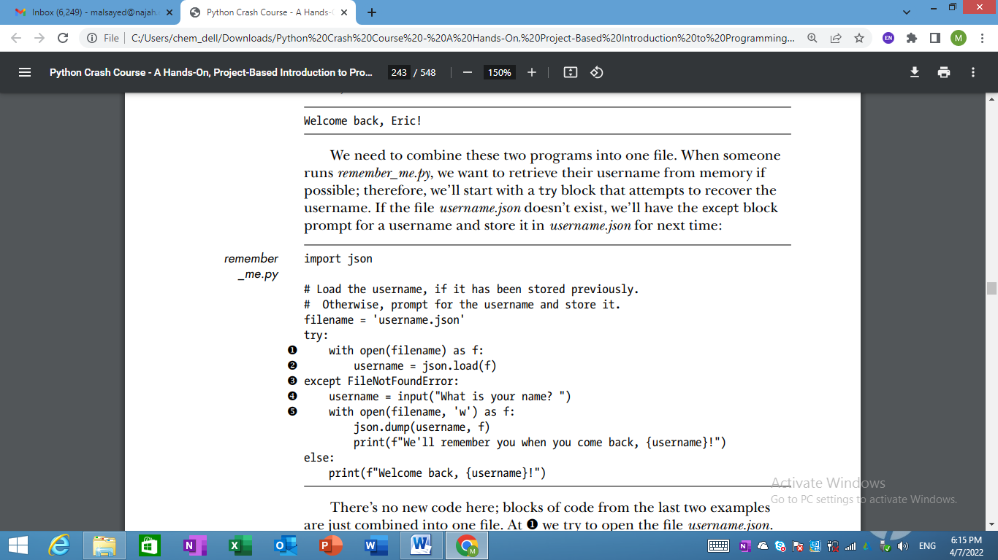
- We need to combine these two programs into one file.
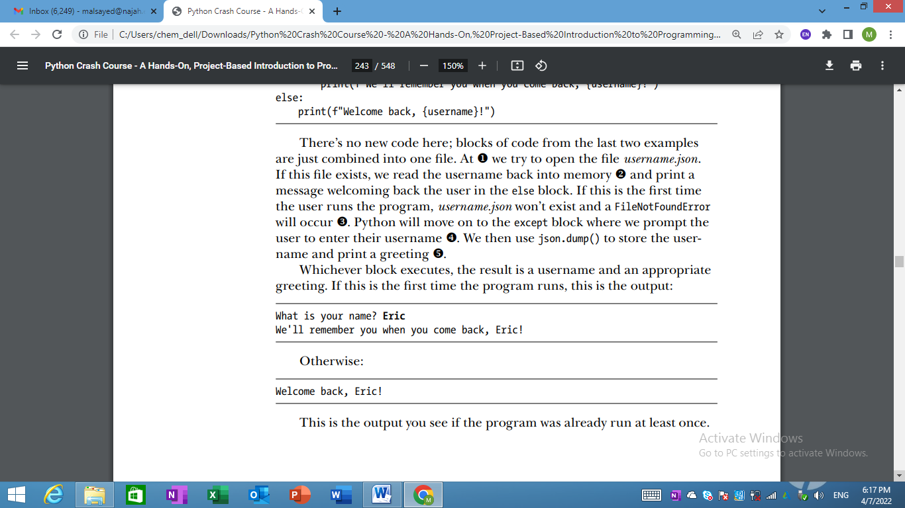
Refactoring
- Often, you’ll come to a point where your code will work, but you’ll recognize that you could improve the code by breaking it up into a series of functions that have specific jobs. This process is called refactoring.
- Refactoring makes your code cleaner, easier to understand, and easier to extend.
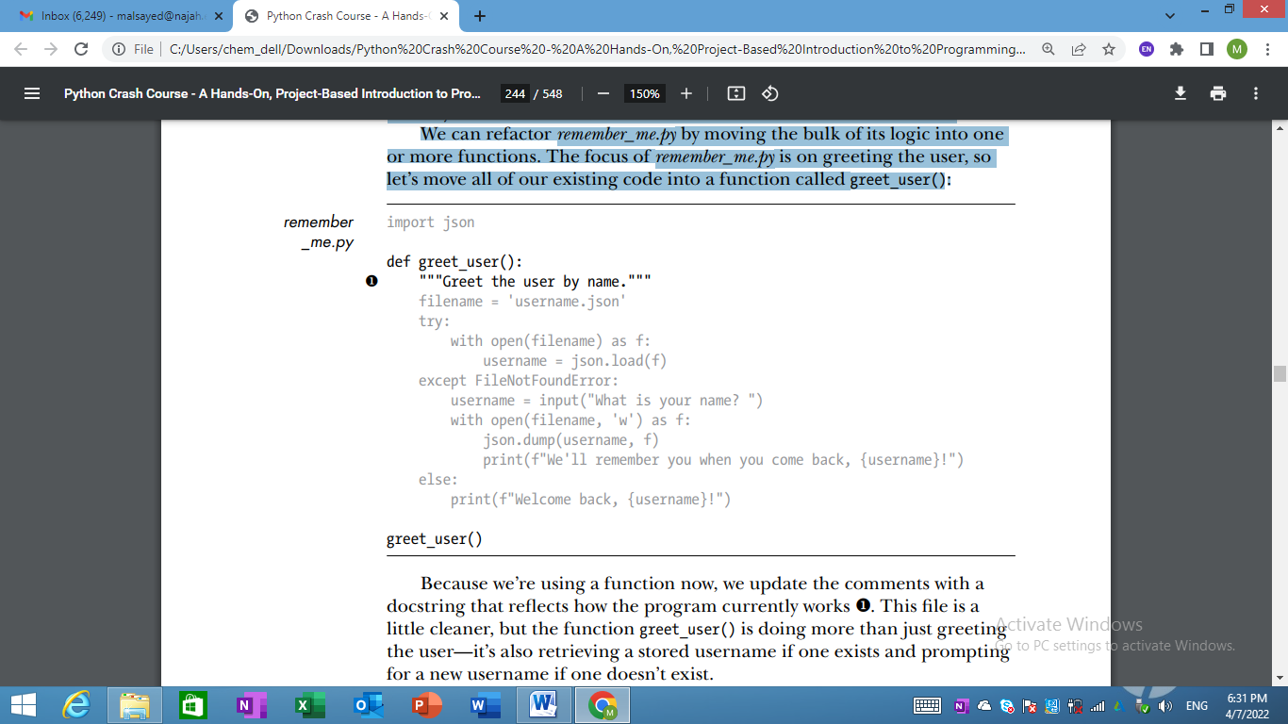
- The function greet_user() is doing more than just greeting the user—it’s also retrieving a stored username if one exists and prompting for a new username if one doesn’t exist.
- Let’s refactor greet_user() so it’s not doing so many different tasks.
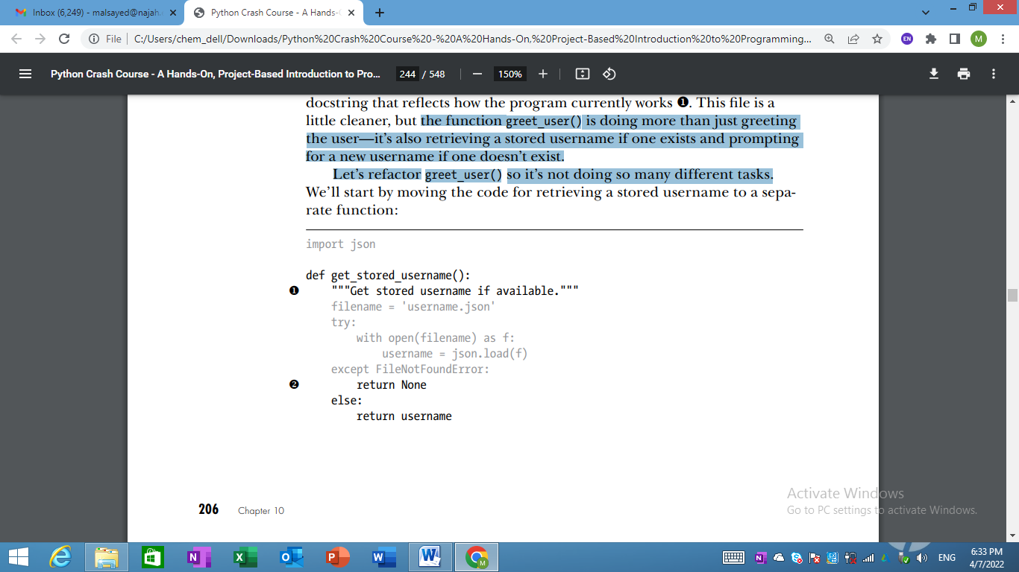
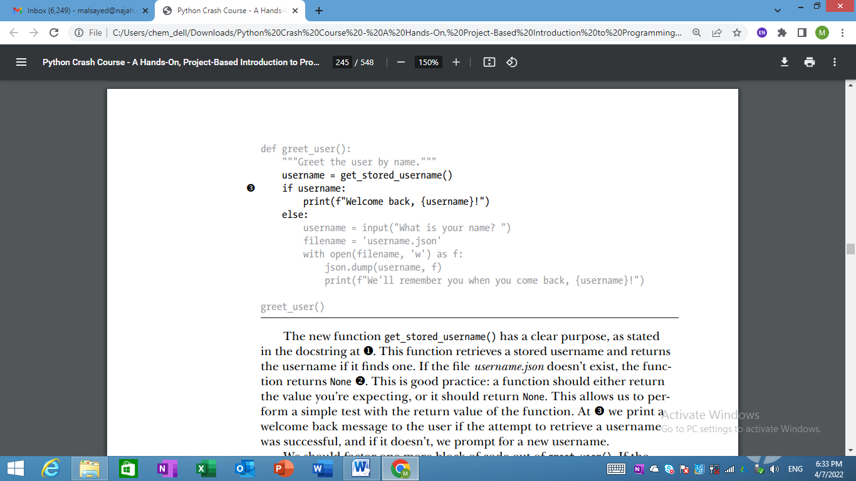
- We should factor one more block of code out of greet_user(). If the username doesn’t exist, we should move the code that prompts for a new username to a function dedicated to that purpose:
