

Toxicology

105447

Second Semester

2013-2014

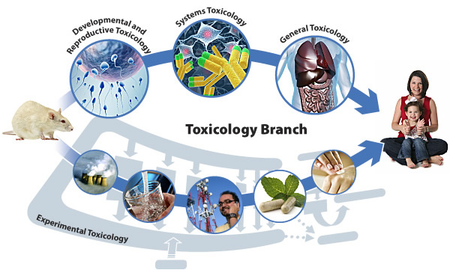

Prepared by

Dr. Basma Damiri

Toxicology

**CHAPTER ONE**

**INTRODUCTION**

**Toxicology: i**s the study of the adverse effects of chemicals on living organisms? Toxicologist is a person dealing with those adverse effects.

**Different Areas of Toxicology:**

1- **Mechanistic Toxicologist:** Concerned with identification and understanding the cellular, biochemical, and molecular mechanisms by which chemicals exert toxic effects on living organisms.

2- **Descriptive Toxicologist**: Concerned with toxicity testing to provide information for safety evaluation and regulatory requirements.

3- **Regulatory toxicologist** responsible for deciding whether a drug (or chemical) has sufficient low risk to be marketed.

The FDA is responsible for allowing drugs, cosmetics, and food additives to be sold in the market.

The U.S. Environmental Protection Agency (EPA) is responsible for regulating other chemicals according to the Federal Insecticide, Fungicide and Rodenticide Act.

**There are other specialized areas of toxicology**

1- **Forensic toxicology**: concerned with the medico legal aspects of the harmful effects of chemicals on humans and animals.

The forensic toxicologist is concerned to aid in establishing:

* Cause of death.
* Determination of death circumstances in a postmortem investigation.

2- **Clinical toxicology**: deals with diseases caused by or associated with toxic substances.

The forensic toxicologist is concerned to aid in establishing:

* Cause, toxi-kinetic of poisoning.
* Determination of how to diagnose and prescribe treatment of poisoning.

3- **Environmental toxicology**: focuses on the hazards of chemical pollutants in the environment on biological organisms.

4- **Ecotoxicology:** is a specialized area within environmental toxicology that focuses more specifically on the impacts of toxic substances on population dynamics in an ecosystem.

**DEFINITIONS**

***Toxic***—having the characteristic of producing an undesirable or adverse health effect.

***Poison*** —is any substance that causes a harmful effect to a living organism.

***Toxicant or poison***—any substance that causes a harmful (or adverse) effect when in contact with a living organism at a sufficiently high concentration.

***Toxin***—any toxicant produced by an organism (floral or faunal, including bacteria); that is, naturally produced toxicants. An example would be the pyrethrins, which are natural pesticides produced by pyrethrum flowers (i.e., certain chrysanthemums) that serve as the model for the manmade insecticide class pyrethroids.

***Toxicity***—any toxic (adverse) effect that a chemical or physical agent might produce within a living organism.

***Toxicology***—the science that deals with the study of the adverse effects (toxicities) chemicals or physical agents may produce in living organisms under specific conditions of exposure. It is a science that attempts to qualitatively identify all the hazards (i.e., organ toxicities) associated with a substance, as well as to quantitatively determine the exposure conditions under which those hazards/toxicities are induced. Toxicology is the science that experimentally investigates the occurrence, nature, incidence, mechanism, and risk factors for the adverse effects of toxic substances.

***Pollution:*** is the introduction of contaminants into the natural environment that cause adverse change and mainly naturally occurring or anthropogenic.

***Contamination:*** is the introduction of contaminants into the natural environment but not necessary to cause adverse change and mainly from anthropogenic sources.

***Exposure*—**to cause an adverse effect, a toxicant must first come in contact with an organism-an organism comes in contact with the substance is the route of exposure (e.g., in the air, water, soil, food, medication) for that chemical.

***Dose*—**the total amount of a toxicant administered to an organism at specific time intervals. The quantity can be further defined in terms of quantity per unit body weight or per body surface area.

***Dosage***: the amount that is taken by the organism and expressed as mg/kg.

***Internal/absorbed dose***—the actual quantity of a toxicant that is absorbed into the organism and distributed systemically throughout the body.

***Hazard***—the qualitative nature of the adverse or undesirable effect (i.e., the type of adverse effect) resulting from exposure to a particular toxicant or physical agent. For example, asphyxiation is the hazard from acute exposures to carbon monoxide (CO).

***Xenobiotic or Pollutant:***  manmade toxicant, anthropogenic.

***Delivered/effective/target organ dose***—the amount of toxicant reaching the organ (known as the *target organ*) that is adversely affected by the toxicant.

***Acute exposure***—exposure over a brief period of time (generally less than 24 h). Often it is considered to be a single exposure (or dose) but may consist of repeated exposures within a short time period.

***Subacute exposure***—resembles acute exposure except that the exposure duration is greater, from several days to one month.

***Subchronic exposure***—exposures repeated or spread over an intermediate time range. For animal testing, this time range is generally considered to be 1–3 months.

***Chronic exposure***—exposures (either repeated or continuous) over a long (greater than 3 months) period of time. With animal testing this exposure often continues for the majority of the experimental animal’s life, and within occupational settings it is generally considered to be for a number of years.

***Acute toxicity***—an adverse or undesirable effect that is manifested within a relatively short time interval ranging from almost immediately to within several days following exposure (or dosing). An example would be chemical asphyxiation from exposure to a high concentration of carbon monoxide (CO).

***Chronic toxicity***—a permanent or lasting adverse effect that is manifested after exposure to a toxicant. An example would be the development of silicosis following a long-term exposure to silica in workplaces such as foundries.

***Local toxicity***—an adverse or undesirable effect that is manifested at the toxicant’s site of contact with the organism. Examples include an acid’s ability to cause burning of the eyes, upper respiratory tract irritation, and skin burns.

***Systemic toxicity***—an adverse or undesirable effect that can be seen throughout the organism or in an organ with selective vulnerability distant from the point of entry of the toxicant (i.e., toxicant requires absorption and distribution within the organism to produce the toxic effect). Examples would be adverse effects on the kidney or central nervous system resulting from the chronic ingestion of mercury.

***Reversible toxicity***—an adverse or undesirable effect that can be reversed once exposure is stopped. Reversibility of toxicity depends on a number of factors, including the extent of exposure (time and amount of toxicant) and the ability of the affected tissue to repair or regenerate. An example includes hepatic toxicity from acute acetaminophen exposure and liver regeneration.

***Delayed or latent toxicity***—an adverse or undesirable effect appearing long after the initiation and/or cessation of exposure to the toxicant. An example is cervical cancer during adulthood resulting from in utero exposure to diethylstilbestrol (DES).

***Allergic reaction***—a reaction to a toxicant caused by an altered state of the normal immune response. The outcome of the exposure can be immediate (anaphylaxis) or delayed (cell-mediated).

***Idiosyncratic reaction***—a response to a toxicant occurring at exposure levels much lower than those generally required to cause the same effect in most individuals within the population. This response is genetically determined, and a good example would be sensitivity to nitrates due to deficiency in NADH (reduced-form nicotinamide adenine dinucleotide phosphate)–methemoglobin reductase.

***Mechanism of toxicity***—the necessary biologic interactions by which a toxicant exerts its toxic effect on an organism. An example is carbon monoxide (CO) asphyxiation due to the binding of CO to hemoglobin, thus preventing the transport of oxygen within the blood.

***Safety***—the measure or mathematical probability that a specific exposure situation or dose will not produce a toxic effect.

***Risk***—the measure or probability that a specific exposure situation or dose will produce a toxic effect.

***Risk assessment***—the process by which the potential (or probability of) adverse health effects of exposure are characterized.

**HISTORY**

Prehistoric Human – used animal venoms and plant extracts for hunting and warfare.

Ebers papyrus (around 1500 BC)

What was it?

Middle Ages-

Maimonides (1135-1204 AD) موسى بن ميمون

What did he do?

Renaissance

Paracelsus (1493-1541)- Grandfather of toxicology.

“All substances are poisons; there is none which is not a poison. The right dose differentiates a poison from a remedy.”

**Industrial Revolution-an Increase in Occupational Diseases.**

Percival Pott (1775): He linked between occupation and particular diseases.

What did he do?

**Orfila-Spanish physician: The Father of Toxicology**

1920’s aresenicals: Arsenic was used to treat syphilis

Triorthocresyl phosphate (TOCP) : an organophosphate compound that is used as a [plasticizer](http://en.wikipedia.org/wiki/Plasticizer) and diverse other applications. It is a colourless, viscous liquid, although commercial samples are typically yellow. It is virtually insoluble in water.

DDT : (dichlorodiphenyl-trichloroethane) discovery in late 1920s for use as insecticide.

1930’s discovered sulfanilamide (antibacterial) and dissolved it into ethylene glycol for delivery. Several patients died of acute kidney failure because the drug crystalizee in the kidney tubules. Lead to the passage of the Copeland Bill *n 1938,*which started the formation of FDA.

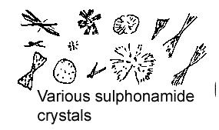 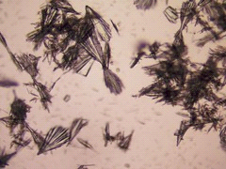

1940’s Elizabeth and James Miller at U Wisconsin: carcinogenesis mechanism

1947- FIFRA (Federal Insecticide, Fungicide, and Rodenticide, Act.) First time in US history that a substance that neither a drug nor a food had to be shown to be safe and efficacious.

1958-Delancy Clause: amendment to the Food, Drug , and Cosmetic Act-broadly stated that any chemical found to be carcinogenic in the laboratory animals or humans could not be added to the US food supply.

Minimata Disease (1950 s): In Japan Methyl Mercury



**Itai-Itai Disease (1950s): In Japan Cd poisoning**

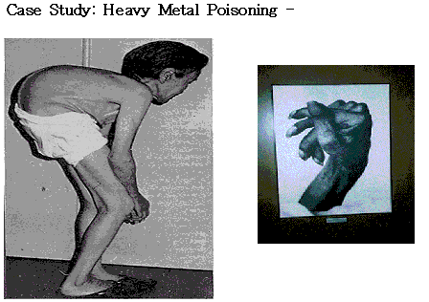

**1960s: Thalidomide:-**



**Rachel Carson’s Silent Spring (1962)**

lent Spring

**DDT &the environment:**

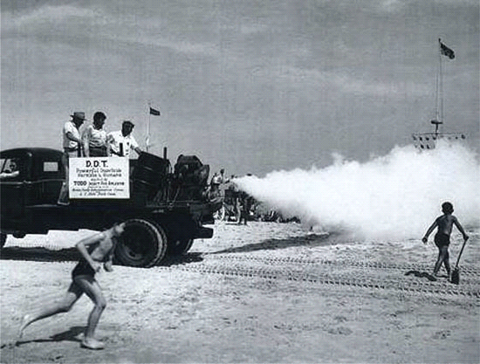

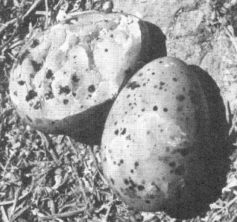 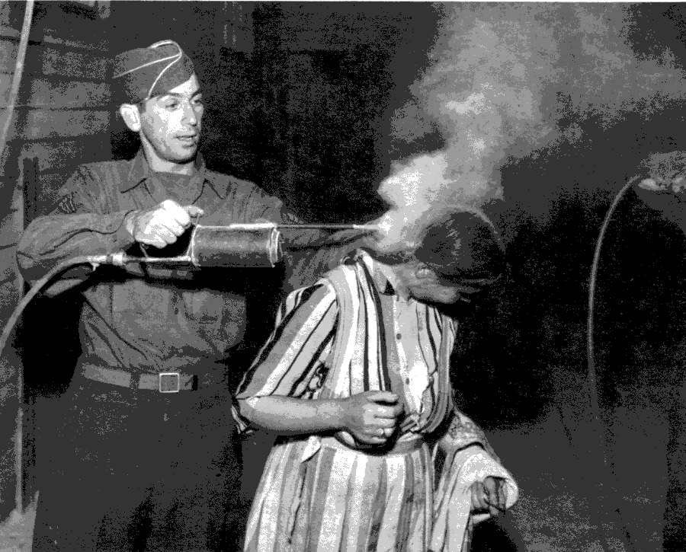

Expand Role of FDA, and established the beginning of the EPA and NIEHS.

**TCDD: contaminant in the herbicide Agent Orange (Vietnam war)**





The worst case in 2004

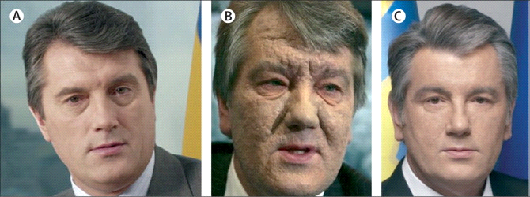

**Love Canal 1970s- concerns regarding hazardous wastes, chemical dump site, and disclosure of information . Led to the Toxic Substances Control Act and eventually to the Superfund bill.**

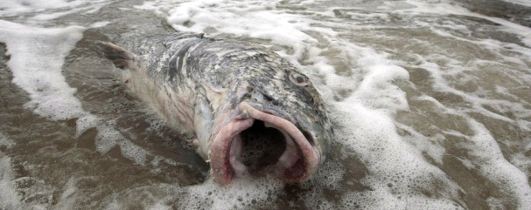

**1960s and 1970s Methyl Mercury in Iraq:**

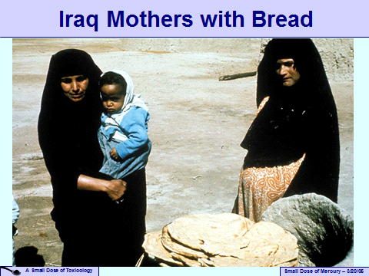

**Arsenic in Bangladesh**

 

**SOURCES OF TOXIC COMPOUNDS:**

|  |  |
| --- | --- |
| **Examples** | **Source** |
|  | Air |
|  | Water |
|  | Mycotoxins |
|  | Plants |
|  | Animals |
|  | Chemicals in the work place |
|  | Drugs of abuse |
|  | Therapeutic Drugs |

**PRINCIPLES OF TOXICOLOGY**

**Every toxicologist performs one or both of the two basic functions of toxicology:**

* Hazard identification function: examine the nature of the adverse effects produced by a chemical or physical agent.

2-Risk assessment function: assess possibility of these toxicities occurring under specific conditions of exposure

Knowledge of toxicity is primarily obtained in three ways:

* by the study and observation of people during normal use of a substance or from accidental exposures.
* by experimental studies [using animals](http://www.eoearth.org/article/Animal_testing_alternatives).
* by studies using [cells](http://www.eoearth.org/article/Cells) (human, animal, plant).

Most chemicals are now subject to stringent government requirements for safety testing before they can be marketed. This is especially true for pharmaceuticals, food additives, [pesticides](http://www.eoearth.org/article/Pesticide), and industrial chemicals.

Exposure of the public to inadequately tested drugs or environmental agents has resulted in several notable disasters. Examples include:

* severe toxicity from the use of arsenic to treat syphilis
* deaths from a solvent ([ethylene glycol](http://www.eoearth.org/article/Health_effects_of_ethylene_glycol_and_propylene_glycol)) used in sulfanilamide preparations (one of the first antibiotics)
* thousands of children born with severe birth defects resulting from pregnant women using thalidomide, an anti-nausea medicine

By the mid-twentieth century, disasters were becoming commonplace with the increasing rate of development of new synthetic chemicals. Knowledge of potential toxicity was absent prior to exposures of the general public.

**Characteristics of exposure:**

Adverse effects are not produced by a chemical agent unless that agent or its metabolic breakdown products reach the appropriate sites in the body at a concentration and for a length of time sufficient to produce a toxic manifestation.

**Variation in Toxic Response:**

* Selective Toxicity:
* Species differences:
* Individual differences:

Species extrapolation is important particularly with carcinogenic chemicals:

Aflatoxin B: Dietary dose as high at 10,000 ppb failed to produce liver cancer in mice, but doses in rats as low as 15 ppb resulted in high amounts of tumors.

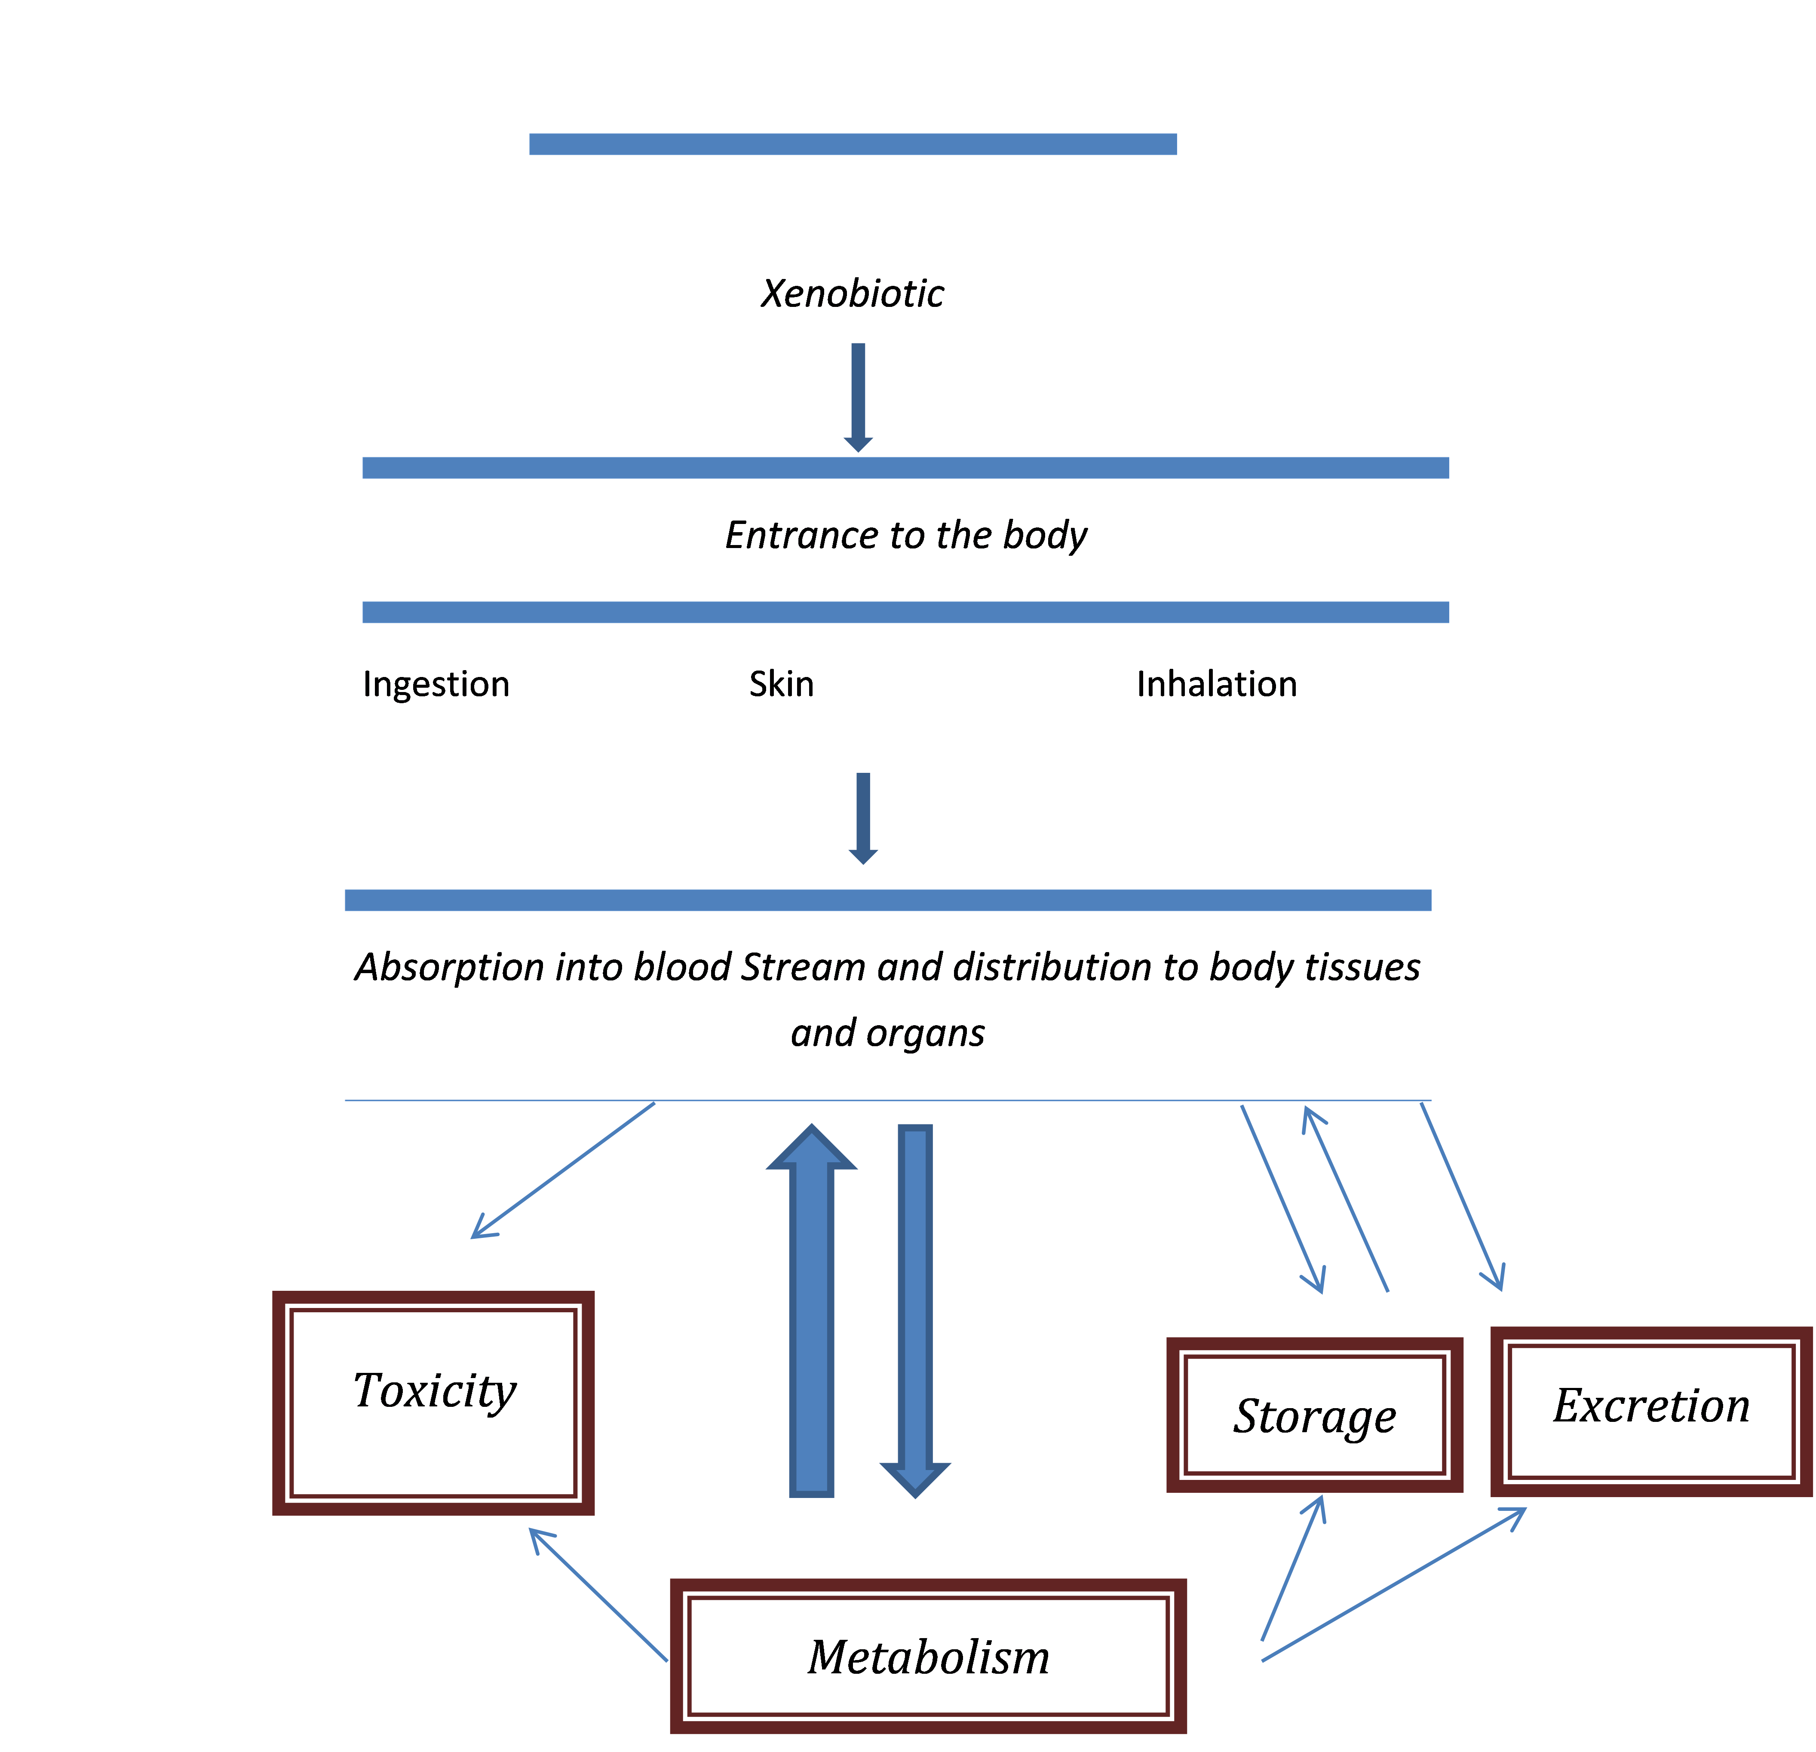

Many chemicals in their native form are not very toxic, but get converted by enzymes in the organism to intermediate forms that are toxic.

**Rout and Sites of Exposure:**

Major pathways of exposure are ingestion (gi tract), inhalation (lungs), and dermal (skin).

**Duration and Frequency of Exposure:**

Usually divide the exposure into four subclasses:

|  |  |
| --- | --- |
| **EXPOSURE** | **DEFENITION** |
| **Acute** |  |
| **Sub-acute** |  |
| **Sub- chronic** |  |
| **Chronic** |  |

**Frequency of administration-**

**Types of Toxic and Side Effects:**

May or may not be deleterious, but it is something that you do not want.

**Allergic Reactions:**

**Idiosyncratic Reactions:**

**Immediate vs delayed Toxicity:**

**Reversible vs Irreversible Effects:**

**Local vs Systemic Toxicity, site of action:**

**Interaction of chemicals:**

|  |  |  |
| --- | --- | --- |
| **Interaction** | **Definition** | **Example** |
| **Additive** |  |  |
| **Synergetic** |  |  |
| **Potentiation** |  |  |
| **Agonist:** |  |  |
| * **Functional** |  |  |
| * **Chemical** |  |  |
| * **Dispositional** |  |  |
| * **Receptor** |  |  |

**Tolerance:** Decrease Responsiveness due to previous exposure by the same chemical or structurally related chemical.

**I. DOSE-RESPOSNE TEST**

**Endpoints:**

* **Mortality**
* **Reproduction**
* **Growth**
* **Behavior**

|  |  |
| --- | --- |
|  | **Definition** |
| **LC50** |  |
| **LD50** |  |
| **LC100** |  |
| **LD100** |  |
| **NOEC** |  |
| **LOEC** |  |

**Draw a dose –response curve and define the previous points on it?**

II-**Dose-response curves for two hypothetical sedative-hypnotics:**

