|  |  |  |
| --- | --- | --- |
| **An-Najah National University College of Medicine and**  **Health Sciences** |  | **جامعة النجاح الوطنية**  **كلية الطب وعلوم الصحة** |

**Toxicology /105447**

**Chapter 6 -Nephrotoxicity**

**Kidney function:**

* Filtration and excretion
* Homeostasis of water-soluble molecules
* Electrolyte homeostasis/acid-base balance
* Metabolism/detoxification
* Hormone production

**Structure and Function**

The tubule resorbs greater than 99% of the glomerular filtrate

The proximal tubule has extensive resorption and selective secretion. Low MW protein resorption and primary site for cytochrome P450s.

Thin loop of Henle - resorption of fluids

Distal tubule - resorption of fluids and acid-base balance

Collecting duct - resorption of fluids, antidiuretic hormone and acid-base balance

**The functional unit of the kidney: Nephron**

**Nephrosis or nephropathy:**

**Kidney as a Target Organ of Toxicity**

* Is a frequent site of toxic injury in rodent toxicity studies (second to the liver).
* Role in filtration, metabolism, and excretion of xenobiotics and their metabolites.
* Toxins can concentrate in the glomerular filtrate or within tubule cells.
* Metabolic activation of xenobiotics

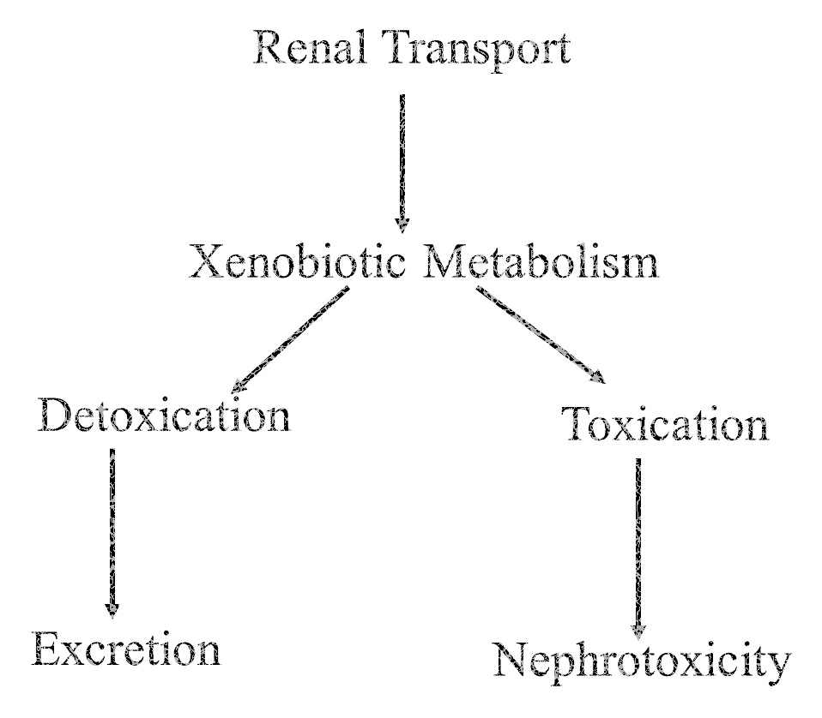

**Renal Metabolism**

Both Phase I and Phase II

Cytochrome P450's

Renal Cortex

Less total activity than liver

Regional differences in activity along nephron

Locally along nephron may be equal to liver

Sex-differences in some species

Cyclooxygenases

Renal Medulla

**Hormonal Activity**

* Produces erythropoietin, which regulates RBC production
* Hydroxylates 25-OH-cholecalciferol (vitamin D metabolite) promotes bone resorption and calcium and phosphorus absorption from gut
* Releases renin to regulate the peripheral renin-angiotensin-aldosterone system (juxtaglomerular apparatus) for maintenance of vascular tension

The structural and functional unit of the kidney.

**The Nephron**

A continuous tube that includes the glomerulus, proximal tubule, loop of Henle, distal tubule, and the collecting duct.

Nephrons exhibit differences depending on the cortical location of the glomerulus.

Composed of highly specialized cells that exhibit structural, functional, and biochemical differences.

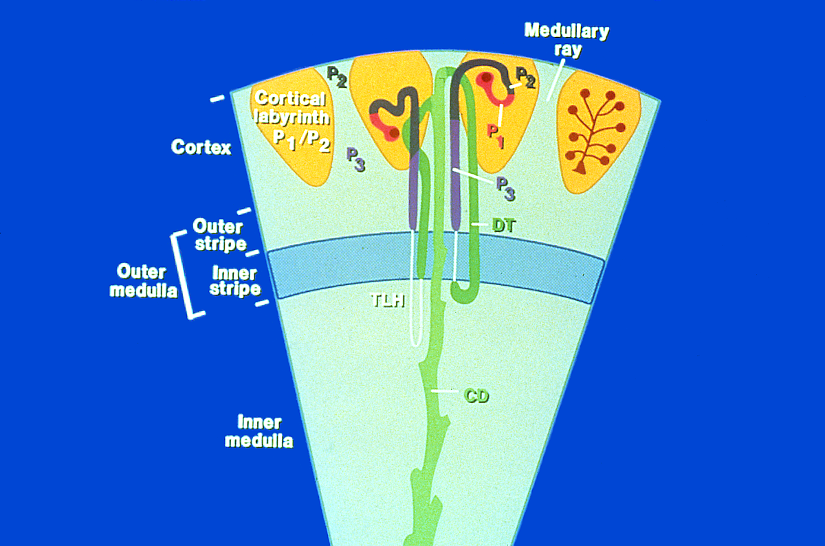

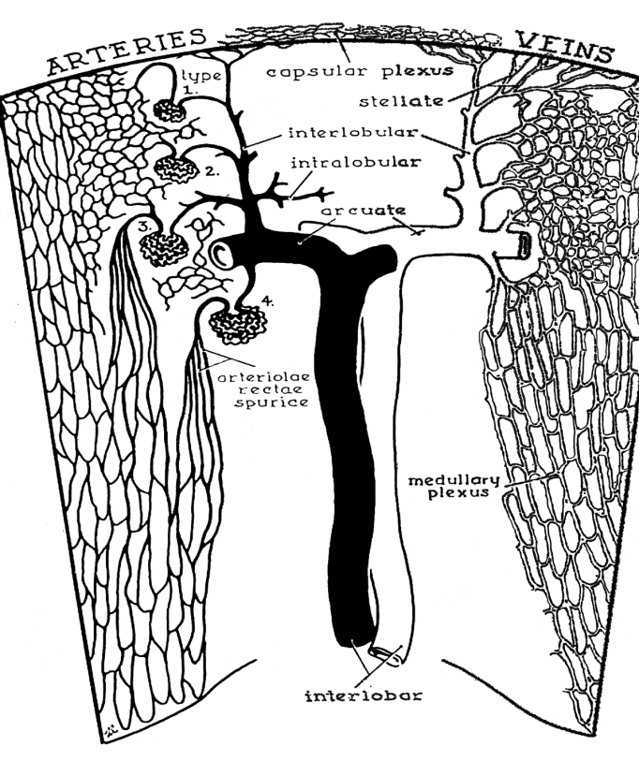

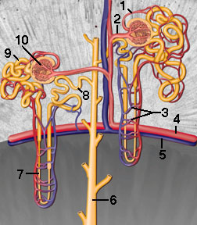

**Glomerulus**

Ultrafiltrate: 20% of renal blood flow, 2-3% of cardiac output

Endothelial surface is negatively charged

Basement membrane between endothelial and epithelial cells anionic sailoglycoproteins, glycoproteins, and collagen IV

Fenestrae

Mesangium for support

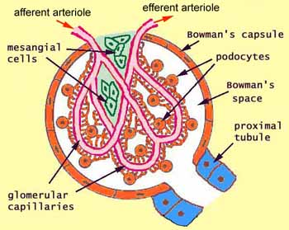

**Renal Blood Flow**

Unique vascular supply

Greatest vascular endothelial surface area

relative to organ weight in the body

High blood flow comprising 20-25% of cardiac output although less than 1% of body weight

Renal cortex receives 90% of renal blood flow

**Renal Proximal Tubules**

Reabsorbtion, secretion, and transport of proteins, ions, and other organic molecules.

Differentiated into P1, P2 and P3 (S1, S2, S3) segments based upon histochemical and ultrastructural characteristics.

Sex differences exist, in some species, in the metabolic capabilities of proximal tubule cells.

**Renal Physiology**

Glomerular filtrate made up of water, electrolytes, and small molecules.

Large proteins and formed elements retained in blood.

Absorption, secretion and transport by tubule cells.

>99% reabsorption of GF (60-70% by PCT).

Concentration (Na reabsorption)

**Damage to the renal tubule**

Halogenated hydrocarbons - chloroform, hexachlorobutadiene, trichloroethylene, dibromochloropropane, & bromobenzene

Heavy metals - cadmium, mercury & lead

Antibiotics - cephalosporins & aminoglycosides

Mycotoxins - ochratoxin A & citrinin

Ethylene glycol

Antineoplastic drugs - cisplatinum

Alpha2u-globulin nephropathy

**Bladder**

The urine that flows from the collecting ducts is deposited in the bladder. Little of the literature is devoted to the bladder and its functioning. However, some compounds are toxic to the bladder. Bladder cancer is thought to be caused by occupational exposure to bicyclic aromatic amines. The bladder epithelium contains high levels of an enzyme, prostaglandin H synthase (PHS), which can activate certain aromatic amines, such as benidine, 4-aminobiphenyl, and 2-aminonaphthalene, to compounds that can react with DNA. The normal metabolism of these compounds involves acetylation, and there are several genetic polymorphisms of the enzymes (N-acetyltransferases) responsible for acetylating them. Individuals with slow acetylating enzymes are more likely to develop bladder cancer after exposure.

**Important Kidney Functions Seldom Considered as Toxic Endpoints**

Renal Erythropoietic Factor The kidney synthesizes hormones essential for certain metabolic functions. For example, hypoxia stimulates the kidneys to secrete renal erythropoietic factor, which acts on a blood globulin (proerythropoietin) released from the liver to form erythropoietin, a circulatingglycoprotein with a molecular weight of 60,000 daltons. The erythropoietin acts on erythropoietinsensitive stem cells in the bone marrow, stimulating them to increase hemoglobin synthesis, produce more red blood cells, and release them into the circulating blood. The increased oxygen-carrying capacity of the blood reduces the effects of hypoxia. Thus, in chronic renal failure, anemia usually develops, in large part caused by decreased synthesis of erythropoietic factor because of damage to the kidney tissues responsible for its synthesis. In addition to hypoxia, androgens and cobalt salts also increase production of renal erythropoietic factor by the kidneys. In fact, administration of cobalt salts produces an overabundance of red cells in the blood (i.e., polycythemia) by this mechanism. Polycythemiahas been observed in heavy drinkers of cobalt-contaminated beer.

**Regulation of Blood Pressure**

The kidney is involved in regulating blood pressure in several ways. The kidney produces renin, a proteolytic enzyme, which cleaves a plasma protein globulin to form angiotensin I. Angiotensin I is converted to angiotensin II, a potent vasoconstrictor. The angiotensin II stimulates release of aldosterone from the adrenal cortex, and aldosterone increases reabsorption of sodium in the kidney, leading to an increase in blood plasma osmolality and an increase in extracellular volume. A decrease in the mean renal arterial pressure is the stimulus controlling kidney renin production and the compensatory increase in arterial pressure by the abovementioned mechanisms. In addition, renal disease and narrowing of the renal arteries are known to cause sustained hypertension in humans. It appears that the kidney produces vasodepressor substances that are thought to be important in the regulation of blood pressure. Thus, changes in the kidney that disturb the renin– angiotensin–aldosterone system and/or secretion of the vasodepressor substances are suspected of playing a key role in the etiology of certain forms of hypertension.

**Metabolism of Vitamin D**

The kidney also plays a key role in the metabolism of vitamin D, thus performing a vital function in the hormonal regulation of calcium in the body. Vitamin D3 (cholecalciferol) is relatively inactive. The liver hydroxylates vitamin D3 to 25-hydroxycalciferol, and then, the kidney hydroxylates the 25-hydroxycalciferol to 1,25-dihydroxycalciferol, the most potent active form of vitamin D. The kidney is also the key to the metabolism of parathyroid hormone, another hormone important to calcium regulation. If the kidney is damaged, thereby disrupting its role in vitamin D and parathyroid hormone metabolism, the development of a renal osteodystrophy can occur, which is characterized by skeletal disease and hyperplasia of the parathyroid gland.

**FUNCTIONAL MEASUREMENTS TO EVALUATE KIDNEY INJURY:**

* Glomerular filtration
* Tubular reabsorption
* Tubular secretion

***Additional Clinical Test*** Alterations in renal function can be determined by a variety of other tests.

A battery of such tests includes urinary pH, measurement of urine volume, and a determination of the excretion of sodium and potassium. An excess of protein or the appearance of sugar in the urine indicates abnormalities in renal function as would changes in urine sediments. These are all general tests, but they can provide information about the changes in total kidney function.

**ADVERSE EFFECTS OF CHEMICALS ON THE KIDNEY**

Frequently, exposure to large amounts of a chemical can cause kidney effects that are not observed at lesser exposures. Effects of kidney damage are frequently assessed in nonspecific terms such as changes in kidney weight (both increases and decreases) or increases in protein content of the urine (proteinuria) or changes in volume of urine (polyuria, oliguria, or anuria).

Acute renal failure (ARF) is one of the more common responses of the kidney to toxicants. ARF is characterized by a rapid decline in glomerular filtration rate and an increase in the concentration of nitrogenous compounds in the blood. Numerous mechanisms have been identified that lead to ARF.

Compounds that cause renal vasoconstriction reduce the amount of blood that reaches the glomerulus and cause hypoperfusion, a reduction in the amount of blood filtered. When toxicants cause glomerular injury, they can reduce the amount of filtrate that enters the tubules, called *hypofiltration.*

When the tubular cells are injured by toxicants, the permeability of the tubule is increased and the filtrate is allowed to backleak into the interstitium and into the circulation, producing an apparent reduction of the GFR. Some toxicants may reduce the adhesion of tubular cells to each other, causing them to obstruct the pathway for filtrate to be reabsorbed and thus increasing the pressure within the tubule leading to a resistance of movement of filtrate into the tubule.

The kidney is capable of overcoming substantial loss of function. If a single kidney is lost, the remaining kidney can increase its GFR by 40–60 percent. Individual nephrons can increase the reabsorption of water and solutes so that the osmotic balance is maintained and there is no apparent difference in tests of kidney function. Although the compensatory mechanisms protect the whole organism in the short term, the compensatory responses may lead to chronic renal failure in the long term. The increase in glomerular pressure leads to sclerosis of the glomerulus and the degeneration of the capillary loops, among other changes in the nephron whose roles in compensatory nephron damage are not as well documented. The loss of additional nephrons and the capacity to remove wastes by this mechanism leads to additional compensation by other nephrons, which are subsequently damaged by similar mechanisms, eventually leading to chronic renal failure.

Other means of protecting the kidney from damage include the induction of metallothionein and

heat-shock proteins. Heat-shock proteins play a housekeeping role to maintain normal protein structure and/or degrade damaged proteins. Metallothionein is a low-molecular-weight protein that binds heavy metals and prevents them from inducing toxic responses. The production of metallothionein is induced by the presence of heavy metals, and, when low doses of the heavy metal are given, the metallothionein is produced and can provide protection against larger doses given at a later time. If no exposure has occurred previously, no protection is provided because metallothionein is not present to bind the heavy metal.

In addition to the organ-level response of the kidney, many toxicants affect specific regions of the nephron. They may damage the glomerulus, the proximal tubule, or the further tubule elements such as the loop of Henle, distal tubule, or collecting duct. The most common site of injury for toxicants is the proximal tubule.

**Nephrotoxic Agents**

Many compounds are known to adversely affect kidney tissues at some exposure level, but the kidney is the tissue affected at the least lowest observed adverse effect levels for only a few compounds. The chemicals for which the American Conference of Governmental Industrial Hygienists (ACGIH) has established Threshold Limit Values (trademark) (TLVs) that are intended to protect against affects on the kidney are given in Table 6.1. For these compounds, however, the renal system may not be the only system the TLV is intended to protect.

Two classes of environmentally or occupationally relevant chemicals that damage the kidney are the heavy metals and halogenated hydrocarbons. The adverse effects of representative chemicals from each group are discussed below. Some occupations that have exposure to nephrotoxicants are given in Table 6.2.

***Cadmium*** The kidney is the organ most sensitive to the toxic effects of cadmium. Numerous factors have been used as indicators of kidney damage by cadmium. One of the early indicators is the presence of 2-microglobulin, a low-molecular-weight protein that is usually reabsorbed by the proximal tubules.

Proximal tubule damage of the nephrons caused by cadmium is also evidenced by glycosuria, aminoaciduria, and the diminished ability of the kidney to secrete PAH. As damage increases, there is an increase in urinary excretion of low- and high-molecular-weight proteins, which predicts an acceleration of the decline in glomerular filtration rate. Workers in factories where nickel/cadmium batteries are manufactured and who are exposed to excessive amounts of cadmium oxide exhibit consistent proteinuria, and cadmium-induced kidney damage may appear years after workers areremoved from exposure.

In Japan excessive cadmium intake was also linked to a peculiar form of renal osteodystrophy

known as “ ouch-ouch disease” or “ itai-itai byo.” It has been proposed that this disease is caused by excessive loss of cadmium and phosphorus in the urine, combined with dietary calcium deficiency.

The kidney naturally accumulates cadmium. Normally cadmium accumulates in the kidney over the lifetime of the individual until the age of 50. About 50 percent of the total burden of cadmium in the body is borne by the liver and kidney, with the kidney having 10 times the concentration of the liver. Cadmium induces synthesis in the liver of metallothionein, a protein with a high binding affinity for cadmium. While metallothionein acts to protect certain organs, such as the testes, from cadmium toxicity, it may play a role in cadmium toxicity in the kidney. After the available metallothionein in proximal tubule cells is overcome by high cadmium concentrations, the free cadmium exerts toxic effects on the cells in the proximal tubule.

Chronic cadmium exposure has also been implicated as a factor in hypertension. However, while the development of hypertension may involve the kidney, the role of cadmium in the etiology of hypertension in humans is far from conclusive.

**Mercury** Inorganic mercury (Hg2+) is a classical nephrotoxicant. It is used as a model compound for producing kidney failure in animals, and massive doses of mercuric ion can damage the proximal tubule and cause acute renal failure. A brief polyuria is followed by oliguria or even anuria. The anuria (kidney failure) leads, of course, to a life-threatening accumulation of bodily wastes and may last many days. If recovery occurs, a polyuria follows, which is probably caused by decreased sodium absorption in the proximal tubule. Such disturbances in tubular function may last several months.

Acute exposure to high concentrations of mercury is rare; usually mercury exposure occurs at lower dose rates. The part of the nephron most sensitive to mercuric ion toxicity is the pars recta or straight portion of the proximal tubule (Figure 6.3). Early damage is characterized by the presence of enzymes in the urine that are normally found in the brush border portion of the cells lining the tubule. Further damage results in the presence of intracellular enzymes from these cells in the urine. Longer-term exposure and damage can lead to the presence of glucose, amino acids, and proteins in the urine. Also associated with long-term exposure to mercury is a reduction in the GFR caused by vasoconstriction, tubular damage, and damage to the glomerulus.

Chloralkali workers exposed to mercury have increased glomerular dysfunction and elevated excretion of high-molecular-weight proteins. 2-Microglobulin has been found at elevated levels in the blood plasma of these workers, but levels in urine were not increased.

**Lead**

See pages 139-140 of the book

Other Toxic metals See pages 140-143 in the book

See Tables 6-1, 6-2, 6-3, and 6-4 in the book.

**Heavy Metals**

Many have regional specificity along nephron that is dose dependent

Usually in proximal tubule but spreads along nephron with higher dose

Various mechanisms

Displace an element

Alter structure

Alter metabolism

Interact with a ligand





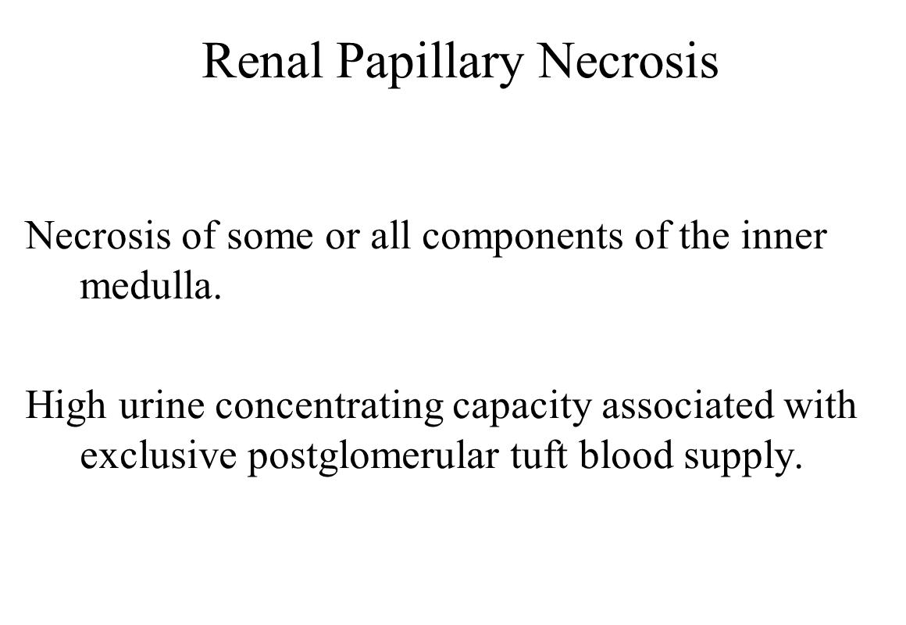

**Glomerular Injury**

Direct Injury to glomerular epithelium – adriamycin

Alteration of renal blood flow (endothelial toxin) – cyclosporin A

Antigen-Antibody complex formation – gold

Antinuclear antibodies (soluble immune complex) – procainamide

Anti-glomerular basement membrane antibody – organic solvents

Secondary to tubulointerstitial disease – chronic tubule toxicity

**Ethylene Glycol Nephropathy**

Toxicity first discovered in humans when ethylene glycol was used as a drug solvent.

Causes acute renal toxicity in animals after exposure to anti-freeze.

Ethylene glycol is metabolized to oxalic acid.

Calcium oxylate crystals form in the lumen of the tubules.

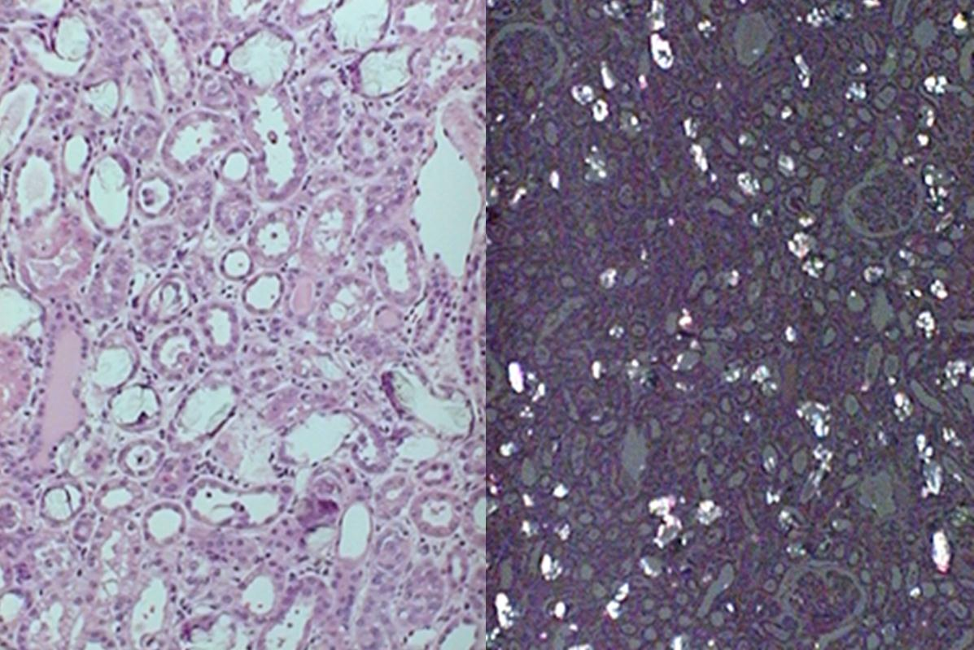

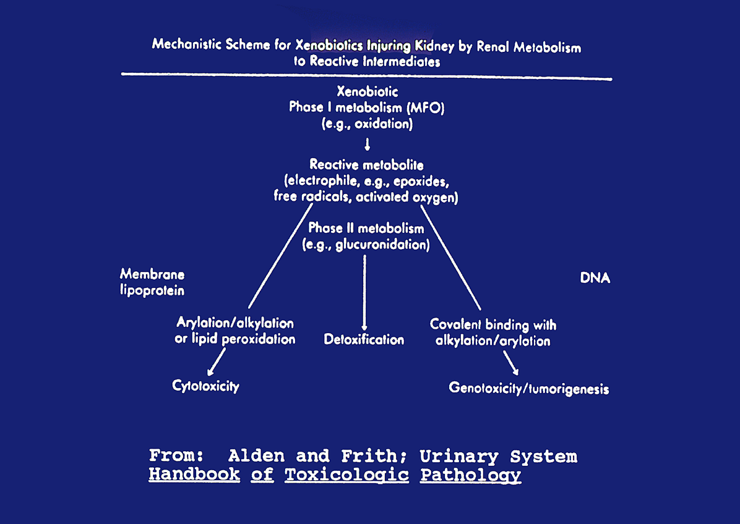

**Nephrocarcinogenicity**

Cortical Tubular Cell: Adenoma,, Carcinoma

Collecting duct cell: Oncocytoma

Transitional Cell: Papilloma, Carcinoma, Squamous Cell Carcinoma

Mesenchymal Tumors (Rat)

Aromatic amines, tobacco smoke and parasitic infections can induce bladder cancer in humans

**Saccharin:** Can act as a tumor promoter

Mechanism requires the formation of calcium phosphate-containing precipitates