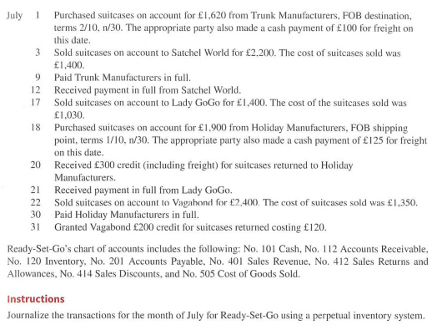

End inv June = beg inv July = 1,200

|  |  |  |
| --- | --- | --- |
| Ready - set - Go company | | |
|  | **Perpetual** | **periodic** |
| 1.July. | Dr inventory 1,620 | Dr purchases 1,620 |
| (2/10 . n/30) | Cr acc pay – trunk 1,620 | Cr acc pay – trunk 1,620 |
|  |  |  |
| 3.July | Dr acc rec - satchel 2,200 | Dr acc rec - satchel 2,200 |
| (1/10, n30) | Cr sales rev 2,200 | Cr sales rev 2,200 |
|  | Dr COGS 1,400 |  |
|  | Cr inventory 1,400 |  |
|  |  |  |
| 9.july | Dr acc pay 1,620 | Dr acc pay 1,620 |
|  | Cr inventory (2%*1,620) 32.4 | Cr purchase discount (2%*1,620) 32.4 |
|  | Cr cash (1620-32.4) 1,587.6 | Cr cash (1620-32.4) 1,587.6 |
|  |  |  |
| 12.July. | Dr cash (2,200-22) 2,178 | Dr cash (2,200-22) 2,178 |
|  | Dr sales discount (1%*2,200) 22 | Dr sales discount (1%*2,200) 22 |
|  | Cr acc rec 2,200 | Cr acc rec 2,200 |
|  |  |  |
| 17.Jul. | Dr acc rec – lady gogo 1,400 | Dr acc rec – lady gogo 1,400 |
| 1/10 n/30 | Cr sales rev 1,400 | Cr sales rev 1,400 |
|  | Dr COGS 1,030 |  |
|  | Cr inventory 1,030 |  |
|  |  |  |
| 18.July | Dr inventory 1,900 | Dr purchases 1,900 |
| 1/10 n/30 | Cr acc pay – holiday 1,900 | Cr acc pay – holiday 1,900 |
|  | Dr inventory 125 | Dr fright in 125 |
|  | Cr cash 125 | Cr cash 125 |
|  |  |  |
| 20.July | Dr acc pay – holiday 300 | Dr acc pay – holiday 300 |
|  | Cr inventory 300 | Cr purchase R & A 300 |
|  |  |  |
| 21.July | Dr cash (1,400-14) 1,386 | Dr cash (1,400-14) 1,386 |
|  | Dr sales discount (1%*1,400) 14 | Dr sales discount (1%*1,400) 14 |
|  | Cr acc rec 1,400 | Cr acc rec 1,400 |
|  |  |  |
| 22.july | Dr acc rec – vogebound 2,400 | Dr acc rec – vogebound 2,400 |
| (1/10, n/30) | Cr sales rev 2,400 | Cr sales rev 2,400 |
|  | Dr COGS 1,350 |  |
|  | Cr inventory 1,350 |  |
|  |  |  |
| 30.July | Dr acc pay – holiday 1,600 | Dr acc pay – holiday 1,600 |
|  | Cr cash 1,600 | Cr cash 1,600 |
|  |  |  |
| 31.July | Dr sales R & A 200 | Dr sales R & A 200 |
|  | Cr acc rec - vagebound 200 | Cr acc rec- vagebound 200 |
|  | Dr inventory 120 |  |
|  | Cr COGS 120 |  |

2. Calculate cost of goods sold for the month July :  
A. perpetual system

|  |  |
| --- | --- |
| **COGS** | |
| **Dr** | **Cr** |
| 3.jul 1,400 | 31.jul 120 |
| 17.jul 1,030 |  |
| 22.jul 1,350 |  |
|  |  |
| Ending bal . 3,660 |  |

B. periodic system ( ending inv in July = 852.6)

COGS = Beg inv + COGP – end inv   
 = beg inv + (net purchases + fright in) – end inv   
 = beg inv + ( [purchase – purchase R & A – purchase D] + fright in) – end inv   
 = 1,200 + ( [ 3520 – 300-32.4]+ 125 ) – 852.6   
 = 3,660