- Genetics is the study of how cells and whole organisms resemble and differ from the cell and organisms that give rise to them. It is the study of genes.
- Gene is defined as a hereditary unit that occupies a specific position (locus) within the genome or chromosome.
- The genome is the complete set of sequences in the genetic material of an organism.
- Cell is the basic functional unit in the living organisms
- Component of cell that involve directly or indirectly with the genetic material:
- nucleolus, ribosome, and centriole
- Mitochondria and chloroplast contain their own unique genetic information.
There are two basic kinds of organisms:
- Prokaryotes: Organisms whose cells lack a nucleus and therefore have DNA floating loosely in the liquid center of the cell
- Prokaryotes are the most common forms of life on earth.
- All bacteria, regardless of nature, are simple, one-celled prokaryotic organisms.
- None have cell nuclei, and all are small cells with relatively small amounts of DNA
- The exterior of a prokaryotic cell is encapsulated by a cell wall that serves as the bacteria’s only protection from the outside world.
- Bacterial cell has cell wall, but chemical composition is a complex macromolecule called a peptidoglycan
- A plasma membrane (membranes are thin sheets or layers) regulates the exchange of nutrients, water, and gases that nourish the bacterial cell.
- DNA, usually in the form of a single circular-shaped piece
- The liquid interior of the cell is called the cytoplasm
- Prokaryotes divide, and thus reproduce, by simple mitosis
- DNA not associated extensively with protein.
- During cell division chromosome compacted into nucleoids.
- In bacteria no distinct nucleolus, but do contain genes that specify rRNA.

- Eukaryotes: Organisms that have a well-defined nucleus to house and protect the DNA.
- Contain organelles surrounded by membranes
- Most living organisms
- Cell is surrounded by a plasma membrane
- functions
- (1) defines the cell boundary, and protects the cell
- (2) Controls the movement of materials such as gases, nutrients, and waste products into and out of the cell.
- Plant have outer covering cell wall
- Primary composed of a polysaccharide called cellulose
- The most important feature of the eukaryotic cell is the nucleus
- The nucleus protects the DNA from damage during day-to-day living.
- Eukaryotic chromosomes are usually long, string-like segments of DNA
Two of the most important organelles are:
- Mitochondria: The powerhouses of the eukaryotic cell, mitochondria pump out energy by converting glucose to ATP (adenosine triphosphate).Both animals and plants have mitochondria.
- Chloroplasts: These organelles are unique to plants. They process the energy of sunlight into sugars that then are used by plant mitochondria to generate the energy that nourishes the living cells.
- DNA differ than that in nucleus.
- Can be duplicate themselves, transcribe and translate their genetic information similar to prokaryotic cells
- Nucleolus is composed of RNA, DNA and protein. The region contain DNA that codes for rRNA
- Cytoplasm nonparticular colloidal material cytosol
- Cytosol surrounded and encompasses the numerous type of cellular organelles
- tubules and filaments comprising the cytoskeleton ----provide support maintains cell shape facilitate cell mobility and anchors the various organelles
- Endoplasmic reticulum (ER):
- Compartmentalizes the cytoplasm
- Increase the surface area available for biochemical synthesis
- Type of ER
- Smooth ER site for synthesis of fatty acids and phospholipids
- Rough ER it is studied with ribosomes
- Ribosomes : Function: translation of the genetic information contained in mRNA into protein.
- Centrioles- Function: Organization of these spindle fibers that function in mitosis and meiosis

- Type of cells in eukaryotic
- body cells (called somatic cells) : Somatic cells are produced by simple cell division called mitosis
- sex cells : are specialized cells that are used for reproduction. Produced by meiosis
- Chromosome Structure :” packaging”
- nucleosome, 200 bp of DNA wrapped twice around a core of 8 histone proteins
- 30 nm chromatin fiber (exists even during interphase)
- chromatin fibers are attached in loops of variable size to a protein scaffold. Scaffold region rich with A&T, loops may be functional units: active vs. inactive in transcription
- supper-coiling ( exists during metaphase)
Classification of chromosomes
- Main features to identify and classify chromosomes
- 1. Size: large, medium and small and sex chromosomes
- 2. Location of the centromeres:
- Metacentric: centromere in the middle, with arms of equal length.
- Telocentric: centromere at one end, with only 1 arm.
- Acrocentric: centromere near one end, with arms of very different lengths
- Sub-metacentric: centromere near the middle, with arms of slightly different lengths.
- 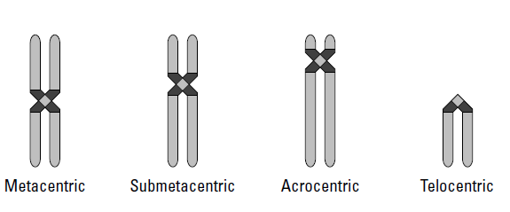
Chromosome numbers haploid and euploid
- Euploidy: Normal variations of the number of complete sets of chromosomes
- Chromosomes number are multiples of some basic number (n)
- N is called the haploid chromosome number.
- 2n is called diploid.
- 3n, 4n, and so on are called polyploid. Haploid, Diploid, Triploid, Tetraploid, etc…
- Aneuploidy: Variation in the number of particular chromosomes within a set
- Monosomy, trisomy, tetrasomy

- Plants commonly exhibit polyploidy
- Polyploid strains often display desirable agricultural characteristics, wheat, strawberries, bananas
- Most animal species are diploid. Polyploidy in animals is generally lethal
- Benefit of Odd Ploidy-Induced Sterility. Seedless fruit
- watermelons and bananas
- Marigold flowering plants
- Prevention of cross pollination of transgenic plants
- Chromosomal aberrations
- Substantial changes in chromosome structure
- Amount of genetic information in the chromosome can change
- Deficiencies/Deletions: Loss of a region of a chromosome example Cri-du-chat Syndrome
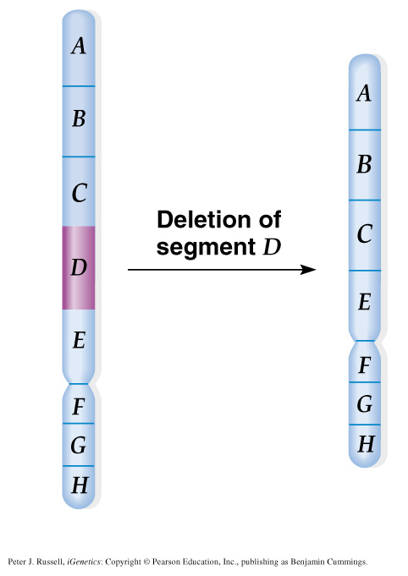
Effect of deletion on the phenotype
- Phenotypic consequences of deficiency depends on
  - Size of the deletion
  - Functions of the genes deleted
- Phenotypic effect of deletions usually detrimental
- Duplications:
Duplications result from doubling of chromosomal segments, and occur in a range of sizes and locations.
a. Tandem duplications are adjacent to each other.
b. Reverse tandem duplications result in genes arranged in the opposite order of the original.
c. Tandem duplication at the end of a chromosome is a terminal tandem duplication.
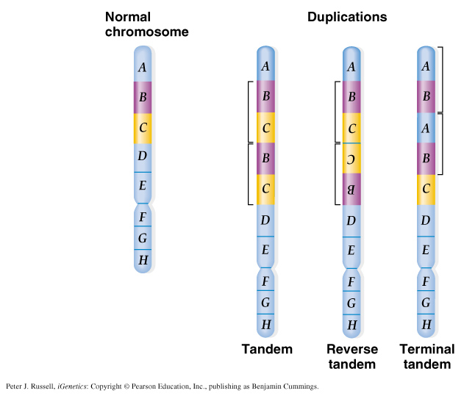
- Phenotypic consequences of duplications correlated to size & genes involved
- Duplications tend to be less detrimental
- The genetic material remains the same, but is rearranged
- Inversions:
  - Pericentric – inversion about the centromere
  - Paracentric – inversion not involving the centromere
- No loss of genetic information
  - Many inversions have no phenotypic consequences
- Break point effect
  - Inversion break point is within regulatory or structural portion of a gene
- Position effect
  - Gene is repositioned in a way that alters its gene expression
  - separated from regulatory sequences, placed next to constitutive heterochromatin

- Translocations: When a segment of one chromosome becomes attached to another
Exchange or joining of regions of two non-homologous chromosomes
- In reciprocal translocations two non-homologous chromosomes exchange genetic material “balanced translocations” Usually without phenotypic consequences.
- In simple translocations the transfer of genetic material occurs in only one direction “unbalanced translocations”. associated with phenotypic abnormalities or even lethality Example: Familial Down Syndrome

