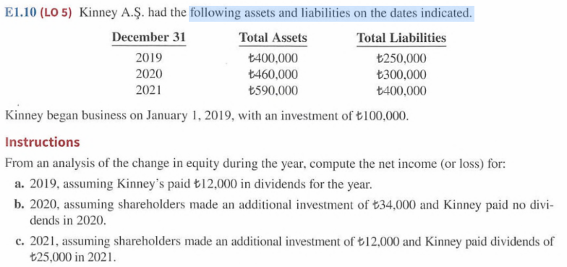

Assets – liability = equity

|  |  |  |  |
| --- | --- | --- | --- |
| Total equity | Total liability + | Total assets = | Dec 31 |
| 400,000-250,000 = 150,000 | 250,000 | 400,000 | DEC.31.2019 / 1.1.2020 |
| 460,000-300,000 = 160,000 | 300,000 | 460,000 | Ded.31.2020/1.1.2021 |
| 590,000-400,000 = 190,000 | 400,000 | 590,000 | Dec.31 2021 |

business started 1/1/2019   
investment 1/1/2019 = 100,000

net income/ loss = Revenue – expense   
RE ( end ) = RE(beg) + Net income/ loss – div

equity = S.C.O + RE(beg) + REV- EXP– div

change in equity = Additional investment + revenue – expense – div   
change in equity = additional investment + Net income – div   
Equity ( end) – equity (beg) = additional investment + Net income – div

1. Dividends = 12,000   
   Net income 2019 =??

Equity ( end 2019) – equity (beg2019 ) = additional investment 2019+ NI 2019 – div2019

150,000 – 0 = 100,000 + NI 2019 – 12,000  
150,000 -100,000 +12,000 = ni 2019 = 62,000

150,000 – 100,000 = 0 + ni – 12,000

(B) add inv = 34,000   
 Div = 0   
 NI 2020 = ???

Equity ( end 2020) – equity (beg 2020 ) = additional investment 2020+ NI 2020 – div2020

160,000 -150,000 = 34,000 + ni 2020 – 0   
10,000 -34,000 = -24,000 = Net loss 2020

1. Add inv = 12,000   
   div = 25,000   
   NI 2021 = ???

Equity ( end 2021) – equity (beg 2021 ) = additional investment 2021+ NI 2021 – div2021

190,000 – 160,000 = 12,000 + ni – 25,000   
30,000 = -13,000 + ni   
Net income 2021 = 30,000 +13,00 = 43,000