An-Najah National University  College of Medicine and  Health Sciences |  | جامعة النجاح الوطنية  كلية الطب وعلوم الصحة
Toxicology /105447
Elimination of Toxicants
From chapter 10 of Modern Toxicology book.
Chemicals can be eliminated by several routes:
- Kidney most important (receives 25% of the cardiac output).
- Liver-Feces
- Lungs
Urinary excretion
Affected by
- Size:
- Water solubility

Toxicant may be eliminated in the urine or may be reabsorbed across the tubule and back into the bloodstream.
In human, the kidney receives 25% of the blood and 20% of the 25% is filtered in the glomerulus. The blood decided what to reabsorb such as sugar and protein.
Filtration by glomerulus and active and passive filtration in the tubules.
Albumin circulate in the plasma: larger than 60, 000 Daltons not filtered, remain bound in the body.
- In general:
  - lipophilic compounds tend to be reabsorbed through Passive diffusion
  - while polar and ionic compounds excreted with urine.
Hydrophilic toxicants can also be secreted through active tubular secretion OATs (organic inion transporters). Weak acids, bilirubin, vitamins, steroids.

OCTs organic cations transporters, pep –peptide transporter weak base

Mrp are active transporters organic ionic transporter, transport glutathione, sulfate and glucuronic conjugation
Mrd: more unconjugated compounds Phase I metabolism.

New born children elimination: The ability of new born to remove toxicant is low because their active transport is not fully developed.

Fecal excretion:
Biliary excretion: is important contribution to fecal excretion.

Liver can extract compounds and prevent their distribution to other parts of the body
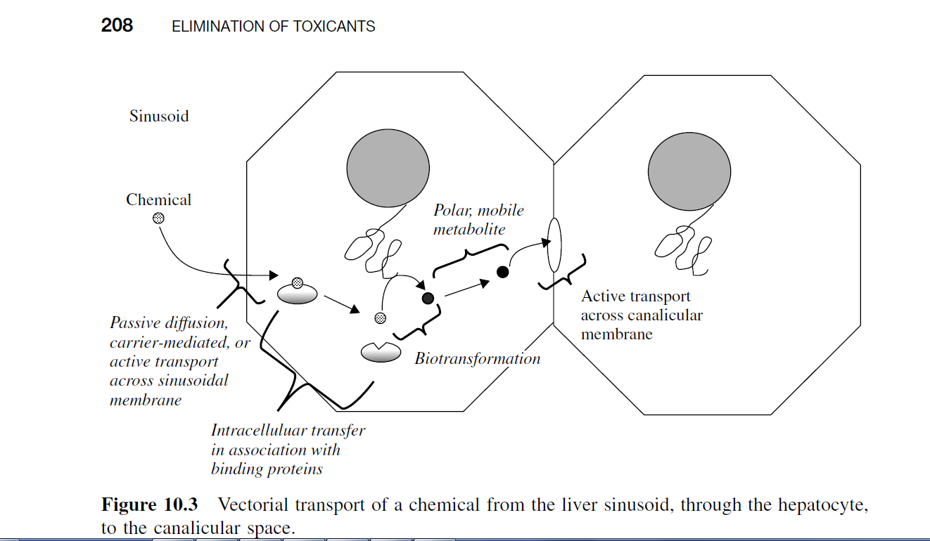

Liver is the main site of biotransformation of toxicants so the metabolites can be directly excreted into the bile:
Transport into the bile: acids, bases, conjugates, and metals.
Mdr1- Remove unconjugated compounds phase I.
Mrp2-more conjugated compounds, glutathione, glucuronitatedation, sulfation, Phase II. It flushes metabolites to the bile.
Bsep- Bile acid

Regulation of the transporters:

Molecular size:
Low MW compounds are poorly excreted in bile, while large compounds tend to be excreted in greater quantity:
> 300 daltons go into feces
< 300 daltons go to urine
Microflora in the intestine can hydrolyze the conjugates ( glucuronide and sulfate ): enterohepatic circulation which increases the retention time of the toxicant and increases its toxicity.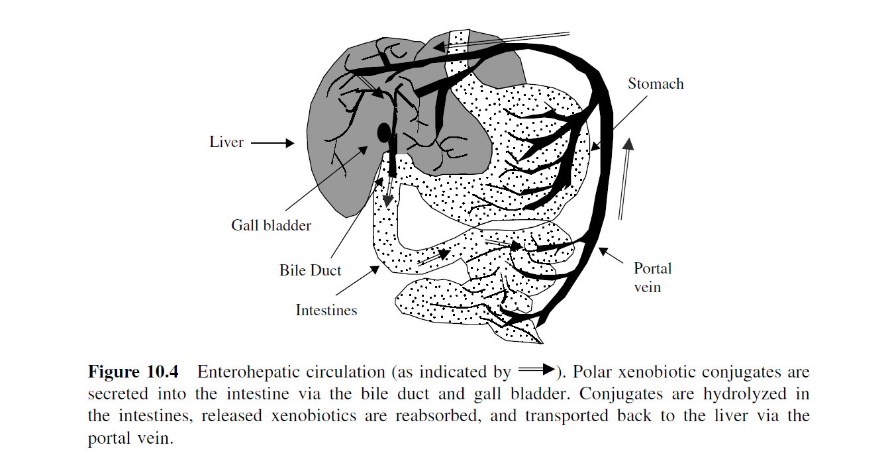
Intestinal excretion: sometime bypass the liver/bile system and is a direct transfer from blood into the intestinal content.
Very lipophilic: some PCBs, dioxin, tend to not be metabolite.

Intestinal wall flora: in gut can have their own Phase I and Phase II enzymes
Exhalation:
Gas phase generally eliminated through lungs. Gas with low blood solubility are rapidly eliminated.

Other routes of elimination can be very-specific-specific:
- Cerebrospinal fluid: brain –blood , Choroid plexus: (blood vessels)

- Milk: lipid rich 40% lipid (find very lipophilic chemicals such as dioxin, DDT, and basic compounds as pH is slightly acidic.

- Eggs: lipophilic compounds , chemical resemble Ca++.
- Sweat and saliva:
- Hair and feather: good to off load metals As, Se, Hg, PCBs.
- Plants: leaves, seeds metals and organic inions.
- Gills: water soluble compounds.

Conclusion
