
An-Najah National University
جامعة النجاح الوطنية
كلية الهندسة
Faculty of Engineering

Building Engineering Department
Computer aided lamination design (68532)
Exercise 3

Student Name:………………………...
Registration Number:………………...
Serial Number:………………………..
Section: ………………………………..
Total Exam Mark:
Exam Weight:
Instructor Name: Sameh Mona
Academic Year:2012/2013
Semester: Spring
Credit Hours: 3
Date:
Exam Duration:
Required Time | Question Grade | ILO’s % | ILO’s | Points | Question
 |  |  |  |  | Q1
 |  |  |  |  | Q2
 |  | Student Grade

Note 1: Latitude: 31.5, longitude: 35.5

Part 1
Calculate the daylight factor and the lighting level for a class room that has 10m long and 6 m width and 3.5m height in the following cases
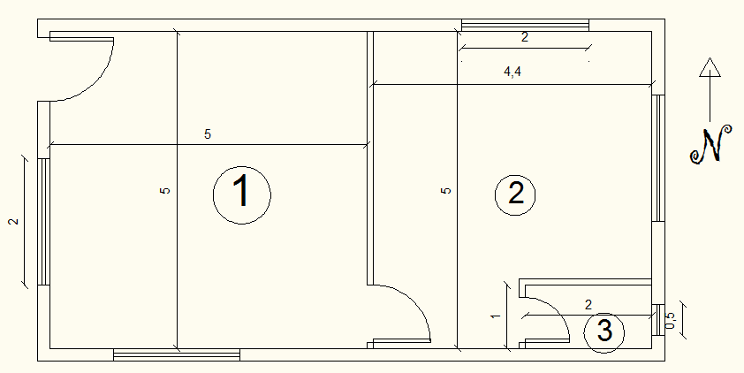

walls reflection: 0.8, ceiling reflection: 0.9, floor: 0.6 | Average daylight factor | Average daylighting level
Room 1
Room 2
Room 3

Part 2
For the previous exercise calculate
walls reflection: 0.5, ceiling reflection: 0.6, floor: 0.2 | Average daylight factor | Average daylighting level
Room 1
Room 2
Room 3

